

Submission to the

Committee on the Rights of Persons with Disabilities

Day of General Discussion

on “The Right to Accessibility”

Today accessibility is a critical concept for addressing non-discrimination and equality in our global society and in programmes of our Member States.
The Committee of the Rights of Persons with Disabilities is charged with overseeing the implementation and monitoring of the Convention on the Rights of Persons with Disabilities. Accessibility, in particular Article 9, is the key to the implementation of the Convention.
Universal Design highlights the reality that the population is comprised of people with a wide range of ages, heights, weights, language skills and abilities. It encourages designers to recognize such diversity within the creative design and planning process, resulting in products, buildings and communication systems that are more accommodating and functional for all users – including persons who are disabled or elderly.

A Universal Design approach is a cost effective approach that accommodates the needs of all users at the initial stage of development and design. It eliminates future costs and accommodation requirements as persons with disabilities arrive, work, play and communicate with each other.

The concept of Universal Design requires that Urban Designers, Architects, Web Designers, Web Developers, Communication Planners, Interior Designers, Librarians, Building Managers, Governments, Tourism Operators, etc., working in both the public and private sector, develop an understanding of the diversity of human characteristics and ability, as well as an appreciation for the challenges that many people encounter when negotiating the built and information and communication technologies environment.

Elements of the built environment are generally addressed by building codes and standards but the design of the urban infrastructure, including street crossings, and sidewalk are seldom addressed.

Each time a technology innovation has impacted the global society, there have been consequences for accessibility and participation for persons with disabilities. For example, when silent movies were screened, sound was not a technical capability so subtitles or captioning was provided. But upon the introduction of movies with sound, all of a sudden persons with hearing disabilities could not understand what was being said because the talking pictures no longer provided captioning.

With respect to the web, there was a similar dramatic consequence when it evolved from a text based environment to a robust, graphical user interface. When the World Wide Web was text based, persons with visual disabilities could use screen reading software that would read the web page out loud to them. They could also use computers with refreshable Braille that would provide tactile Braille letters to the reader as the software moved from character to character.

But when the web evolved from command-line text interfaces to graphical user interfaces, all of a sudden, the text based environment was replaced with images that could no longer be read by screen reading technology. Keyboard commands were replaced with mouse clicks that required users to see the screen as they navigated with the mouse. People with visual disabilities were suddenly prevented from participation. In addition, audio streaming was moving forward without consideration about how people with hearing loss could access audio streaming content without captioning. These are just a two examples of the barriers that were erected.

Technical design standards, whether they are for the built environment or for technologies, play a critical role in the implementation of accessible built environments and technologies. Standards represent a consensus in the industry on the critical components needed to implement accessibility. They also provide certainty for users with disabilities that barriers will not prevent them from participation in society.

Although assistive or adaptive technologies have evolved as specialized tools and equipment for persons with disabilities to use, the trend today is to incorporate accessible design into mainstream technologies. In doing so, the industry has reduced the cost of expensive customization for people with disabilities.

In order to assist States Parties to develop an indepth understanding of the concept of accessibility of the built and virtual environment, the UN DESA Secretariat commissioned GAATES to undertake the develop of a Monograph: Accessibility Provision in the UN Convention on the Rights of Persons with Disabilities. The GAATES’ Monograph was discussed at the Meeting of Experts held in June 2010 in Washington at the World Bank. The following case studies are excerpts from the study.

Case Studies

Education
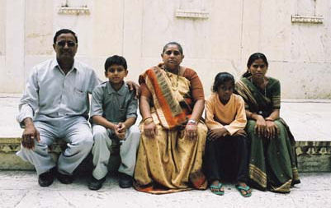
Abdullah is a taxi driver in Riyadh, Saudi Arabia. He is Indian and has a wife and family back home living with his brother. Abdullah and his wife have 3 children, one of whom, Ahmed, is deaf. Abdullah can only afford to go home to India twice a year. He earns enough money driving his taxi to be able to send his children to school; the local school will not, however, accept Ahmed, who stays home and helps take care of the family chores. Abdullah worries about all his children but especially Ahmed. Will he be able to learn enough skills in order to support himself? Will he ever have a family? Will Abdullah and his wife have to support him? What will happen after they are gone?
Figure 53: Indian family.
Photo: Charles Timmer

Problem: Ahmed was unable to go to school because the school policy was not to accept children who are deaf.

Applicable Sections of the Convention:

Article 24.2 (a) and (b) | Ensure that people with disabilities are not excluded from general education system on basis of disability; access to inclusive quality and free primary and secondary education.
Obligation | The school is obliged to provide education to children with disabilities.
Article 24.2 (d) | Ensure support for effective education within general education system.
Obligation | The school is obliged to provide effective education within the general education system itself.
Article 24.2 (e) | Effective individualized support measurers are provided to maximize academic and social development consistent with the goal of full inclusion.
Obligation | The school is obliged to provide education to children with disabilities with effective individualized support.
Article 24.3 (a) | Facilitate learning of Braille, alternative script, augmentative & alternative modes, means and formats of communication and orientation and mobility skills, peer support and mentoring.
Obligation | The school is obliged to facilitate the learning of appropriate languages and means of communication.
Article 3 (b) | Facilitate learning of sign language and promote linguistic identify of the deaf community.
Obligation | The school is obliged to facilitate learning of sign language and promote the linguistic identify of the deaf community.
Article 3 (c) | Ensure education of people with disabilities and children who are blind, deaf or deafblind, is delivered in appropriate languages and modes and means of communication that maximizes academic & social development.
Obligation | The school is obliged to provide education to children who are deaf in appropriate languages and means of communication.
Article 4 | Employ teachers, including teachers with disabilities who are qualified in sign language and/or Braille.
Obligation | The school is obliged to employ teachers who have a disability and are qualified in sign language.

Actions to be Taken:
The school should develop an inclusion policy for educating children who are deaf and provide the appropriate support, communication and accommodation including the provision of sign language.

Health Care
Eduardo lives in Bolivia. He and his family live about a five hour walk from the nearest town. Eduardo has a busy life making crafts for sale at the local market. Eduardo has noticed that he is increasingly having trouble seeing his work.

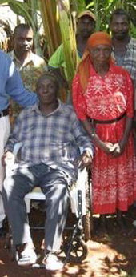
Unfortunately Eduardo can’t get to a health clinic to have his eyes examined. The Health Clinic is held once very 2 weeks in a health center that is not accessible to wheelchairs. Eduardo can not get to the clinic because he has a disability and uses a wheelchair. Eduardo boss has offered to give him the time off but still there is no way for Eduardo to get into the clinic. He is worried that he will lose his eye sight if he does not get some medical attention soon.

Problem: Eduardo is unable to get to the health clinic (he could not wheel for 5 hours without destroying his wheelchair and there is no accessible transportation) and the clinic is not wheelchair accessible.
Figure 54: Bolivian Family. Photo: unknown

Applicable Sections of the Convention

Article 9.2(b) | Ensure that private entities offering services open or provided to the public take into account accessibility.
Obligation | The health clinic is obliged to make their facility physically accessible to people with disabilities, including people who use wheelchairs.
Article 25 | Access to health services.
Obligation | Health care providers are obliged to make all health care services accessible and usable by persons with disabilities.
Article 25(b) | Provide health services including early identification and intervention and services designed to minimize further disabilities, including children and older adults.
Obligation | Health Services are obliged to provide adequate services to minimize further disabilities.
Article 25(c) | Provide health services as close as possible to people's own communities, including rural areas.
Obligation | Health services should be provided as close as possible to people’s communities.
Article 27.1(k) | Promote vocational & professional rehabilitation, job retention and return-to-work programmes for people with disabilities.
Obligation | Vocational support such as job retention should be provided to people with disabilities.

Actions to be Taken:
Accessible transportation to the health clinic should be provided to people with disabilities and the health clinic should conduct an accessibility audit of their facility and implement the recommendations.

Government
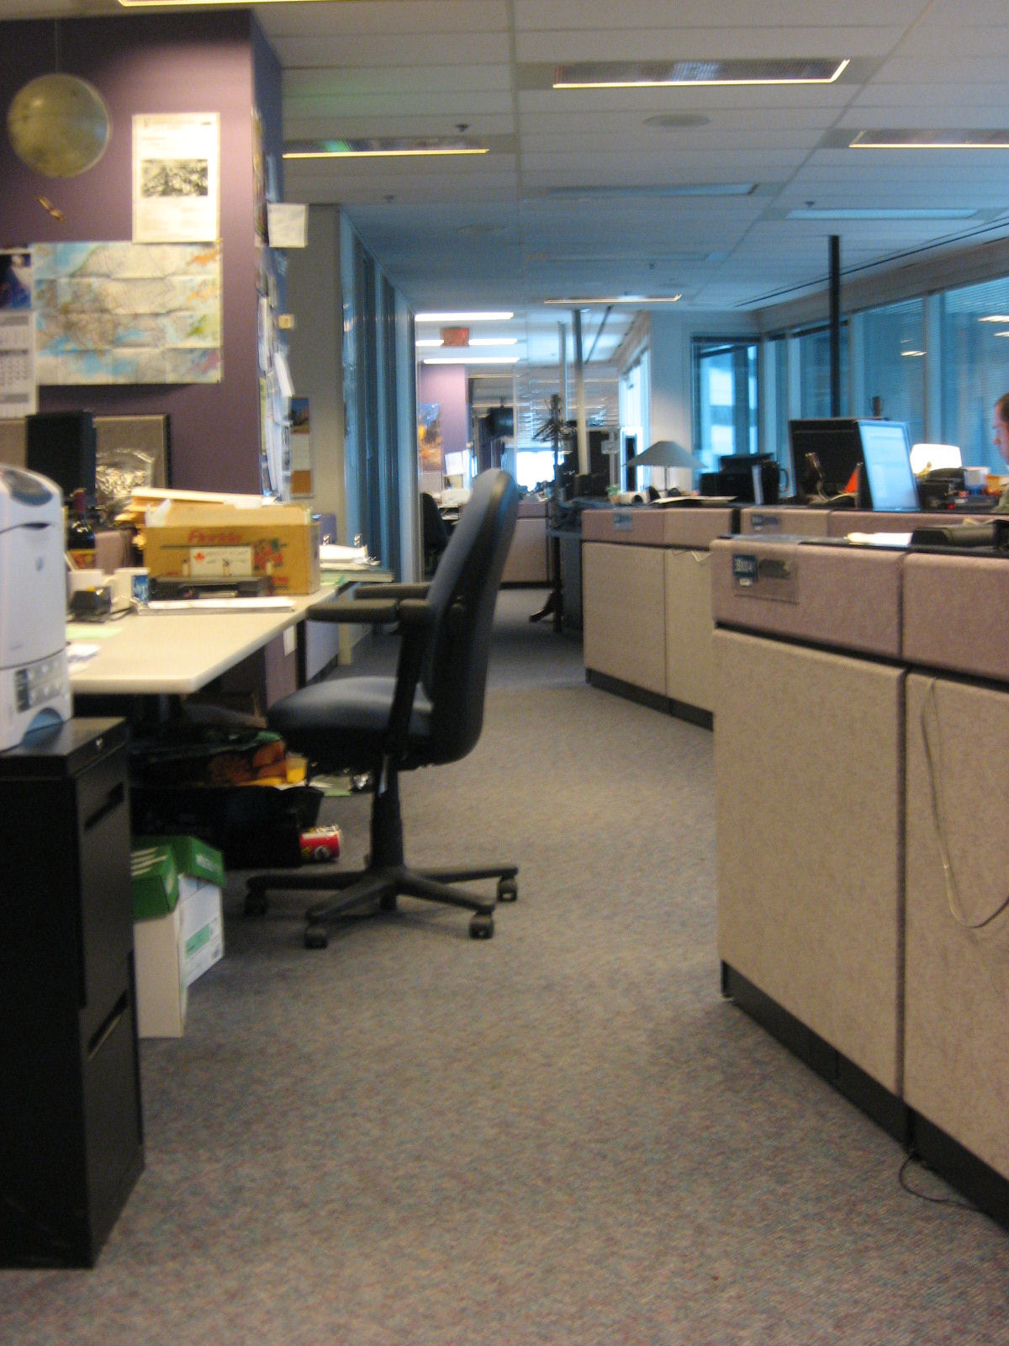
Susan works for the government as a library assistant and she is deaf. She is provided with a desk and telephone but there is no teletypewriter (TTY) or visual warning system to alert her if there is an emergency.

There was a bomb scare at work and employees were informed (audibly) that they were required to evacuate the building. Susan had been assigned a “buddy” near her work station, who, unfortunately, was sick on the day of the bomb scare. No one else was aware of Susan’s deafness and no one was able to communicate in sign language to tell her what was going on. Eventually someone took her by the arm and convinced her to leave. She was extremely distressed and was not told anything for two days until a sign language interpreter was available.
Figure 55: Office work stations. Photo: Marnie Peters

Problem: Susan was unable to hear the fire alarm and was not aware that a bomb scare had occurred.

Applicable Sections of the Convention

Article 9 | Equal access to information and communications technologies and obligation to identify and eliminate barriers.
Obligation | The employer is obligated to provide appropriate communication technology to facilitate communication and to warn employees in the event of an emergency.
Article 27 | Right of people with disabilities to work in accessible labour market and work environment
Obligation | The employer is obligated to provide an accessible work environment.
Article 11 | Ensure protection and safety of persons with disabilities in situations of risk.
Obligation | The employer is obligated to provide emergency protection for all employees, including an appropriate warning system.

Actions to be Taken:
The employer should ensure that all people are considered in emergency preparedness planning. A personal warning device (such as a pager) and appropriate training should be provided.

Transportation

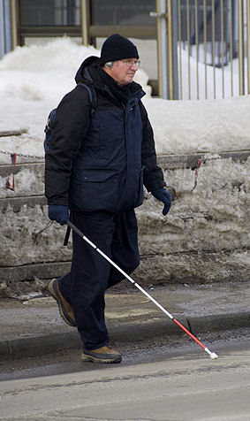
Ross had planned a wonderful winter holiday in the Bahamas. Ross lives in Canada and the winter has been long and cold, which has been especially difficult as he is blind and walking safety in cold wintry conditions can be challenging.

Ross woke up on the departure day and listened to the weather forecast on the radio. It did not sound very good. He decided to check with the airport. Using the Internet, he logged on to the airport website only to find that it was not accessible to him – the website had not been designed to be accessible. Ross uses a screen reader that is designed to allow him to read information on websites. He tried calling but the telephone was always busy. Ross, being a rather optimistic person, called the taxi and went to the airport. Unfortunately, his flight was cancelled.
Figure 1: Visually impaired man using long white cane. Photo: Tim Van Horn

Problem: Ross was not able to access information via the website so he, unnecessarily, had to go to the airport to find out if his flight was going to depart as scheduled.

Applicable Sections of the Convention

Article 9 | Equal access to information and communications technologies and obligation to identify and eliminate barriers.
Obligation | The service provider is obligated to provide appropriate information and communication technology (an accessible website) to facilitate use by all people.
Article 9.1 | Take measures to ensure equal access to information and communications, including ICT and systems; identify and eliminate barriers; applies to services open or provided to public in urban and rural areas.
Obligation | The service provider is obliged to undertake the identification and elimination of barriers to people with disabilities.
Article 9.2(b) | Ensure that private entities offering services open or provided to the public take into account accessibility.
Obligation | The service provider is obliged to provide services that are available to all people.
Article 21(a) | Provide information for the public in accessible formats.
Obligation | Public information should be provided in accessible formats.

Actions to be Taken:
The airport should direct their web designers to make their website accessible to all people.

Recreation
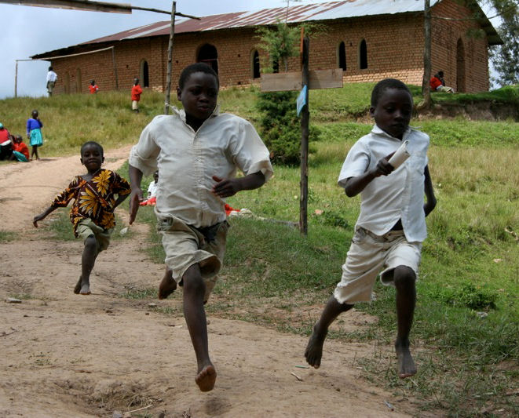
Aziz is a fast runner. In fact he is the fastest runner in his school, which is a school for children with disabilities. Aziz is hard of hearing and he loves to run as his disability does not limit his ability to run faster than anybody. Aziz, who is only 12 years old, wishes to represent his country one day in the Olympics. He trains every morning and has been working toward winning his national racing event. The big day arrives and Aziz go to the race. The organizers announce that everyone must register in person at the registration desk. Of course, Aziz does not hear the announcement and he misses his opportunity to participate in the race. He is devastated, and he feels like his life’s dream was been obliterated.
Figure 57: Boys racing at school. Photo: Karina Swan

Problem: Aziz did not hear the announcement on the public address system.

Applicable Sections of the Convention

Article 9.1 | Take measures to ensure equal access to information and communications, including ICT and systems; identify and eliminate barriers; applies to services open or provided to public in urban and rural areas.
Obligation | The service provider should identify and eliminate barriers to ensure that people with disabilities are able to participate fully.
Article 30. 5(c) | Ensure that people with disabilities have access to sporting, recreational and tourism venues.
Obligation | The service provider should ensure that people with disabilities are able to participate in sporting, recreational activities.
Article 30.5(d) | Ensure that children with disabilities have equal access with other children to participate in play, recreation and leisure and sporting activities, including those in the school system.
Obligation | The service provider should ensure that people with disabilities are able to participate in play, recreation and sporting activities.
Article 30.5(e) | Ensure that people with disabilities have access to services from those involved in the organization of recreational, tourism, leisure and sporting activities.
Obligation | The service provider should ensure that people with disabilities are able to participate in play, recreation and sporting activities.

Actions to be Taken:
The race organizers should review their practices and procedures to ensure that they do not exclude the participation of people with disabilities.

Annex

Submission to the

Committee on the Rights of Persons with Disabilities

Day of General Discussion

on “The Right to Accessibility”

7 October 2010

Global Alliance on Accessible Technologies and Environments suggestion to the Committee on the Rights of Persons with Disabilities.

Creating accessible technologies and environments is a complex process involving thousands of decisions, some stages of which are regulated, while other areas fall through the cracks.

After careful consideration, we present the following suggestions for action:

1. - A universal weakness in the design and implementation of accessible built environments and information and communication technologies is the public's perception that it relates only to people with mobility impairments, primarily wheelchair users.
GAATES suggests that an international awareness campaign about the Convention and the population of people with disabilities be developed and promoted internationally.
2. - Accessibility policies, codes and standards and even legislation have been created in many countries around the world but there is no monitoring of their implementation making them virtually ineffective.
GAATES suggests that uniform effective monitoring of accessibility provisions be a requirement for states parties and a model monitoring model be developed by the Committee.
3. There is a misconception that the design of accessible information and communication technologies can be accomplished with the use of assistive technologies but a more effective is approach is to design mainstream technologies to be accessible.
GAATES suggests a targeted campaign focusing on the benefits of designing accessible mainstream technologies.

4. A uniform benchmarking of accessibility is recommended. It should not be targeted primarily to codes and standards, but be transparent, with efficient controls and tools that make it easier to link assessments to the stages of planning, designing and actually building a facility or technology. We recommend that a CRPD assistance group be created that does benchmarking, information campaigns and consulting on a worldwide basis instead.

It's not as difficult as it sounds, some work in this direction is already happening. It could be a very important push in the direction of better quality in accessibility. They must be presented to them accompanied by examples of model programs that pull together the best, simple practices.

5. States are quite curious when you compare them to others, and often feel compelled to do something if they're falling too much behind. They may not even be aware where they stand in the picture.

The International Best Practices in Universal Design: A Global Review that compares accessibility standards of the built environment from 40 countries was an unexpected best seller. The document that is available in French, English, Spanish, Serbian and Arabic was distributed to over 6000 people.

It is suggested that the CRPD support the bi-annual publishing of best practices in accessibility for both the built environment and information and communications technologies.

Respectfully submitted,

Betty Dion
The Global Alliance on Accessible Technologies and Environments
www.gaates.org

International Best Practices in Universal Design: A Global Review, www.gaates.org

