 |  | CERD/C/KHM/Q/8-13/Add.1
 | International Covenant on  Civil and Political Rights  ADVANCED UNEDITED VERSION |  | Distr.: General  17 february 2010  Original: English
Committee on the Elimination of Racial Discrimination
Seventy-sixth session
Geneva, 15 February to 12 March 2010
Written replies by the Kingdom of Cambodia concerning the list of issues (CERD/C/KHM/Q/8-13) formulated by the Committee on the Elimination of Racial Discrimination relating to Cambodia’s eight to thirteenth periodic reports (CERD/C/KHM/8-13)*
1. Please provide detailed data or recent estimates regarding the ethnic composition of the population. Please also indicate whether the national census undertaken by the State Party in 2008 reflects the ethnic diversity and whether ethnic, linguistic, or religious groups were given the possibility of self-identification.
Answer Q1: Please see the annex attached.
2. Please provide data or recent estimates on the number of immigrants, asylum seekers and refugees, as well as their legal status. If possible, provide this information disaggregated by nationality, country of origin, ethnic origin and places of settlement.
Answer Q2: Number of foreigners who have applied for the official recognition as immigrants in Cambodia accounts for 11, 165 families equivalent to 24, 505 people (11, 967 females) with 9 different nationalities.
- The total number of immigrants is 59 among those 16 are females with the mixture of 8 different nationalities (1 Vietnamese, 10 from Somalia, 9 Burmese, 5 from Sri Lanka, 1 Pakistani, 1 Sudanese, 1 from Congo, and 1 from Algeria)
- 29 are requesting the rights to settle in Cambodia, among those 6 are females with a mixture of 8 different nationalities (3 Vietnamese, 2 Chinese, 19 Burmese, 1 Iranian, 1 Pakistani, 1 Sudanese, 1 from Congo, and 1 from Ghana)
Article 1
3. How does the government ensure that decisions about naturalization as well as citizenship are made in a consistent manner in all parts of the country and in accordance with the national law? Please explain if, pending their acquisition of Khmer ID cards, Khmer Krom can enjoy protection under refugee law or any other national legislation? (CERD/C/KHM/13, paras. 48 and 96)
Answer Q3: In regarding to the recognition of the Khmer Kampuchea Krom people as legal Cambodian citizens and the accusation that it creates unlawful conditions and influences the rights of ownerships. This may be because they see the issue only from one corner of an impropriate condition but not to see from the legal aspects and general condition as a whole related to those Khmer Kampuchea Krom living in Cambodia
In principle, Khmer Kampuchea Krom are recognized as Cambodian citizens without any discrimination. Due to the statistics, currently there are about 82,000 of Khmer Kampuchea Kroms living in Cambodia and they are legally recognized. They form 15 Khmer Kampuchea Krom Organizations and Associations legally registered and freely perform their activity to protect the interests of Khmer Kampuchea Krom, including the participation in political activities.
Particularly, with the issuance of Khmer national ID cards which are the most important documents used as national identity. Previously, there were some problems occur related to this issue, especially with Khmer Kampuchea Krom since they are not clearly aware of the conditions and procedures required by laws or procedure in order to obtain their ID cards.
Forms and conditions required when someone proposes for ID card include:
- He/she must have permanent address in Cambodia.
- He/she must have Khmer birth certificate.
- He/she must have family record book k4
- He/she must have any verdict from the court to recognize that he/she was born by parents with Khmer nationality or
- Royal Decree on the recognition of Khmer national
- Any evidence which shows that he/she was born by parents having Khmer national.
4. In its report, the State party refers to “administrative and other special measures” taken to ensure the adequate development of all races and ethnicities. Kindly specify the types of measures the State party is referring to. (CERD/C/KHM/13, paras. 49-51)
Answer Q4: To ensure the livelihood with harmony and good understanding getting along with all minorities living in Cambodian society, the Royal Government of the Kingdom of Cambodia has taken the measures as follows:
General Administrative Measurement:
Facilitate with many organizations wishing to understand, preserve and implement humanitarian works with different minority groups in Cambodia. The Royal Government of Cambodia welcomes some other organizations working with minorities on languages and cultural development aspects.
The Ministry of Rural Development has one Department which manages the works of the minorities to ensure a better understanding of all problems exist in minority society so as they have basic knowledge on the community for the resolution when problems arise.
All problems and offences related to the minorities, the resolutions to those problems are implemented based on the same law applied to all Cambodian citizens living in the Kingdom of Cambodia without any discrimination whether they are Cambodian or minority.
Special Measures:
The Criminal Code of the Kingdom of Cambodia also focuses on the prevention of racial discrimination as stipulated in articles 494, 495, 496. Furthermore, the Royal Government has set out policies on the land registration and rights to the land use of indigenous community through Sub-Decree No. 83 dated 09 June 2009, signed by Samdech Akka Moha Sena Padei Techo Hun Sen aiming to protect the ownership of the land of indigenous community stipulated in Chapter 3, Article 6.
In the public forum, the Prime Minister of the Kingdom of Cambodia released the declaration to permit the Muslim women to wear their masks anywhere in Cambodia. This shows that the Royal Government has taken certain measure to ensure harmony to all minorities living in the Kingdom of Cambodia.
Article 2
5. Please provide more information on the methods pursued by the parliamentary human rights commissions (of the National Assembly and the Senate) and by the Cambodian Human Rights Committee (CHRC) to monitor and control the activities of local authorities regarding the application of laws and policies aimed at combating racial discrimination (CERD/C/KHM/13, paras. 27 and 28). Please provide data on the number of complaints received by the parliamentary commissions and the CHRC and the results of any relevant enquiries undertaken. (CERD/C/KHM/13, para. 31)
Answer Q5: There are three institutions which hold the mandate to receive the complaints on human rights and to conduct the investigation on the cases.
A. Commission on Human Right and Receiving Complaints of the Senate
This Commission is one of the 9 commissions of the Senate and it has the role to protect legal rights of the people. As the representative of the Senate, this Commission performs its roles and duties to solve all requests and complaints made by the people whose rights are violated. This Commission has the rights to examine and investigate all complaints made by the people and make the report and inform to the Royal Government to settle those problems. In 2009, the Commission received 24 complaints, among which 6 cases related to the breaches of the verdict issued by the court, 16 cases are the complaints filed against provincial authorities and other 7 cases are being solved by the people themselves.
B. Commission on Human Right and Receiving Complaints of the National Assembly
This Commission is one the 9 commissions of the assembly and it has the roles to protect legal rights of the people. As the representative of the assembly, this Commission performs its roles and duties to solve all requests and complaints made by the people whose rights are violated by any units/entities as what the same Commission does in the Senate. This Commission received 126 cases of complaints in its first semester of 2009, among which 87 cases related to land disputes and other 39 cases related to the judgments of the courts and other businesses.
C. Cambodian Human Right Committee
This Committee is an institution under the Royal Government of Cambodia which is assigned to perform its duties to improve the situation of human rights and the rule of laws in Cambodia. The Cambodian Human Right Committee was established under the Royal Decree No. 0100/008 dated 18 January 2009 and by the Royal Decree No. 029/163 dated 13 February 2009 on the amendment made to Article 2 and Article 5 of the Royal Decree No. 0100/008 dated 18 January 2000 on the establishment of the Cambodian Human Right Committee with the roles and functions to investigate and deal with all complaints, collect all information related to human rights implementation, organize the trainings, disseminate the laws on human rights, write and submit the reports to UN. In 2007, Cambodian Human Right Committee received 810 complaints among which 625 are under the review process. The Committee is proceeding its procedures on other 185 cases more among which 171 cases are under investigation. Moreover, the Committee has issued 89 letters of intervention among which 7 cases have been settled. All three institutions are mandated to visit the prisons in Cambodia nationwide on its regular basis.
6. Please comment on the status of the draft refugee legislation initiated in 2008 and provide information on its provision for the recognition of refugees and the protection of asylum seekers?
Answer Q6: Sub decree No. 224 on the procedure of screening, recognition, and the acceptance the status as refugees or rights to have asylum has come to effect since 17 December 2009.
Since 2001 until now, Cambodia has been cooperating with UNHCR and other relevant organizations very well in implementing its duty as a signatory state to the convention on the recognition of refugees in 1961. Particularly, Cambodia has properly implemented in accordance with the spirits of tri-parties agreement among Cambodia, Vietnam and UNHCR, on the solution for Vietnamese highlander tribes, which was signed in Hanoi on 25 January 2005.
Particularly, according to the statistics it reveals that between 2004 and 2009, Cambodia received 1,830 Mongtenha refugees to stay in its safe camp in Phnom Penh and took action to overall protect their safety.
We have facilitated and given favorable condition to UNHCR and other foreign parties, especially the United States of America to implement the procedures in compliance with the 1961convention. 902 Mongtenha refugees were sent to resettle in third countries and other 704 were rejected by UNHCR and they were sent back to Vietnam among whom 502 were done on the voluntary basis. Among those, 75 of them were found cheated because they were truly Cambodians and later they were sent back to their hometowns. 15 of them escaped from the safe camps, and now there have been 98 more have been brought under the observation and procedure of UNHCR.
In addition to this, the accusation of Cambodian people for assisting those Vietnamese tribes to come into Cambodia is done under the existing laws on immigration regardless of the transfer of Montague refugees into Cambodia, but regarding their case as the illegal border crossing.
7. In his letter dated 19 May 2009, the Special Rapporteur on the situation of human rights and fundamental freedoms of indigenous peoples reiterated his concerns expressed in his letter of 22 July 2008 regarding the Sub-Decree on registration of indigenous communal land. Kindly provide information on concrete steps taken to address these concerns. (CERD/C/KHM/13, paras. 68-69)
Answer Q 7:
- Sub-decree on the procedure of the registration of indigenous community land determines the principles, procedures and mechanisms for registering the land of indigenous community in the manner of collective ownership. Procedure used in the preparation of this sub-decree was conducted in a democratic environment under the process of public consultation with the participation from relevant stakeholders, organizations, civil society and people from indigenous community. This consultation was welcomed and approved by the senior political dignitaries having the background as indigenous people who are now the members of senate and national assembly, governors and deputy governors of Rattanak Kiri and Mondul Kiri provinces as well. Therefore, civil society should not be concerned too much about this issue.
- The contents related to the procedures of processing the land identification of the community and land registration in the manner of collective ownership was made in compliance with the procedure with the participation of all stakeholders in the process of identification, especially the participation of indigenous people to ensure that their land entitlement was fully guaranteed.
- The contents within this sub-decree is in compliance with any international instruments related to the land rights of indigenous people community that Cambodia has been obliged to implement. In this spirit, every provision of the international instruments shall be verified and considered so as to make it consistent with the international and national standards.
See sub-decree No. 83 on the registration of the land of indigenous community
Article 4
8. Please provide information on provisions in the new Penal Code aimed at outlawing racial discrimination and incitement to racial hatred. What concrete steps has the Government taken to defuse possible racial tension.
Answer Q8:
Article 494:- Prioritized conditions of the incitement shall be punished when following acts have been committed:
- By means of whatever kind of verbal forms addressed in the public places or at the public meeting hall.
- By means of whatever kind in written forms or in drawing which are distributed or displayed among the publics
- By every means of telecommunications and audios delivered to the publics.
Article 495: Any acts of inciting someone to commit any crimes such as directly inciting somebody to commit a crime or commit an offense that result in serious social disorder and threaten social security through any means as stipulated in Article 494 (the prioritized condition in acting such incitement) of this code, that person shall be imprisoned from six (6) months to two (2) years with an the amount from 1,000,000 (one million) Riels to 4,000,000 (four million) Riels shall be fined if such incitement is not effective.
Article 496:- Act of incitement that leads to discrimination
Direct incitement using one of the means stipulated in Article 494 (the prioritized condition of incitement) of this code that incites someone to intentionally commit the discrimination, revenge or using violence to a person or a group of people due to the reason that the individual or that group of people are not the member of any ethnic groups, origin of people or religious group as they have determined, that person commit such acts shall be imprisoned from one (1) year to three (3) years and the amount of money from 2,000,000 (two million) Riels to 6, 000,000 (six million) Riels shall be fined if that incitement is not effective.
Article 497:- Act of incitement using media as a means
Offenses stated in this section committed through a means of media shall be subject to the provisions of law on the press.
Article 498:- Additional punishment: categories and term
The following additional punishment shall be declared for the offenses stated in this section:
- Partially or totally deprived of the rights as citizenship or within the course of 5 (five) years in maximum.
- The absolute prohibition of handling or carrying all types of weapon and other explosive items or in the course of five (5) years in maximum
- The posting or displaying of the decision of conviction for the period of two (2) months in maximum.
- Releasing the decision of conviction on media.
- Publicize the decision of conviction through all means of audio, telecommunication for the period of eight (8) days in maximum.
9. What measures has the Government taken to counter negative ideas and prejudice against Africans living in Phnom Penh? Please provide information on the arrest of 57 Africans, who attended a religious service in Phnom Penh on 2 August 2009.
Answer Q9: Based on the existing laws, immigration competent officials have duties to use forces to conduct any investigations aiming to prevent and crackdown all crimes or offences which may harm the national security:
Obviously, on 2 July 2009 at 11:00, Phnom Penh municipal immigration officials went to inspect and check at House No. 42 E2, Street No.338, Sangkat Toul Svay Prey 1, Khan Chamkar Morn, Phnom Penh capital. This location used as a Christian church namely called Diplomatic Christian Church of Cambodia(Preah Vihear SasnaKristr Tout Kampuchea). As a result, we found 57 foreigners staying there, among those 9 of them are females with a mixture of 7 different nationalities (47 Nigerians, 4 Guinea-Bissau, 1 Sera Leon, 1 Liberia, 1 Guinea Conakry, 1 South African, and 2 others are the Philippines).
To deal with the above case, the following actions were taken by Phnom Penh immigration officials:
- 43 of them were permitted to go back home (9 of them are females with the mixture of 6 different nationalities) since they have all legal residential document in staying in Cambodia.
- 14 others have been sent to Immigration Department for further dealing with case (13 Nigerians and 1 Guinea-Bissau)
With those illegal immigrants,the Department taken legal action against 13 immigrants by sending them out of Cambodia. Other 3 Nigerians are staying in the centre awaiting for the process of sending out. The three Nigerians are:
      - AKPOGBDI CTENTILITY JANE, male, born in 1988
      - KONTE AMADOU, male, born in 1988
      - ALEXANDE COLUMBA, male, born in 1988
Article 5
10. In light of the Committee’s previous concluding observations (para.10), please indicate the concrete measures taken by the State party to ensure equal protection and access to basic human rights (education, standard of living, health care) to all persons under the jurisdiction of the State, including minority groups such as the Khmer Krom and ethnic Vietnamese (CERD/C/KHM/13, paras. 44, 51). As some members of the Khmer Krom and ethnic Vietnamese groups do not have a Khmer ID card, how can their basic rights be guaranteed?
Answer 10: The Ministry of Education, Youth and Sports have performed the measures and strategic plans of educational sector with the following contents:
(a). Law on Education:
The contents of the Convention on the Elimination of all Forms of Racial Discrimination is used as one of other sources in making law on education with the consent from the senate and it was approved on 21 November, 2007. Law on education determines the mechanisms and authorities of concerned institutions to ensure the participation with full responsibility in educational activities in conforming to a slogan "Education for all, all for education."
In Chapter 5, article 23, paragraph 2 states that civic education, education for living together with unity and harmony, education for peace, education for sustainable development, education on how to get along with other cultures, and education for the respect of traditional value which have been determined as major elements of core curriculums.
Chapter 5, article 24, paragraph 3 states that language used for Cambodian learners having minority origin shall be determined by the ministry in charge of education using bilingual text books.
Chapter 7, Article 33, there was a paragraph states that all forms of forcing all learners and those people concerned with education to join any religious activities and/or religious practice as a form of direct or indirect education shall be prohibited.
(b) . Strategic plan of educational sector 2006-2010:
Item 4.3 on the institutional development policy and capacity building educational decentralization activities in all strategies and all interventions of educational strategic plan determine physical materials program and curriculum reform for indigenous people are encouraged, especially the deployment of staff to areas with hardship.
11. Taking into consideration that registration of indigenous land is among the priority actions envisaged for the land reform process, please provide data on registration numbers and the number of titles issued, indicating also the ethnic groups which have benefited from such land registration. Please provide information on measures taken or planned to operationalize the newly adopted ‘Sub-Decree on communal registration of indigenous land (dated 24 April 2009).
Answer Q11.Today, we have implemented the pilot projects on land registration of indigenous people in a form of collective ownership in 3 villages including Andaung Kraleung village, Mondul Kiri province, Lan In village and La Eun Kreng village, Rattanak Kiri province. In Andaung Kraleung village, the poles installment for demarcation process is finished. Moreover, the process of poles installment for demarcation process in other two villages are going to start in early 2010.
- After this sub-decree is in effect, it will have an effect to apply for all communities within the Kingdom of Cambodia. Indigenous community can easily request for land registration in a form of collective ownership after those communities have been officially registered and recognized as legal entity by the Ministry of Interior.
- The Ministry of Land Management, Urban Planning and Constructions has collaborated with the working group of land registration of the Ministry of Interior conducting the population census on indigenous people in the communes which are qualified enough for establishing such community and based on this, there are 07 communities (03 communities in Mondul Kiri and 04 communities in Rattanak Kiri province) conducted consultative meeting to prepare the statute and to select the community committee which is now the registration procedure in the Ministry of Interior is currently in the process.
12. Please provide information on concrete measures taken to avoid illegal land grabbing and ensure adequate protection of indigenous peoples’ collective ownership? Has the sale of indigenous land, or the lease of such lands through the granting of economic land concessions, been prohibited pending finalization of the registration process? What measures have been taken by the State party to ensure that national and transnational corporate activities do not obstruct the access by indigenous peoples to their natural resources? (CERD/C/KHM/13, para. 98)
Answer Q12:
- The local authority, especially the provincial authority of both in Mondul Kiri and Rattanak Kiri provinces, where there are many minority population, took all legal actions against the sales and encroachment of the land of the indigenous people by the outsiders of the community. In this regard, Ratanak Kiri authority issued a letter of notification No. K740 on the termination of the claim for ancestral inheritance on all the assets owned before 1979 and the decision No. 418 SCN dated 08 December, 2008 on the preventive measures to ban all activities related to the issuance of standard letter in relation with the sales, transfer, and pawn of the land in Ou Chum district. Meanwhile, Mondul Kiri provincial authority issued a letter of notification No. 025 SCN/MKR dated on 7 March 2008 on the termination of signing the letters to permit land transfer, sales, purchasing in the villages, communes and district levels. Moreover, we still have other laws and other legal frameworks to support and ensure the community ownership of the indigenous people to access to natural resources and land titles as stipulated in the Land Law 2001, and Forestry Law 2002.
- The Royal Government of Cambodia has never sold out the land belong to the indigenous people community.
- We should understand clearly the procedures of economic land concession before reaching the conclusion for the decision of economic land concession for development purpose, we conduct the social and environmental impact assessment and consult with the local people to ensure that it does not impact the private land being used in the community. It is thus no reason that providing the economic land concession causes the loss of the community land of the indigenous people whose lands are being used.
- The assessment of the social and environmental impact is the main effort of the Royal Government of Cambodia which has always paid attention on conducting the study and evaluation as well as to get the local authority and stakeholders actively engaged in the process in order to ensure the economic land concession truly contribute to development and never harm the people living in the community.
- The rights of indigenous people in land use and to have access to natural resources have been guaranteed under the laws and regulations such as Land Law 2001 and Forestry Law 2002.
Granting the economic land concession will not be pending till the completion of the registration of the indigenous people community land because the previous economic land concession made by the Ministry of Forestry and Fishery was concluded according to the contents of Sub Decree No. 146 dated 27 December, 2005 on the Economic Land Concession including reporting on the assessment of the social and environmental impact prior to conclusion of the land concession, and dispatching experts to cooperate with local authority at all levels to monitor and evaluate the actual status of the locations in order to cut off the lands which partly belong to the people and register the state land in accordance with the Law. Therefore, before granting the economic land concession, the Ministry of Forestry and Fishery has made a comprehensive inspection and the Technical Secretariat for Economic Land Concession has a role to provide advices to the Ministry before reaching any decision.
13. Please provide information on the number of non-Khmer nationals incarcerated in the prison system and on laws and measures to protect their rights (including access to religious observances). What provisions (including adequate budget) exist to ensure that defendants who do not understand the Khmer language are provided with interpretation and legal representation in the courts?
Answer Q13:The total foreign prisoners imprisoned in Cambodia are as follows:
- 559 prisoners in total (140 females)
- 201 culprits (53 females)
- 358 convicted ( 87 females)
- All culprits and convicted either Cambodian nationals or foreigners receive the same proportion of food, clothes, and daily supplies as stipulated in Sub-Decree No. 86 dated 19 June, 2009 of the Royal Government of Cambodia.
- Those prisoners can enjoy the freedom of choice of their religious practice, rights to adequate clean water needed to have healthy life, rights to have special daily food as prison director seeing that the food listed in the prescription as well as special food given in accordance with their religious requirement, following the Declaration No. 217 dated 31 March, 1998 of Ministry of Interior.
- Article 144 of Criminal Procedure Code state that; “ In a necessary case, investigating judge needs to have a professional interpreter for the court procedure. The interpreter is required to do an oath in accordance with religion he/she belongs to, assuring that he/she works all the best to help the court and swearing that he/she interpret accurately. In any case, the interpreter cannot be selected among those who are the judges, court clerks, police officials, gendarmeries, or witnesses at all.”
- Article 301 of the Criminal Procedure Code 2007 state that; “ Legal assistance from lawyer is a must in the following cases: ”
- It is a felony case
- When the accused is the minor. If the selection of lawyer is not done by the accused, a lawyer shall be assigned with the initiation of court director in compliance with the conditions set in the law on the statue of lawyers.
14. Taking into consideration the efforts made by the State party to ensure equal access to education, please explain if the implementation of small scale bilingual education projects in the north-east provinces will be extended so as to fit within a comprehensive strategy to target all ethno-linguistic groups for whom Khmer is not a native language? Have the specific needs of Cham communities both in terms of religion and language been taken into consideration in the education curriculum reform? What efforts have been made to preserve indigenous languages facing the threat of extinction?
Answer Q14: The Ministry of Education, Youth and Sport has paid its utmost attention to constitute bilingual education program which is a bridge in response to the need for education of the indigineous children and adults and to ensure their rights to access education through:
Education at Primary School
In implementing the rights to access to education of the indigenous people and the minorities, the Ministry of Education, Youth and Sport has built 16 community schools in 10 districts, 5 provinces (Kratie, Steung Treng, Preah Vihear, Ratanak Kiri, Mondul Kiri) where bilingual education is being implemented in the academic year 2006-2007 for indigenous children from grade 1-3, funded by UNICEF, ICC, CARE and SCN. Meanwhile, the Ministry developed a mixed education which currently some indigenous people have become teachers and the public school directors.
Non-formal education
The Ministry developed a literacy program which is now being implemented for illiterate people throughout the country and encouraged the bilingual education both Khmer language and the language of origin for illiterate adults living in indigenous people community. In addition, the Ministry of Education, Youth and Sport constituted a bilingual educational program for adults in the community of indigenous people nationwide. Obviously, the Ministry has cooperated with the relevant NGOs to develop the bilingual textbooks in which languages of Kreung, Tumpoun, Prov, Kaven, Phnong etc are used in addition to Khmer language. Moreover, the Khmer script is allowed to be used as a writing system to record their languages since 2003 in order to encourage them learning and writing their historical events. Moreover, the Ministry has designed and supplied the books on life skills, especially the Ministry recognized and permitted to establish private language schools teaching Chinese, Vietnamese, English, French, Korean, Japanese and Muslim languages as international languages and the other ethnic languages based on their needs.
15. Please provide information on concrete measures taken to ensure access to educational services in remote areas inhabited by indigenous peoples and minorities. Please indicate the measures taken to improve minority representation among teachers in public schools. (CERD/C/KHM/13, paras. 149-150)
Answer Q15: Every year, The Ministry of Education, Youth and Sport is committed to providing the favorable condition of policy for those living in the remote areas allowing them to be able to recruit new teachers in order to ensure that education services are properly delivered to indigenous people and minority. As a result, the indigenous people applicants have successfully passed and have been recruited as the public school teachers. Obviously, in Preah Vihear province, there are originally 29 Kouy teachers (6 females) and within this year there is one female teacher trainee studying in the Pedagogy School. In Mondul Kiri, there are 61 teachers and teacher trainees who are the indiginous people, 22 of them are females. In Kampong Cham province, there are 17 Islamic teachers (10 females) and within this year there are 3 Islam teacher trainees (2 females) are doing their studies. In Ratanak Kiri province, there are 47 teachers in which 8 of them are females. Among those, 8 of them are Charay, 18 of them are Tumpoun, 18 Kruengs, other 3 are Prov. In this academic year, there are 4 Tumpoun teacher trainees, and 16 Laotian minority (12 of them are females).
16. Please provide more information on steps taken to ensure that all children, regardless of their ethnic or national origin, have equal access to education. More specifically, please explain how the State party intends to address the issue of Khmer Krom children within the five provinces of Phnom Penh, Takeo, Kandal, Preah Sihanouk and Koh Kong, who cannot attend school because their families are poor and lack legal documents? (CERD/C/KHM/13, paras. 153 and 156)
Answer Q 16: The Ministry of Education, Youth and Sport has implemented the National Educational Program namely called Education for All to encourage all children of all races throughout the country to enroll for schooling. Regarding the enrollment, the Ministry requires people to show their identity through family book or book of residence and such enrollment is a free of charge process.
17. Please indicate the measures taken to address the high rate of illiteracy among Khmer women. (CERD/C/KHM/13, para. 139)
Answer Q17: The Ministry of Education, Youth and Sport is committed to building the secondary schools in all communes, primary schools in all villages, and to provide scholarship and dormitories for female students. For example, in Ratank Kiri province dormitory is built and scholarship are offered to the female students in order to let them complete their primary education, secondary education so as they are able to further to higher education. Particularly, in regarding to the classroom content, the Ministry of Education, Youth and Sport has integrated the education on human rights into the national curriculum starting from grade 1 to grade 12 within the social studies subject and do mainstreaming on human rights related regulations and its values into other subjects.
18. Please provide more information on the question of access to health for minority groups, especially indigenous peoples, in a language that they do understand. Please provide information on existing programmes in this regard. (CERD/C/KHM/13, para. 134)
Answer Q18: The policy guidelines of the Ministry of Health is to provide health care service to all people with quality, effectiveness, with equity nation wide, especially for the poor and those living in the remote areas including minority. The expansion of the physical infrastructure facilitates in compliance with the health coverage plan providing more favorable condition to people to have more access to the health care services especially those living in the rural areas. To accelerate the rate of coverage of health care services to people living in the remote areas including the minority who mostly inhabitate in the Northeastern part of the country such as Rttanak Kiri, Preah Vihear, Mondul Kiri, Stung Treng and Kratie etc. Previously, the Ministry of Health delivered health care services directly to the local people which include health education, pregnancy check up, vaccination, treatment of malaria and tuberculosis using Village Health Volunteers and other health services. To communicate with the indigenous people in the health centers and village health post, the Ministry of Health has recruited the indigenous people who can speak Khmer language to learn and train them to become health staff working in health centers and they have used those staff as a communication agency to communicate with other indigenous people. Obviously, the Regional Secondary School of Health based in Stung Treng province accepted and trained the indigenous youths living in the Northeastern part of the country like Rattanak Kiri, Preah Vihear, Mondul Kiri, Stung Treng as well as other Health Regional Schools do. The recruit of the volunteers to work in health care services in the villages are prioritized for the indigenous people who can speak Khmer and they will become the village health volunteer since it is easy to do the communication and convey message related to health education as well as to provide health related information to them.
The Ministry of Health has prioritized the deployment of the staff to ensure that health service delivery has reached the remote areas including those minority people. The deployment of midwives to every new health centers is done as well. Many health posts have been built in the indigenous people community and remarkable progress has been made and seen. An overall goal of the Ministry of Health still prioritizes the delivery of health care services with quality and equity to the people nationwide without having any discrimination on their status, race or color or skin, nationality especially the effort made in building the health infrastructures and health facilities to be more closer to the beneficiaries.
Article 6
19. What measures have been taken to combat acts of violence against members of ethnic minorities and to ensure that such acts are always promptly and effectively investigated and prosecuted? The Committee is particularly concerned about reported incidents in connection with demonstrations by Khmer Krom monks in the spring of 2007. Please indicate whether an investigation has been carried out into the murder of Khmer Krom monk Eang Sok Thoeun on 27 February 2007, and whether the perpetrators have been brought to justice.
Answer Q19: The constitution of the Kingdom of Cambodia and the principle of the Royal Government of Cambodia never set any actions or measures against indigenous people or any ethnic minorities at all.
In 2007, the act of preventing illegal demonstrations by Cambodian competent authorities against anarchic groups with the participation of some Khmer Krom monks was done in order to ensure national security and social order of the country.
And in the case of the monk named Eang Sok Thoeun, according to the report released by investigating teams revealed it was a case of murder.
20. In light of the Government’s assertion that all Khmer Krom are Khmer citizens, please explain the legal basis on which Khmer Krom monk Tim Sakhorn, who possessed a Cambodian ID card and who had been residing in Cambodia since 1979, was expelled to Viet Nam on 30 June 2007, where he later served a one-year prison sentence.
Answer Q20. In the case of a Khmer Krom named Tim Sakhorn, he was found committing against the disciplinary principle of monks, therefore he was required to leave monkhood. After leaving monkhood on 30 June, 2007, district authorities, district office of cults and religions, commune councils, pagoda commission, together with the warrant from Takeo provincial court thoroughly inspected and checked Tim Sakhorn’s room and as a result they found Saingkim knife (a kind of knife used by soldiers in the battle field), sex movies VCD, and other two people staying in his room, together with a letter of request written by Tim Sokhorn requesting to go back to his home country(Vietnam).
21. Please provide concrete examples of land dispute settlements adjudicated by judges or cadastral commissions in favour of indigenous peoples as well as those against indigenous peoples. Please also provide data on the compensation amounts and resettlement programmes established after expropriation. Please provide information on mechanisms put in place to protect victims of land expropriation from criminal charges whenever they try to defend their rights. (CERD/C/KHM/13, para. 168)
Answer Q21: Within the Kingdom of Cambodia, there are two means of land dispute resolutions:
- For those land which do not have land title yet, the dispute shall be dealt with at district/Khan cadastre committee, provincial cadastre committee, and national cadastre committee. If still solutions cannot be found at those levels, the case shall be further sent to National Authority for Land Dispute Resolutions at the council of minister.
- For those lands which already have land titles, the dispute resolutions shall be done by the court and they shall implement in accordance with the legal procedures.
Article 7
22. In its report, the State party states that the Government is promoting tolerance among all residents of Cambodia. Please provide additional examples of concrete measures taken to foster understanding between different ethnic groups and to promote awareness and the preservation of the histories and cultures of minority groups, such as the Cham, Vietnamese, Khmer Krom and indigenous peoples. (CERD/C/KHM/13, paras. 55-56 and 171-175)
Answer Q22: Same as answer provided in question 8.
Article 14
23. Please indicate whether the State party envisages making the declaration under article 14 of the Convention as recommended by the Committee in its previous concluding observations (CERD/C/304/Add.54, para.24).
Answer Q23: Kingdom of Cambodia is an independent state with its sovereignty having a separate and independent court system where people can file their complaints to two levels of courts and disciplinary council of judges.
- The death penalty is eliminated
- The announcement of judgement is made publicly except for the benefit of minor-family dispute and the conflict on the children’s guardian.
- Doubt is prevailed to the accused until there is a find judgement issued then the accused can be considered a guilty. The accused can defend themselves and the rights to access to lawyer for legal assistance and the rights to access to information. Moreover, the accused shall not be forced to confess for the sake of their own guilt and the two-time trials shall be prohibited for the same case.

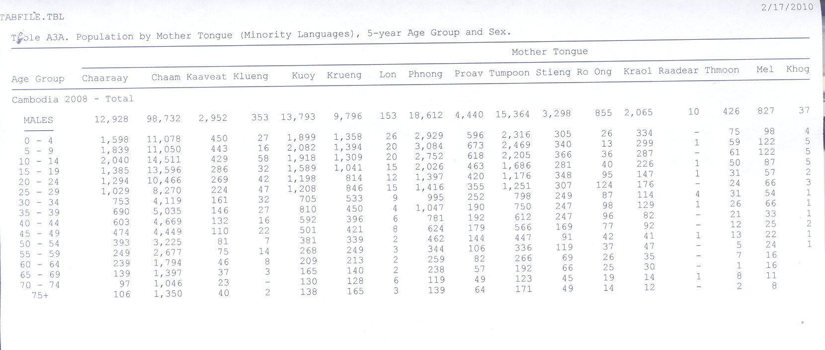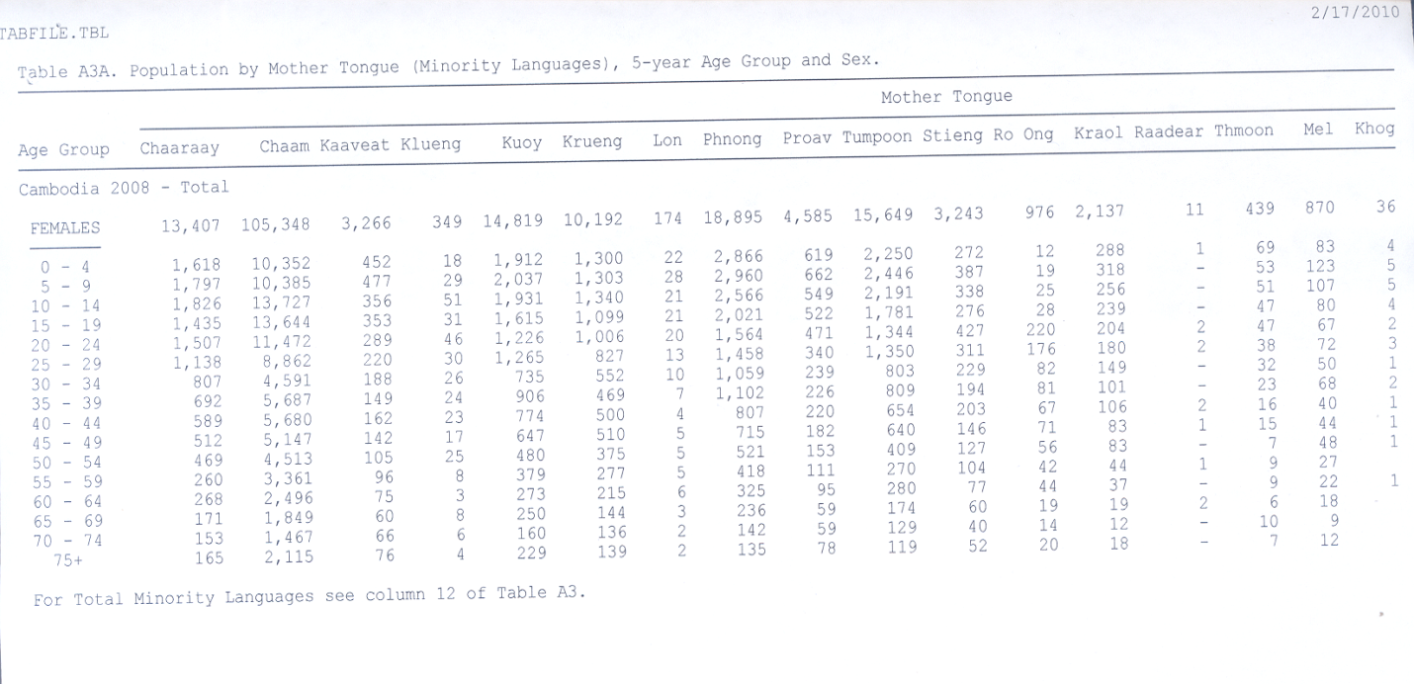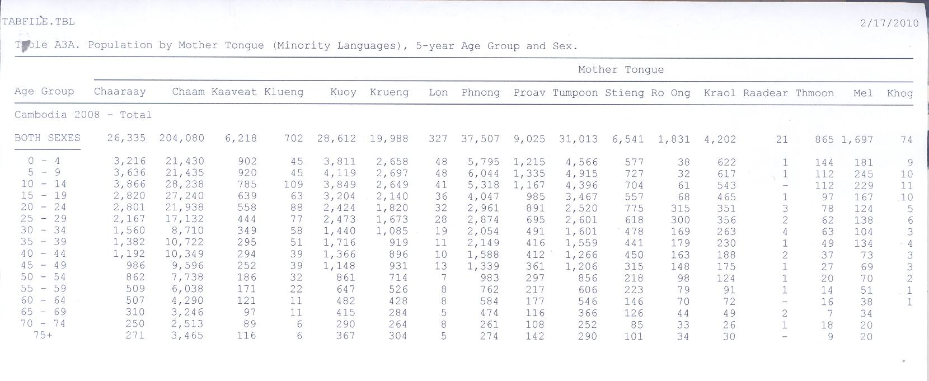
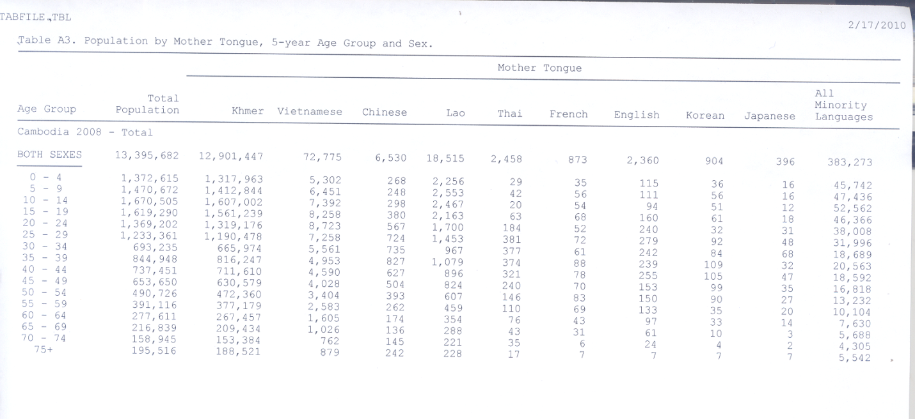

Annex I

* * In accordance with the information transmitted to States parties regarding the processing of their reports, the present document was not edited before being sent to the United Nations translation services.
? A/HRC/12/34/Add.1, para. 12-24

