UNITED  NATIONS |  | CAT
 | Convention against Torture  and Other Cruel, Inhuman  or Degrading Treatment  or Punishment | Distr.  GENERAL  CAT/C/81/Add.2  5 April 2005  Original: ENGLISH
COMMITTEE AGAINST TORTURE

CONSIDERATION OF REPORTS SUBMITTED BY STATES PARTIES UNDER ARTICLE 19 OF THE CONVENTION

Fifth periodic reports of States parties due in 2004

Addendum*

DENMARK
[19 July 2004]
CONTENTS
Paragraphs Page
Introduction 1 - 5 3
I. INFORMATION ON NEW MEASURES AND NEW
DEVELOPMENTS IN RELATION TO THE
IMPLEMENTATION OF THE CONVENTION 6 - 142 3
Article 1 6 3
Article 2 7 3
Article 3 8 - 32 4
Article 4 33 7
Article 5 34 - 35 7
Article 6 36 7
Article 7 37 8
Article 8 38 - 39 8
Article 9 40 8
Article 10 41 - 72 8
Article 11 73 - 133 13
Article 12 and article 13 134 - 139 23
Article 14 140 24
Article 15 141 24
Article 16 142 24
II. ADDITIONAL INFORMATION REQUESTED BY
THE COMMITTEE 143 24
III. COMPLIANCE WITH THE COMMITTEE’S
CONCLUSIONS AND RECOMMENDATIONS 144 - 171 24

Introduction
1. This report is submitted in pursuance of article 19 (1) of the Convention against Torture and Other Cruel, Inhuman or Degrading Treatment or Punishment, which entered into force with respect to Denmark on 26 June 1978. The report is organized in conformity with the general guidelines regarding the form and content of the periodic reports to be submitted by States parties under article 19 (1) of the Convention (CAT/C/14/Rev.1). A Part IV concerning the situation in Greenland will be forwarded separately.
2. The report deals with changes in legislation and legal and administrative practice relating to the individual material provisions of the Convention that have occurred since the Government of Denmark submitted its fourth periodic report (CAT/C/55/Add.2). Reference is made to the general description of Danish society in the core document (HRI/CORE/1/Add.58). To the extent that no changes have occurred in legislation and legal practice since Denmark submitted its fourth report reference is made to Denmark’s previous reports.
3. Statistical information is provided in annexes 1-5.* Annex 6 contains information provided by the independent Research and Rehabilitation Centre for Torture Victims (RCT) on its activities. RCT and the International Rehabilitation Council for Torture Victims (IRCT) respectively receive annually DKK 38 million (RCT) and DKK 12 million (IRCT) from the Ministry for Foreign Affairs.
4. Prevention of torture and the rehabilitation of torture victims is a high priority issue in Danish international human rights and development policy. In addition to the contributions to RCT and IRCT Denmark supports a number of projects against torture and the United Nations Voluntary Fund for Victims of Torture receives DKK 2 million annually.
5. Each year Denmark submits the omnibus resolutions against torture in the Commission on Human Rights and the General Assembly, respectively. On 25 June 2004 Denmark ratified the Optional Protocol to the Convention against Torture.

I. Information on new measures and new
developments IN relation to the
implementation of the Convention

Article 1
6. No new information.

Article 2
7. No new information.

Article 3
8. According to section 7 (1) of the Aliens Act (Udlændingeloven), an alien is issued with a residence permit if the alien is covered by the Convention relating to the Status of Refugees of 1951. The Refugee Board (Udlændingenævnet), which makes the final decision in asylum cases in the second instance, has stated that a residence permit pursuant to section 7 (1) of the Aliens Act is granted inter alia in cases involving a risk of torture, and where the persecution can be considered as falling within the Refugee Convention.
9. By Act No. 365 of 6 June 2002 the de facto refugee concept, as referred to in paragraph 5 of Denmark’s fourth periodic report, was abolished. Instead, the new protection status provision was introduced. According to the current section 7 (2) of the Aliens Act, a residence permit is issued to an alien if the alien risks the death penalty or being subjected to torture or inhuman or degrading treatment or punishment in case of return to his/her country of origin. The Act entered into force on 1 July 2002.
10. The general notes to the amendment state that it is assumed that the protection status provision is administered in accordance with, inter alia, article 3 of the Convention against Torture. Thus, in cases where a risk of torture exists, the protection status provision ensures residence permit under section 7 (2) of the Aliens Act if the persecution cannot be deemed to fall within the Refugee Convention as referred to in section 7 (1) of the Aliens Act. In cases where a person, owing to experienced torture, has a considerable subjective fear of persecution, but where the fear can no longer be considered objectively motivated - for example because a change of system has occurred in the country of origin - residence permits with protection status cannot be obtained. In a few cases such asylum-seekers may, however, fall within the Refugee Convention as referred to in section 7 (1) of the Aliens Act.
11. As regards applications for asylum lodged before 1 July 2002, the earlier section 7 (2) (the de facto provision) of the Aliens Act applies. For the practice of the Refugee Board in these cases and in cases where it is found to be a fact that the asylum-seeker has been subjected to torture, reference is made to fourth periodic report, paragraph 8.
12. Annex 1 gives examples of cases where the Danish Immigration Service (Udlændinge-styrelsen), which makes decisions in asylum cases in the first instance, has issued residence permits to asylum-seekers who have claimed fear of torture as their asylum motive. The examples represent decisions made according to the Aliens Act, article 7 (2) before the law was changed in 2002.
13. Annex 2 gives examples from the practice of the Refugee Board concerning the scope of application of section 7 of the Aliens Act in cases where torture was relied on as (part of) the asylum motive. Examples are given of cases in which application of asylum was lodged before as well as after 1 July 2002.
14. To some extent, the Immigration Service institutes medical and torture examinations of asylum-seekers. Reference is made to Denmark’s third periodic report, Part II, paragraphs 17 and 18.
15. The Danish Immigration Service states that the institutes of forensic medicine are still requested to carry out torture examinations of asylum-seekers to the extent required by the Immigration Service. Reference is made to the fourth periodic report, paragraph 14, for details on how and where the examination is carried out.
16. The Refugee Board states that in situations where the Board is in doubt about the correctness of the asylum-seekers’ evidence of torture, the Board can institute a torture examination. (For the earlier practice, according to which the Board requested the Danish Immigration Service to institute such examinations, see fourth periodic report, paragraph 13.) In such cases the Institute of Forensic Medicine (Retsmedicinsk Institut) at Copenhagen University, Aarhus University or the University of Southern Denmark, depending on the asylum-seekers’ place of residence, is requested by the Board to carry out a detailed examination of the asylum-seeker to assess whether any clinical findings can be characterized as caused by physical torture. In connection with the Board’s decision to adjourn the case pending a torture examination, the asylum-seeker’s consent is procured. The examination is carried out with the assistance of interpreters in order for the asylum-seeker to be able to explain his situation to a doctor. For a torture examination, a doctor will make a physical examination after an interview in which the asylum-seeker explains what he has been subjected to. An examination will also be made at the clinic of Forensic Psychiatry (Retspsykiatrisk Klinik) where a psychiatric certificate is prepared. Moreover, other specialist examinations may be carried out.
17. The total number of requests for torture examinations made by the Danish asylum authorities varies, but has since 2000 typically been between 20 and 50 a year. However, in recent years the number of examinations has decreased along with the decreasing number of asylum applicants.
18. In certain situations, the asylum-seeker has contacted Amnesty International’s medical group or other medical experts. In such cases, the reports from these sources are included in the basis for deciding the case.
19. Where the Danish Immigration Service or the Refugee Board refuses to grant residence permit to an alien under sections 7 or 8 of the Aliens Act (asylum) according to section 32 (a) of the Aliens Act, which was inserted by Act No. 482 of 24 June 1992, the refusal also has to include a decision as to whether section 31 of the Aliens Act will prevent the alien from being returned if he does not leave voluntarily.
20. Section 31 of the Aliens Act was effected by Act No. 362 of 6 June 2002 whereby the former section 31, as referred to in paragraphs 17-19 of Denmark’s fourth periodic report, was abolished.
21. Pursuant to the current section 31 (1) of the Aliens Act, an alien may not be returned to a country where he or she will be at risk of the death penalty or of being subjected to torture or inhuman or degrading treatment or punishment, or where the alien will not be protected against being sent on to such country. The provision must be applied in compliance with Denmark’s international obligations, including the prohibition, from which no derogation is possible, to be inferred from, inter alia, article 3 of the European Convention on Human Rights and article 3 of the Convention against Torture, on return to a country where the alien will be at risk of torture or inhuman or degrading treatment or punishment.
22. Pursuant to the current section 31 (2) of the Aliens Act, an alien covered by section 7 (1) of the Aliens Act (aliens who are covered by the Refugee Convention) may not be returned to a country where he or she will risk persecution on the grounds set out in article 1 A of the Refugee Convention, or where the alien will not be protected against being sent on to such country. This does not apply if the alien is reasonably deemed a danger to national security or if, after final judgement in respect of a particularly dangerous crime, the alien must be deemed a danger to society (but cf. subsection 31 (1) of the Aliens Act).
23. By Act No. 362 of 6 June 2002, the provisions of the Aliens Act concerning exclusion from a residence permit, revocation of a residence permit and expulsion from Denmark were adjusted in accordance with the Refugee Convention. The adjustment of the provisions was one of many initiatives against terrorism, and is intended to prevent aliens who are deemed a danger to national security or a serious threat to the public order, safety or health from residence in Denmark in order to comply with United Nations Security Council resolution 1373 (2001) of 28 September 2001. This does not mean, however, that the alien will be returned to a country where he or she is at risk of being, for example, subjected to torture or inhuman or degrading treatment or punishment (cf. the remarks concerning section 31 of the Aliens Act).
24. The provision in section 31 (1) of the Aliens Act thus applies to the return of all aliens, including aliens who must reasonably be deemed a danger to national security or who, after final judgement in respect of a particularly dangerous crime, must be deemed a danger to society, whereas the provision in section 31 (2) of the Aliens Act only applies to aliens who are covered by the Refugee Convention. If an alien who has been refused asylum or is otherwise not entitled to stay in Denmark relies on section 31 in connection with his departure, the police can refer the case to the Danish Immigration Service or the Refugee Board in the form of a request for resumption of the asylum case or an application for asylum, respectively.
25. An alien who cannot be granted residence permit in Denmark because of the provisions regarding exclusion and who - at the same time - cannot be returned to his or her country of origin or former residence because of the risk of the death penalty or of being subjected to torture or inhuman or degrading treatment or punishment or of persecution on the grounds set out in article 1 A of the Refugee Convention, can stay in Denmark if he or she wishes so. In such cases the alien is referred to a tolerated stay in Denmark (tålt ophold) without residence permit.
26. According to section 33 (7) of the Aliens Act, an application for reconsideration of a decision under section 7 (asylum) and section 9 (b) (residence permit on humanitarian grounds) only suspends enforcement of the decision with a view to the time limit for departure if the authority that made the decision whose reconsideration is requested so decides. Under the section 33 (7), second sentence, it is also possible to allow an application for reopening of an asylum case, or a case on a residence permit on humanitarian grounds to suspend enforcement if the time limit for departure has been exceeded, if exceptional reasons make it appropriate.
27. Such exceptional reasons will exist if there is a specific reason to assume that the reopened application may lead to a changed assessment of the decision previously made. By contrast, non-motivated reopening of applications or applications that contain no new information or views in relation to the decision previously made may not be allowed to suspend enforcement.
28. The provision in the second sentence of section 33 (7) of the Aliens Act was effected by Act No. 365 of 6 June 2002, whereby the former provision under section 33 (7), as referred to in paragraph 20 of Denmark’s fourth periodic report, was abolished. Under the former provision, an application for reconsideration could not suspend enforcement of the decision, if the alien’s time limit for departure had been exceeded.
29. It should be noted in this connection that Act No. 365 of 6 June 2002 also requires that aliens normally be ordered to leave immediately upon final refusal of an application for asylum (cf. section 33 (2), first sentence, of the Aliens Act). This provision implies that the time limit for departure will be extended until the final refusal of asylum and the order for the alien’s immediate departure issued by the immigration authorities has been served.
30. Act No. 365 of 6 June 2002 implied various other amendments to the Aliens Act: the first country of asylum rule was adjusted. According to the new provision in section 7 (3) of the Aliens Act, the only condition for refusing a residence permit with reference to a first country of asylum is that the alien has either obtained protection in another country, or has close ties with another country where the alien must be deemed to be able to obtain protection.
31. The Act abolished the possibility of applying for asylum from Danish missions abroad on the grounds that none of the international conventions to which Denmark has acceded oblige Denmark to allow aliens to apply for and obtain asylum from a Danish diplomatic or consular mission abroad.
32. The provision laid down under section 48 a of the Aliens Act concerning refusal of entry to asylum-seekers and return to safe third countries was amended. It was thus specified that return to a safe third country may only be effected to a country that has acceded to and in fact honours the Refugee Convention, and that provides access to an adequate asylum procedure. Return to a safe third country may not be effected to a country where the alien will be at risk of the death penalty or of being subjected to torture or inhuman or degrading treatment or punishment, or where there is no protection against return to such country.

Article 4
33. Please refer to part III.

Article 5
34. As stated during the examination of the fourth periodic report, the Ministry of Justice has set up a committee to examine the provisions in the Criminal Code concerning jurisdiction, including the question of jurisdiction in cases of torture committed abroad.
35. The considerations in the committee are still going on, and for the time being it is not known when the committee will finish its work.

Article 6
36. No new information.

Article 7
37. No new information.

Article 8
38. On 4 June 2003, the Danish Parliament passed a bill amending the Extradition Act and the Nordic Extradition Act in order to comply with the European Union (EU) Council Framework Decision on the European arrest warrant (“the Framework Decision”). The amendments came into force on 1 January 2004 and apply to extradition requests submitted after that date.
39. In accordance with the Framework Decision, the Act extends the scope and simplifies the procedure for extradition between EU member States of persons charged with, indicted for or convicted of an offence.

Article 9
40. No new information on legislation, but see part III, “Incorporation of the Convention”, concerning a High Court judgement relating to international cooperation.

Article 10

Training of the police
41. With reference to paragraph 41 of Denmark’s fourth periodic report, a considerable part of the three-year basic training of the police is devoted to the use of force by the police, including training in the practical application of police self-defence holds and techniques. Moreover, the Danish National Commissioner of Police (Rigspolitichefen) will shortly enhance the maintenance training of police officers in the use of force and systematize this training more by issuing new and more binding course plans, among other initiatives.
42. Against the background of a case before a police complaints board that questioned the training concept for the use of handcuffs, the National Commissioner of Police also decided to prepare more detailed written teaching material on the use of handcuffs. This teaching material will also be used in the maintenance training in the police regions.
43. Paragraph 43 of Denmark’s fourth periodic report mentioned a complaint from a Peruvian national who broke his arm when placed in a detention cell, which made the relevant regional public prosecutor (statsadvokaten) request the National Commissioner of Police to consider whether to insert a description of the influence of alcohol on the pain threshold into the textbook on police self-defence holds and techniques. The regional public prosecutor also requested the National Commissioner of Police to assess whether the opinion of the Medico-Legal Council (Retslægerådet) in the case gave rise to a change of the textbook section on arm-twisting holds.
44. In that connection, the National Commissioner of Police stated that during the instruction and training in police self-defence holds and techniques attention is drawn to the potential influence of alcohol and other stupefying substances on the human pain threshold, which must form part of the assessment of the power used for the hold.
45. This matter will be incorporated in the discussion of more general issues concerning the use of self-defence holds and techniques when a new edition of the said textbook is published.
46. Moreover, under the heading “influence of strong alcohol”, which is included in the curriculum of “police theory”, attention will now also be drawn to the potential influence of alcohol on the pain threshold.
47. The opinion of the Medico-Legal Council did not give rise to any change of the said textbook as concerns the specific description of the arm-twisting hold. In that connection, the National Commissioner of Police has emphasized that the police candidates train the arm-twisting hold and other holds very thoroughly with accurate information to the candidates on the various risks of its use.

Police control of large crowds
48. Based on the experiences from the unrest in connection with the EU referendum on 18 May 1993 and experiences from the United Kingdom, the Netherlands and Germany, the National Police prepared a new tactical action concept for mobile police units in the spring of 2000. In this connection reference is made to paragraph 132 of Denmark’s fourth periodic report.
49. The mobile tactical action concept was implemented by the Danish police during the autumn of 2000, courses in the concept being held in the Danish police regions in the course of the year 2000.
50. The most important innovation of the mobile tactical action concept is the increased use of low-security and high-security group vans, which makes the police forces much more mobile and provides better security for the staff in action, and the presence of the vans also signals a “show of force”, which often has a dampening effect on demonstrators and crowds.
51. The mobile tactical action concept was successfully tested during the Danish EU Presidency in 2002 and is now in routine use at demonstrations as well as high-risk football matches, etc.
52. The mobile tactical action concept is now being taught in the emergency part of basic police training.

Use of police dogs
53. The current rules for the use of dogs as a means of force are stipulated in National Police Notice II, No. 40, of 6 May 1998. The rules are discussed in paragraphs 133-136 of Denmark’s fourth periodic report.
54. In 1998 the Ministry of Justice set up the Police Commission (Politikommissionen), which has submitted Report No. 1410/220 on police legislation, proposing a comprehensive legal basis for police activities, including the powers granted to the police concerning their use of force. The report includes proposals for special rules on the use of police dogs.
55. On that basis the Minister of Justice presented a Bill on Police Activities on 4 February 2004. Section 19 of this bill, which is based on the above-mentioned report, prescribes rules on the use of dogs by the police as a means of force. The provision only governs the use of dogs by the police in connection with the exercise of force and not in connection with other tasks, such as searches for missing or lost persons, searches for items related to offences and searches for clues from scenes of crime. The provision, which is a general continuation of the current administrative rules, comprises an exhaustive list of the situations in which the police may use dogs as a means of force. Accordingly, the police may use dogs in the same situations as previously, but the right to use dogs against passive resistance has been restricted and clarified as compared to the current administrative rules. According to the bill, it is thus a condition for the use of dogs against passive resistance that the implementation of the action is deemed urgent and that other and less coercive uses of force are deemed obviously unsuitable.

Composition of the police force
56. As stated in Denmark’s fourth periodic report (para. 44) the National Commissioner of Police is of the opinion that the police force should reflect the composition of the population as far as possible. This also applies in relation to representation of ethnic minorities in the police force. Therefore, since the submission of Denmark’s fourth periodic report, the National Commissioner of Police has worked actively to get individuals with ethnic backgrounds other than Danish to apply for appointment as police officers.
57. In February 2000, at a conference on ethnic equality, etc., held by the Council for Ethnic Equality (Rådet for Etnisk Ligestilling), the National Commissioner of Police agreed to focus in the year 2000 on the issue of increasing the proportion of police employees having an ethnic background other than Danish. The National Commissioner of Police therefore contacted persons with competence and knowledge concerning youths with ethnic backgrounds other than Danish to provide information on any barriers keeping the young from applying for appointment with the police. In cooperation with several police districts, local authorities, job centres and ethnic minority associations, etc., this initiative led to targeted recruiting arrangements intended to recruit as many applicants as possible with ethnic backgrounds other than Danish.
58. Every year the National Commissioner of Police holds 30 to 40 recruiting meetings across the country. Efforts are made to ensure that a police officer of an ethnic origin other than Danish participates in these meetings.
59. Since Danish legislation prohibits registration in the labour market of the ethnic backgrounds of employees, it is impossible to prepare actual statistics of police force employees with ethnic backgrounds other than Danish. However, according to estimates made by the National Commissioner of Police concerning the numbers of newly appointed police officers in the period 2000-2003, on average 10 persons with ethnic backgrounds other than Danish were appointed per year during those four years.
60. In addition, on 20 February 2003 the Ministry of Justice issued an action plan for employment of third-country immigrants and descendants within the Ministry of Justice and the judiciary. It appears from this that the aggregate target figure for the number of third-country immigrants and descendants employed was 0.4 per cent before the end of 2003 for police and prosecutors, which was achieved during 2003.
61. In 2004, the State Employer’s Authority of the Ministry of Finance (Personalestyrelsen, Finansministeriet) launched the training of so-called ethnic equality ambassadors. Four employees of the Office of the National Commissioner of Police have completed this training. The recruitment manager for new police officers has been appointed as the National Police representative in the ambassador scheme.

Danish Immigration Service
62. Examination of asylum applications is in the first instance carried out by the Danish Immigration Service on the basis of, inter alia, information provided through interviews with the asylum-seeker. The interviews are conducted by the Immigration Service.
63. The Danish Immigration Service has stated that since the drafting of the fourth periodic report, the Service has taken several initiatives related to the examination of asylum applications to increase staff focus on and knowledge of potential torture victims. These initiatives include:
(a) All employees who conduct interviews with asylum-seekers as part of the processing procedure for asylum applications are thoroughly trained in interviewing techniques. This training is to give the staff enhanced cultural understanding and insight into psychological mechanisms, including insight into how persons who have been subjected to torture can be expected to react/not to react in the interview situation;
(b) All caseworkers receive a folder with material on torture. The folder includes guidelines on how to interview potential torture victims as well as a copy of selected decisions of the Committee Against Torture;
(c) Visits to the Institute of Forensic Medicine are arranged according to need;
(d) In 2000 and 2002 the Immigration Service held a theme day on torture with participation from the Institute of Forensic Medicine, the University of Southern Denmark and the Rehabilitation and Research Centre for Torture Victims;
(e) In the spring of 2000, the Immigration Service appointed a reference group on the gathering of background information for use in the examination of asylum applications. The reference group includes representatives of the Danish Institute for Human Rights, The Rehabilitation and Research Council for Torture Victims (IRCT) and a group of clerics. The task of the reference group is to discuss what information should be provided on the situation in the countries of origin of the asylum-seekers, etc.;
(f) Following the amendment of section 7 (2) of the Aliens Act in 2002 the Danish Immigration Service established a special unit in order to monitor the decisions of CAT and the European Court of Human Rights. Reports from this unit are used in the continuous education of the caseworkers and are used as background information in the decision-making.

The Refugee Board
64. Reference is made to the fourth periodic report, paragraphs 49-50.
65. The annual report of the chairmanship of the Refugee Board further describes general asylum law problems and cases that the Board has considered. The 2001 report, which was published in July 2002, thus has a separate section on the Board’s examination of cases concerning torture.

Education and research at universities
66. Torture is a topic within a number of subjects taught at universities in a number of subjects such as medicine, psychology, psychiatry, law, anthropology and international development studies. The universities themselves are the backbone of the education in torture-related subjects, but professional and scientific personnel of the Rehabilitation and Research Centre for Torture Victims (RCT) are widely used in this connection.
67. The subject of anthropology - at Copenhagen University - includes torture related topics often in relation to courses focusing on violence and conflict issues dealing with the causes and background of torture and organized violence. In addition, there are Ph.D. studies in relation to torture, i.e. on contextualized narratives.
68. The ban on torture and the Danish diplomatic activities in this respect are used as examples in the teaching of subjects under the International Development studies at the Roskilde University (RUC). At RUC academic counselling is often given in relation to torture-related project work - often combining subjects such as psychology, geography or communication.
69. Students of medicine are twice a year offered optional courses and one-day seminars at RCT under the heading “Torture and the medical profession”.
70. The Master’s course in International Health at Copenhagen University includes topics such as torture and organized violence, identification of torture survivors and rehabilitation of torture survivors. These topics are taught by doctors and medical staff from the RCT.
71. The Master’s course in Public Health at Aarhus University includes topics such as prevention of torture and the treatment of torture survivors. These topics are also taught by doctors from the RCT.
72. In the study of psychology the topic of torture has previously been taught on an ad hoc basis at Copenhagen University. However, plans for a more formalized teaching have been initiated from 2002, and from the fall semester of 2004 the topic will be an integral part of the Bachelor education for all students of psychology.

Article 11

The bill on the activities of the police
73. As mentioned above (cf. article 10), the Minister of Justice on 4 February 2004 presented a bill on the activities of the police to the Parliament. The new law was adopted on 27 May and will enter into force on 1 August 2004.
74. The purpose of the bill is to establish an inclusive and up-to-date legislative framework for the activities of the police, including laying down the fundamental principles for the use of force as part of the general maintenance of law and order. The main parts of the bill primarily aim at codifying the current state of law.
75. The proposed bill lays down the general purpose and lists the various tasks of the police. The bill further regulates police interference in cases other than criminal prosecution. It gives a clear legal basis for the tasks and interventions of the police in relation to general maintenance of law and order, especially in relation to children and sick and helpless as well as intoxicated persons. The bill expressly regulates detention of intoxicated persons, including to what extent detention can take place in relation to intoxicated persons below the age of 18.
76. The bill further outlines those police tasks that can justify the use of force, and it lays down general and basic conditions for the use of force by the police in cases of criminal prosecution as well as in other cases. It follows from the bill that the use of force must be necessary, justifiable and proportional. The bill also contains rather detailed provisions on the use of firearms, truncheons, dogs and gas, and establishes a legal basis for the Ministry of Justice to issue further regulations on the use of force by the police.

Act on Enforcement of Sentences, etc.
77. The Act on Enforcement of Sentence entered into force on 1 July 2001. Please refer to the discussion of the Act in Denmark’s fourth periodic report.

Special units for difficult inmates
78. Since the Danish Parliament decided in 1999 that three units in closed institutions were to be set up for difficult inmates, it has proved necessary to take further measures with respect to this group. Certain inmates have created a negative attitude towards staff and exercised increasing pressure on staff, including in the form of threats. This has necessitated more placement options and better opportunities for dividing up the special units, and it has also proved necessary to upgrade staff abilities to handle these special inmates.
79. Due to major problems in one unit, it was decided in early 2003 to establish yet another unit in a closed institution. It has also been decided during 2004 to establish a special local prison unit accommodating 25 inmates in the Police Headquarters Prison, to which inmates can be transferred if deemed necessary to prevent assaults on staff/fellow inmates. Presumably, this is particularly relevant in relation to inmates who act in a violent or threatening manner in the existing State prison units for difficult inmates or in the local prisons. The special unit will also be used for convicted offenders sentenced to less than four months’ imprisonment and for remand prisoners.
80. Facilities for associating with other prisoners will be limited, but it will be possible to offer such possibilities mainly in the form of cell association for two inmates at a time, and outdoor exercise to a few inmates at a time. The requisite leisure-time facilities will be organized. Occupation will be available in the form of work in the cells. Conditions will thus equal those currently existing in a number of the other local prisons or local prison units.
81. To provide a better overall view and flexibility, it has also been decided to divide the existing units into smaller units wherever possible in view of the physical facilities.

Use of force against inmates
82. Annex 3 gives a survey of complaints from inmates in the period 2000-2004 to the Department of Prisons and Probation concerning unauthorized use of force and outrages, etc., committed by prison officers. It should be noted that complaints of the use of force by prison staff are first examined by the prison institutions, whose decisions can then be appealed to the Department, which thus makes the decision in the second instance. The Department is not aware of the number of complaints that are decided by the prison institutions without being appealed to the Department.
83. Annex 4 lists the use by prison staff of handcuffs, manual force, truncheons and CS gas in the period 1995-2003. The first two figures of annex 4 show the total number of confinements and occupancy compared with the prison capacity. As the figures show, there has been a drop in the total number of confinements from 11,200 inmates in 1996 to 8,417 inmates in 2003. However, due to more severe punishments and longer stays in remand prison, the occupancy rate increased in the same period from 89.8 per cent of the prison capacity in 1996 to 96.5 per cent in 2003. This increase is the main explanation of the increase in the numbers of disciplinary punishments (see below).
84. As seen in annex 4, the number of incidents of individual use of handcuffs has increased significantly since 1999 (from 639 cases per year in 1999 to 1,700 cases per year in 2003). This increase is partly due to the rise in occupancy, but also due to a much more frequent use of handcuffs during transportation to prevent escape. In 2003, 91 per cent of the cases of handcuff use occurred only during transportation to prevent escape.
85. The number of cases of use of manual force has remained on a steady level of less than 200 per year. Truncheons and CS gas are very rarely used.

Disciplinary punishments, exclusion from association and confinement in security and observation cells, etc.
86. Annex 5 gives a survey of disciplinary punishments and compulsory exclusion from association in 2003 with the relevant reasons as well as the number of security cell and observation cell confinements.

Disciplinary punishments
87. Inmates are subject to disciplinary punishment if they violate the rules of their stay. Such violation may be possession of drugs or alcohol, escape and violence or threats of violence. Depending on the nature and extent of the violation, the punishment may vary from a warning or a suspended fine to confinement in a disciplinary cell. A fine may correspond to a week’s wages at the most, and the maximum duration of confinement in a disciplinary cell is normally four weeks.
88. The years 2000 and 2001 show a decrease in the use of disciplinary punishments. However, in 2002 and 2003 the figures again increased from a total of 7,827 in 2001 to a total of 10,541 in 2003. This increase is mainly due to a much higher occupancy rate in the last few years.
89. In the past 10 years, the number of disciplinary cell confinements has been between 1,200 and 1,900 confinements a year. 2003 saw a total of 1,643 disciplinary cell confinements, which is 180 more than 2002, but 102 less than 1999. In 2003, a total of 8,584 fines were imposed as disciplinary punishments, which was 81 per cent of all disciplinary punishments. In 1994, the proportion of fines was 78 per cent.

Trend in number of disciplinary punishments, 1993-2003
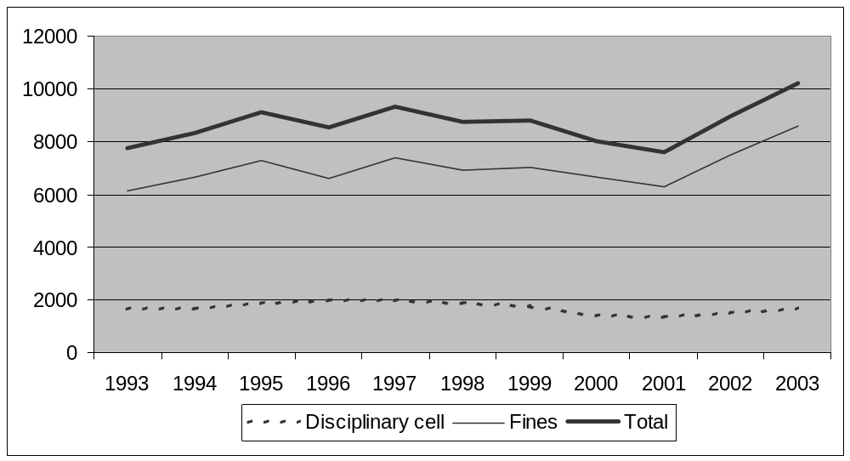
90. The statistical methods of summing up the various types of offences that may imply a disciplinary punishment were changed in 2001. Thus, the statistical survey in annex 5 regarding violations of the Criminal Code has now been subdivided into “smuggling, possessing or using drugs”, “smuggling, possessing or consuming alcohol” and “smuggling or possessing a weapon”. In 2003, most punishments were imposed for the three categories mentioned above, with smuggling, possessing or using drugs accounting for nearly 40 per cent of all disciplinary punishments. Violations of rules on order and security accounted for 21 per cent of the disciplinary punishments.

Exclusion from association (solitary confinement of convicted offenders)
91. The Prison and Probation Service may decide that an inmate will be excluded from association with other inmates for the time being. This may be done, for example, to prevent escape or criminal activities. The reason could also be that it would be obviously unjustifiable to let the inmate involved associate with other inmates. Segregation in solitary confinement differs from a disciplinary punishment by its prophylactic and forward-looking purpose. Inmates are segregated in solitary confinement in a special unit of the prison or in their own cells.

Trend in the number of terminated compulsory
exclusions from association, 1993-2003
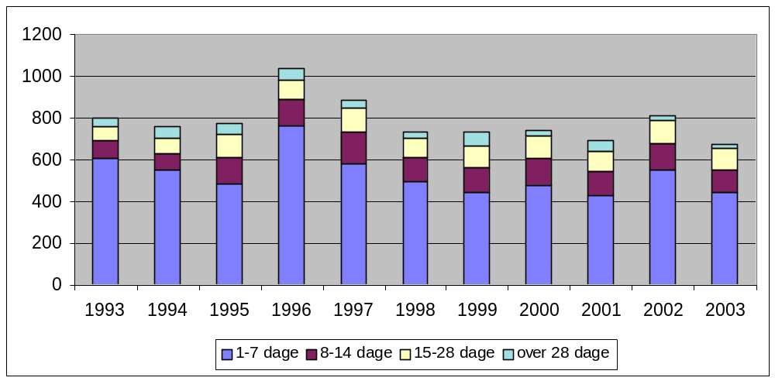
1-7 days | 8-14 days | 15-28 days | over 28 days
92. In 2003 the institutions of the Prison and Probation Service made a decision on exclusion from association in 672 cases, which together with 2001 is the lowest figure in the last 10 years. Apart from 2002, when the figure increased slightly, there has been a small drop in the number of exclusions from association since 1994. In 2003, 65 per cent of the exclusions were terminated within seven days. In 19 cases the exclusion lasted for more than 28 days. The average duration of confinements of more than 28 days is 51 days. As in previous years, the main reasons for exclusion from association in 2003 were to prevent criminal activity and that continued association was unjustifiable.
93. Exclusion from association can be imposed in various degrees. Thus it is possible to be excluded from association and still have the opportunity to associate with one or more inmates in the same situation. There are no statistics yet regarding this matter. However, statistics are currently being prepared and will be ready in the summer of 2004.

Confinement in security cell

94. Most closed prisons and some of the large local prisons have security cells. A security cell can be used if necessary to avert imminent violence, overcome violent resistance or prevent self-mutilation or suicide.
95. The number of confinements in a security cell has fluctuated over the past 10 years. The lowest confinement figure in the period was recorded in 1992 with 223 confinements, and the highest confinement figure was in 1995 with 352 confinements. During the last two years, the confinement figure has stabilized. In 2003 the number of confinements was 264. Since the third quarter of 1999, the use of handcuffs instead of security cell confinement has been reported as security cell confinement. Therefore, as from the third quarter of 1999, such cases will be recorded statistically as security cell confinements.
96. Since 1992 the cases of immobilization by force in connection with security cell confinement has been recorded. In 2003, immobilization by force was used in 77 per cent of all security cell confinements.

Terminated security cell confinements, 1993-2003
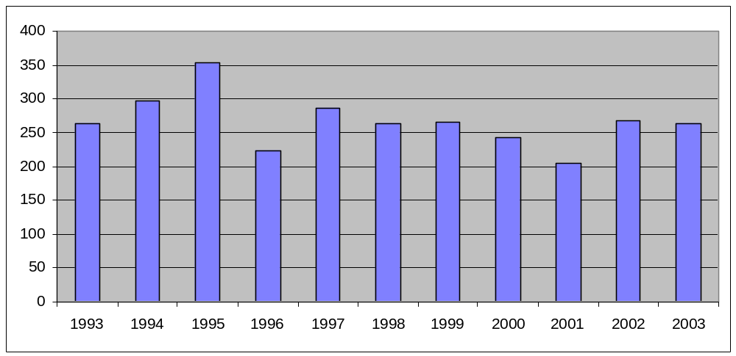

Observation cell confinements
97. An inmate can be confined in an observation cell to prevent malicious damage, to maintain order and security in the institution, or where special observation is deemed to be necessary, e.g. at the suspicion of drug intake.
98. In recent years some institutions have converted security cells to observation cells, and a number of open prisons have had some special cells approved for use for short-term observation cell confinements. Confinement in such cells has subsequently been recorded statistically as confinement in an observation cell.
99. As from the second half of 1994, the number of observation cell confinements has been recorded for statistical purposes. In 1995, there were 875 confinements, and the 2002 and 2003 figures were 1,004 and 1,108 confinements, respectively.

Observation cell confinements, 1995-2003

Terminated observation cell confinements
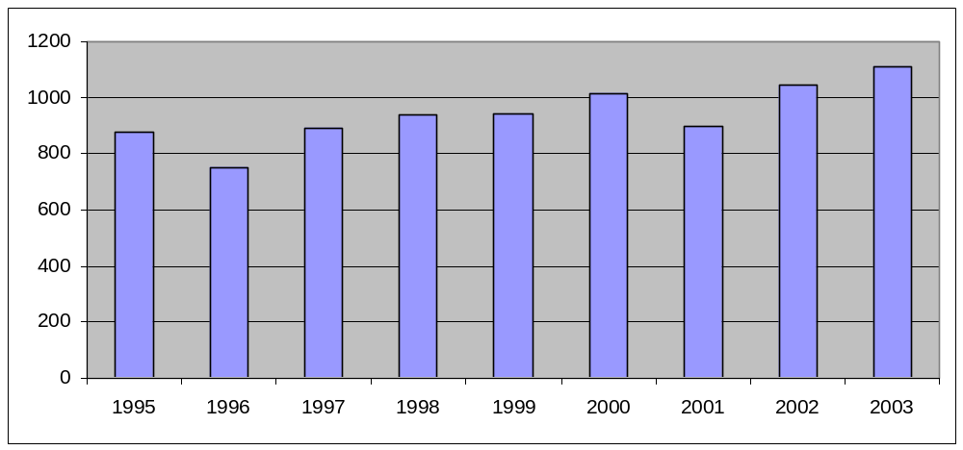

Uprising in the Nyborg State Prison
100. On 15 February 2004 the Nyborg State Prison experienced violent unrest. About 100 inmates barricaded themselves inside the prison and in that connection committed extensive malicious damage. The uprising ended after about two hours, when all inmates had been locked into their own cells. No individuals, neither staff nor inmates, were injured during the incident. To avoid further incidents, all inmates were kept locked up in their cells for two days. Then inmates who had not been involved in the incident returned to their normal regime. Conditions for the remaining inmates have gradually been normalized, and the normalization process was completed during May 2004.

Transport belt with handcuffs
101. Following successful testing of a transport belt with handcuffs during a pilot period, the Department of Prisons and Probation approved the use of the transport belt as an alternative to handcuffs by circular letter of 28 May 2001. The transport belt with handcuffs is gentler to the inmate and is used, for example, during long trips by car or for transporting ill inmates, when gentler means of restraint is deemed necessary. The transport belt with handcuffs is not as secure as ordinary handcuffs and is therefore not used if it is deemed to be an inadequate means of restraint in cases where the use of handcuffs is authorized under current regulations.

New rules on disciplinary punishments
102. On 26 February 2004 the Government introduced Bill No. 175 amending the Act on Euphoriants and the Enforcement of Sentence Act. The bill will make it possible to perform routine urine sampling of inmates in the institutions of the Prison and Probation Service to check for any abuse of illegal euphoriants or other illegal substances.
103. According to the proposed provision, an inmate may be required to provide a urine sample without any specific suspicion of abuse. This provision can also be applied to a large group of inmates, for example, so that all inmates of one or more institutions or units can be ordered to provide urine samples.
104. The purpose of the provision is to enhance the control of the unlawful smuggling of, trade in and abuse of unlawful substances in prison institutions. This enhanced control aims to prevent several unfortunate effects of drug and other abuse that are incompatible with sentence enforcement, including an atmosphere characterized by violence and threats against staff and between inmates.
105. The right to request urine samples is expressly authorized by the proposed provision, which is restricted to urine sampling intended to check for drug and other abuse. There must be an objective reason for the urine sampling, which must be carried out as humanely as circumstances permit.
106. Urine sampling by means of physical coercion (catheter) is not contemplated, the only element of coercion being that refusal to provide a urine sample may result in a disciplinary punishment. The purpose of this is to ensure that refusal to provide a urine sample is subject to the same sanction as if the inmate provided a positive urine sample indicating the intake of illegal substances. It will therefore be impossible to avoid a disciplinary punishment by refusing to assist in providing a urine sample.
107. According to the bill, more detailed guidelines for its implementation will be laid down by administrative regulations.

New rules concerning exclusion from association
108. On 15 August 2003, a new Executive Order concerning the treatment of inmates excluded from association for reasons of order and security came into force. The Executive Order is a result of the work of a working group set up by the Department of Prisons and Probation in March 2001. The working group had to consider the extent to which the amendment of the rules on pretrial detention in solitary confinement should influence the rules on compulsory solitary confinement of convicted offenders.
109. The working group found that the possibility of association with other inmates is of great importance to the inmates who have compulsorily been excluded from association for more than two weeks. For this reason the institutions should consider carefully in each case whether compulsory exclusion from association for more than two weeks can be combined with association with one or more co-inmates.
110. Following two weeks’ exclusion from association, the staff must be particularly attentive to such inmates. This includes considering whether the inmate could be offered work together with others or work in specially fitted rooms, individual tuition or leisure-time activities together with staff. It should also be considered whether to suggest a consultation with a priest, doctor or psychologist.
111. The working group made special recommendations in respect of inmates compulsorily excluded from association for more than three months.
112. The working group found that the most expedient regime for inmates excluded from association on a long-term basis was the establishment of small high-security units (4-8 persons) with considerable physical security, etc., which makes it possible to allow a high degree of liberty within the unit. The Department of Prisons and Probation agreed with this. In order to limit the use of total exclusion from association as much as possible, such a high-security unit has been established at the Vridsløselille State Prison accommodating 14 inmates, and on 1 February 2002 a corresponding unit accommodating 6 inmates was established at the Nyborg State Prison.
113. The establishment of these units has made it possible to suspend the very long-term exclusion from association of the prisoners deemed by the Prison Service to be very dangerous or to present an extremely high risk of escape. Furthermore, the establishment of these units makes it possible in future to limit long exclusions from association.
114. Several separate high-security units can also be fitted out in the new prison being built as a replacement of the Horsens State Prison.
115. The working group mentioned above also recommended that inmates excluded from association for more than three months without any association with other inmates must be offered particularly well-equipped cells, a free computer for use in the cell and an extended right to visits.
116. As a result of the recommendations of the working group the new Executive Order concerning exclusion from association came into force on 15 August 2003. Rules were added as to compulsory exclusion from association for more than two weeks and as to inmates compulsorily excluded from association for more than three months. The rules are in accordance with the recommendations of the working group.

Initiatives concerning staff at the institutions of the Prison and Probation Service
117. Members of staff are regularly trained as debriefers. Debriefers are used in situations where employees have experienced violent events, threats, etc. The training comprises a two-day course followed up by an annual brush-up course lasting one day. The target group is all staff categories from State and local prisons and halfway houses. Currently, the Prison and Probation Service has 223 trained debriefers.
118. Moreover, the Prison and Probation Service has concluded an agreement with Nordic Mental Corporation (NMC). The NMC provides anonymous and free crisis help to both staff and their close relatives, for example in case of problems relating to work or family.
119. Both the debriefing scheme and the NMC have been successfully integrated as accepted and utilized parts of the crisis facilities of the Prison and Probation Service, and both schemes work to the satisfaction of all.

Climate study among staff
120. In 2001, the Prison and Probation Service made a study of staff motivation and satisfaction, the so-called “climate study”. The climate study revealed that one in three employees felt under mental stress. However, the factors causing a negative mood were monotonous work, lack of personal and professional development and dissatisfaction with management rather than the mental working environment. One of the most positive conclusions of the study was that three out of four employees wanted to use their abilities better on the job. Staff interests included new and more challenging fields of work.
121. All establishments were asked to submit an action plan for the continued work in regard to the climate study by 1 April 2002. The establishments worked very seriously with the action plans, and the Department returned individual feedback to each institution concerning the action plans. Along with the feedback the Department provided suggestions and ideas for the future work. A follow-up on the climate study was included as a performance target in the prisons’ contracts for 2002 and 2003. A catalogue with examples and suggestions for the future work in this area was sent to all institutions in July 2003.
122. A new climate study is expected to be carried out in 2005.
123. The Prison and Probation Service has launched the following initiatives to improve the working environment and reduce absences due to sickness.
124. A handbook on absence due to sickness was finished in spring 2003 and sent to the management of each institution. The goal is to inspire the local management to discuss and implement a policy on how to handle absence due to sickness in a caring and constructive manner. The goal is to enable local management to deal with sickness quickly and adequately. The Department will monitor the establishments’ work to reduce absenteeism, and reduction of absenteeism was included as a performance target in the prisons’ contracts for 2003.
125. In collaboration with Statens Center for Kompetence og Kvalitetsudvikling (the State Centre for Competence and Quality Development), the Prison and Probation Service has completed a multi-year management development programme, “Management in growth”. The programme comprises 170 managers within the Prison and Probation Service and focuses on methods to enable the individual manager to handle the comprehensive restructuring process involved in implementing the new organizational and management structures, the new management model, the new treatment initiatives, the many IT projects, etc. set out as targets in the political multi-year agreement and performance contract for 1999-2003.
126. A working group was appointed in August 2002 in view of a special effort to reduce the number of incidents of violence and threats against staff. The working group was to further develop and make the reports on violence and threats conform to a quality assurance system and
consider how to minimize the number of incidents. The working group submitted its recommendations in March 2003, one recommendation being the introduction of a new registration system. The new registration system was introduced on 1 January 2004. Further initiatives are intended to be launched in 2004.
127. The Prison and Probation Service has received an extra appropriation of DKK 5 million to improve the working environment of prison staff. The purpose of this appropriation is, among other things, to finance projects on improvement of the mental working environment and to reduce absences due to sickness.
128. In collaboration with the State Centre for Competence and Quality Development, the Prison and Probation Service has started a pilot project about competence development for 26 of its institutions. The purpose of this project is to enable the institutions to work systematically and strategically in developing staff competences. The study done by the State Centre for Competence and Quality Development and the climate study show that the employees in the Prison and Probation Service want to be able to develop their skills.

Preschool project
129. As mentioned in the fourth periodic report, the Prison and Probation Service has started a “preschool project” in order to increase the recruitment of unit officers with a multicultural background. The first preschool class finished in 2001 and a new class started in the spring of 2002. A third preschool class started in the autumn of 2003.

The use of force in psychiatric treatment
130. The Danish Psychiatric Act was amended by Act No. 377 of 6 June 2002. The change involved only one department, namely the Security Unit at the Psychiatric Centre of the West Zealand hospital. Authority is vested in the Minister for Justice in exceptional cases where less radical measures are deemed inadequate to rule that a person of unsound mind and who persistently acts to seriously or immediately endanger the lives or bodies of others must be placed in the custody of this unit. The amendment of 6 June 2002 made it possible under certain strict conditions to lock up patients’ wards at the Security Unit for safety or treatment reasons. The decision has to be made by a doctor.
131. The consolidation act on patients’ advisers has been amended (Act No. 858 of 21 October 2003) to increase the fee paid to patients’ advisers. Advisers are automatically appointed as advisers to any person who is subjected to involuntary placement, involuntary retention or involuntary treatment. The patient adviser’s job is to guide and advise the patient on all matters pertaining to placement, retention and treatment in a psychiatric ward. The patient adviser also assists the patient in filing and carrying through any complaints.
132. The Consolidation Act on involuntary treatment, immobilization, restraint protocols, etc. at psychiatric wards (Consolidated Act No. 194 of 23 March 2004) has been amended. The departments are to report to the national Board of Health on the extent of coercive measures applied. The Board of Health prepares annual statistics in this field. Information may now be
reported electronically, and from 1 January 2005 electronic reporting will be mandatory. Electronic reporting will enable much faster compiling of statistics on the use of coercive measures, and this will improve one of the tools being used as a basis for the ongoing process of developing psychiatrics generally.
133. The Danish Psychiatric Act is scheduled for reform in the 2005/06 parliamentary year. Preparations for the reform are organized in a two-track procedure. The amendments to the Psychiatric Act, which entered into force on 1 January 1999, are to be scrutinized by an independent research institution. Furthermore, the Ministry of the Interior and Health last year submitted the Act to stakeholders in the psychiatric field, in particular organizations of users and their relatives, for consideration. Based on the responses, themes will be selected for further reviewing. These analyses, together with the findings of the scrutiny of the Psychiatric Act, are to form a solid basis for reforming the Act.

Article 12 and article 13

Complaints against the police
134. The rules for examining complaints against the police that entered into force on 1 January 1996 were described in Denmark’s third periodic report and mentioned during the examination of that report. Reference is made to the report (CAT/C/34/Add.3, paras. 84-87) and to the examination (CAT/C/SR.288, para. 17). Denmark’s fourth periodic report (CAT/C/55/Add.2, paras. 137-141) includes a description of the evaluation of the police complaints board scheme carried out after the scheme had been in operation for three years.
135. In his latest report from 2002 concerning the examination of complaints against the police, the Director of Public Prosecutions (Rigsadvokaten) stated that the length of complaint proceedings was generally satisfactory at the end of 2002. That year saw as many decisions as new complaints, and the overall objective therefore must be considered to be fulfilled. The report also shows that the first six years of operation of the police complaints board scheme were appraised at the annual meeting of the police complaints boards in January 2002, and that it was concluded that the scheme was viable and generally accepted by the citizens, the police as well as other interested parties, and that no major amendments of the rules were needed.

The Administration of Justice Act
136. The Administration of Justice Act was amended in 2002 in order to provide for better protection of witnesses, including those witnesses who are at the same time victims.
137. In the investigative phase, it is now possible for the courts - if required, inter alia, for the sake of the witness - to impose restrictions on the defendant’s right to be present in court in meetings concerning the ongoing investigation.
138. As for the court hearing, the court can - as long as it must be presumed to be without importance to the defence - impose restrictions on the defendant’s access to information on the data of the witness and can decide that the defendant must leave the room when the witness is testifying, if there is reason to believe that the defendant’s presence would bring the security of the witness or his or her close relatives in danger.
139. Further amendments concerning, inter alia, the right of access to documents for the defence were made in 2003 as part of the fight against organized crime. For instance, if necessary, inter alia for the sake of the witness, the court can decide to withhold police information from the defence to the extent that it is not significant to the defence.

Article 14
140. No new information.

Article 15
141. No new information.

Article 16
142. No new information.

II. Additional information requested by the Committee
143. No specific information requested.

III. Compliance with the committee’s conclusions
and recommendations

Incorporation of the Convention
144. When the Committee concluded its examination of Denmark’s fourth periodic report, the Committee recommended that Denmark should ensure the speedy implementation of the recommendation of the Ad Hoc Committee with regard to incorporating the Convention into Danish domestic law.
145. As mentioned in paragraphs 111-113 in Denmark’s fourth periodic report (CAT/C/55/Add.2), the Minister of Justice appointed the Committee on Incorporation of Human Rights Conventions into Danish legislation (the Incorporation Committee) in 1999.
146. The Incorporation Committee was assigned to examine the advantages and disadvantages of incorporating the general human rights conventions into Danish law. The Committee concluded its work in October 2001, and recommended the incorporation of three United Nations conventions: the International Covenant on Civil and Political Rights, the International Convention on the Elimination of All Forms of Racial Discrimination and the Convention against Torture and Other Cruel, Inhuman or Degrading Treatment or Punishment.
147. The Government has taken note of the recommendation of the Incorporation Committee to incorporate the Convention against Torture and Other Cruel, Inhuman or Degrading Treatment or Punishment into the domestic law. However, in January 2004 the Government decided not to incorporate that Convention into Danish law. This decision was based on several considerations.
148. Firstly, the Convention itself does not place any obligations on States parties to incorporate the Convention into the domestic law. When ratifying the Convention, the Danish Government followed the standard procedure and assessed whether the domestic law and practice were in conformity with the provisions of the Convention, or whether any changes of the domestic law and practice were necessary prior to the ratification. After ratifying the Convention, the Government has also continuously taken steps to ensure that Danish law and practice is in conformity with the Convention, for instance when drafting proposals for new legislation. Hence, the Government is of the opinion that even though the Convention has not been incorporated into Danish law, Denmark fully respects the provisions of the Convention.
149. Secondly, the human rights conventions that Denmark has ratified are relevant sources of law regardless of the method of implementation, as emphasized by the Incorporation Committee. Conventions that have not been specifically implemented, because harmony of norms has been ascertained, can be and are in fact invoked before and applied by the Danish courts and other law-applying authorities. For example, the High Court of Eastern Denmark recently applied the Convention against Torture and Other Cruel, Inhuman or Degrading Treatment or Punishment (cf. the High Court’s judgement printed in Danish Law Reports 2004, p. 715). The subject of the case was whether the Public Prosecutor, during the investigation of a case concerning alleged torture committed abroad, could divulge confidential information to a foreign authority with details from the charged person’s application for asylum, including his photographs and fingerprints. The High Court stated that according to the Convention against Torture and Other Cruel, Inhuman or Degrading Treatment or Punishment, Denmark was obliged to carry out an eventual legal proceeding concerning acts of torture committed by persons who are not extradited for legal proceedings in another country. Since the confidential information was passed on during an investigation of alleged violence and torture (cf. sections 246 and 245 of the Criminal Code), the High Court stated that this was a legal divulgement.
150. Considering that the existing state of law in Denmark ensures that the Convention and other ratified - but unincorporated - United Nations human rights conventions are relevant sources of law and may be applied by the courts and other law-applying authorities, the Government finds that it is neither legally necessary nor politically appropriate to incorporate the Convention into Danish law. Incorporation would only be of a symbolic character, since it would not change anything with regard to the existing state of law in Denmark, and the Government finds that laws should not be passed if they only are of a symbolic character. For these reasons, the Government has also decided not to incorporate any of the other United Nations conventions on human rights.

Incorporation of the definition of torture of the Convention - article 1
151. When the Committee concluded its examination of Denmark’s fourth periodic report, the Committee recommended that Denmark establish adequate penal provisions to make torture, as defined in article 1 of the Convention, a punishable offence in accordance with article 4, paragraph 2, of the Convention.
152. Reference is made to paragraphs 30-36 of Denmark’s third periodic report (CAT/C/34/Add.3), which describe the Government’s position on this issue.
153. In addition, the Government can inform the Committee that in 2002, the maximum penalties for violation of sections 244, 245 and 246 of the Criminal Code were increased to 3, 6 and 10 years of imprisonment, respectively. Further, by way of a 2004 amendment, it has now been explicitly spelt out that, in determining the penalty, it must generally be considered an aggravating circumstance, inter alia if the offence has been committed while executing a public office or function, or while abusing a position or another relationship of trust.
154. The above-mentioned case from the High Court of Eastern Denmark (cf. Danish Law Reports 2004, p. 715) also illustrates that torture is included in the provisions in the Criminal Code even though the act does not have a specific provision about torture.
155. As appears from the comments on the considerations concerning incorporation, the Government has decided not to incorporate the Convention into Danish law. Given the fact that, in the opinion of the Government, the Criminal Code is presumed to provide the requisite authority for imposing a suitably severe penalty in case of torture, this decision has not brought about a change in the Government’s position on the issue of establishing a separate Criminal Code provision on torture.

Monitoring of the effects of solitary confinement on detainees and the effects of the new bill on solitary confinement of remand prisoners
156. When the Committee concluded its examination of Denmark’s fourth periodic report, the Committee recommended that Denmark continue to monitor the effects of solitary confinement on detainees and the effects of the new bill, which has reduced the number of grounds that can give rise to solitary confinement and its length.
157. The concrete effects of solitary confinement on detainees are taken into consideration when the courts review the concrete cases. The obligation for the courts to do so is explicitly stated in section 770 b of the Administration of Justice Act.
158. On a more general level - as it was stated during the examination of the previous Danish report - the Standing Committee on Administration of Criminal Justice has been given the task to evaluate the amendments adopted in 2000 on solitary confinement in pretrial detention and has to give its opinion on them by 2005. Until the Committee’s response is available, the Ministry of Justice once a year receives information from the Director of Public Prosecution about the developments.
159. The most recent report dates from 13 October 2003 and contains data for the year 2002. It appears from the report that there has been a drop in the number of cases of solitary confinement of more than 51 per cent from 1998 to 2002. The number of cases has steadily decreased from 618 in 2000, to 553 in 2001 and 501 in 2002. Further, in 2000, solitary confinement was used in 10.4 per cent of pretrial detention cases, whereas the percentage has dropped to 9.5 in 2001 and 8.2 in 2002.
160. In 2002, 64 per cent of the cases of solitary confinement were concluded within four weeks, while 85 per cent were concluded within eight weeks. On average, solitary confinement was upheld for 30 days. Only in four cases was solitary confinement upheld beyond three months.

Access to review in case of exclusion from association
161. When the Committee concluded its examination of Denmark’s fourth periodic report, the Committee expressed its concern about the lack of effective recourse procedures against decisions imposing solitary confinement upon persons serving a sentence. The Committee recommended that the law governing solitary confinement for convicted prisoners should establish adequate review mechanisms relating to its determination and duration.
162. Concerning the possibilities of appealing a decision of exclusion from association, it is prescribed by law that, when such decision has been made, the prison must consider at least once a week whether exclusion should be terminated completely or partially. In case of exclusion from association for more than four weeks, the prison has to report the case to the Department of Prisons and Probation, and subsequently submit a report after every four-week period. The current rules therefore already include an automatic central review of long-term exclusions from association.
163. Moreover, an inmate can also at any time appeal the prison decision of exclusion from association to the Department of Prisons and Probation. In addition, decisions of exclusion from association can be brought before the Parliamentary Ombudsman (Folketingets Ombudsmand). Finally, it is also possible to have the decision brought before the courts pursuant to the general rule of judicial review under section 63 of the Danish Constitution. Under this rule, the court shall test whether the decision is authorized by law and has been made on objective grounds. The review thus does not include a review of the appropriateness of the discretion exercised.
164. The access to review of decisions of exclusion from association is thus deemed to be adequate, and the establishment of further rights of review is not considered necessary.
165. As to judicial review, the explanatory notes to the Sentence Enforcement Bill state as follows concerning the reason why exclusion from association is not comprised by the special right of judicial review pursuant to the Sentence Enforcement Act: The special right to judicial review laid down by the Act comprises decisions that are similar to criminal proceedings or are otherwise of an especially coercive nature for prison inmates. But decisions motivated by the consideration of order and security in the prison - including decisions about exclusion from association - are not comprised. The reason is that, to a great extent, an assessment of the need for intervention in such cases would be based on an assessment made by the Prison and Probation Service. They are often discretionary decisions made on the basis of a thorough knowledge of the environment in the prison, and the courts do not have such comprehensive knowledge. Furthermore, due to their nature, these decisions normally have to be made and effected quickly, and generally a judicial review will not act as a stay of execution. It would take some time after a decision was made before the outcome of the judicial review would be known, and therefore a judicial review of such decisions is neither expedient nor required.

Measures to prevent deportation during the processing of applications to the Committee
166. At the conclusion of its examination of the fourth periodic report the Committee recommended that it was ensured that amendments to the Aliens Act would not frustrate effective recourse to article 22 of the Convention.
167. The fact that a case is brought before the United Nations Committee against Torture is not in itself considered to be sufficient reason for suspending the decision on forced return of the complainant while the case is under consideration before the Committee.
168. Suspending the forced return of a complainant in a case brought before the Committee is optional, and such a decision is based on a concrete evaluation of every single case. In this evaluation it is taken under consideration if the return of the complainant will involve a reasonable risk of a violation of the Convention against Torture and Other Cruel, Inhuman or Degrading Treatment or Punishment.
169. If the Committee with reference to the rules of procedure of the Committee, rule No. 108, demands the Danish immigration authorities to suspend the forced return of the complainant while the case is under consideration before the Committee, the forced return of a complainant is in general suspended.
170. Denmark has not as of yet forced the return of a complainant whose case was brought before the Committee.

Dissemination of the Committee’s conclusions and recommendations
171. Immediately upon receipt of the conclusions and recommendations a comprehensive press release is issued and the document is forwarded to human rights NGOs and the Legal Committee of Parliament (Folketingets Retsudvalg). It is also available at the website of the Ministry for Foreign Affairs.
-----

* For the initial report of Denmark, see CAT/C/5/Add.4; for its consideration, see CAT/C/SR.12 and 13 and Official Records of the General Assembly, Forty-fourth Session, Supplement No. 44 (A/44/46), paras. 94-122. For the second periodic report, see CAT/C/17/Add.13; for its consideration, see CAT/C/SR.228, 229, 229/Add.1, 229/Add.2, 233 and 233/Add.1 and Official Records of the General Assembly Fifty-first Session, Supplement No. 44 (A/51/44), paras. 33-41. For the third periodic report, see CAT/C/34/Add.3; for its consideration, see CAT/C/SR.287 and 288 and Official Records of the General Assembly, Fifty-second Session, Supplement No. 44 (A/52/44), paras. 171-188. For the fourth periodic report, see CAT/C/55/Add.2; for its consideration, see CAT/C/SR.508, 510 and 518 and Official Records of the General Assembly, Fifty-seventh Session, Supplement No. 44 (A/57/44), paras. 68-74. GE.05-40925 (E) 200905
* The annexes are on file with the Secretariat, where they may be consulted.

