 | United Nations | CEDAW/C/ZWE/2-5
 | Convention on the Elimination  of All Forms of Discrimination  against Women |  | Distr.: General  22 November 2010  Original: English
Committee on the Elimination of Discrimination
against Women
Consideration of reports submitted by States parties under article 18 of the Convention on the Elimination of All Forms of Discrimination against Women
Combined second to fifth periodic report of States parties
Zimbabwe*
Contents
Paragraphs Page
List of abbreviations 4
I. Introduction 1–10 5
A. The report-writing process 8–9 6
B. The structure of the report 10 6
II. Measures undertaken to eliminate discrimination against women 11–272 6
Article 1: The definition of “discrimination against women” 11–16 6
Article 2: Legal and administrative measures to eliminate discrimination
against women 17–71 7
Article 3: Measures to ensure the full development and advancement of
women and basic human rights and fundamental freedoms on
an equal basis with men 72 16
Article 4: Temporary measures to accelerate de facto equality between
women and men 73–82 16
Article 5: Social and cultural patterns that lead to discrimination and
stereotyped roles for women 83–88 19
Article 6: Suppression of the trafficking in and exploitation of the
prostitution of women 89–107 20
Article 7: Elimination of discrimination against women in political and
public life 108–144 23
Article 8: Equal opportunities with men to serve as representatives of
Government at international level and as participants in the
work of international organizations 145–150 33
Article 9: Equal rights to acquire, change or retain nationality 151–153 34
Article 10: Elimination of discrimination against women in the field of
education 154–172 35
Article 11: Elimination of discrimination against women in employment 173–190 37
Article 12: Equality in access to health facilities 191–216 40
Article 13: Elimination of discrimination against women in other areas of
economic and social life 217–233 45
Article 14: Rural women 234–256 49
Article 15: Equality before the law 257–261 52
Article 16: Equality in marriage and family law 262–272 55
III. Conclusion 273–278 53
References 57
List of figures and tables
Figure 1: Types of violence experienced by women 12
Figure 2: Female representation in the public service 17
Figure 3: Primary schoolteacher enrolment 18
Figure 4: Enrolment in universities 18
Figure 5: Female representation in Parliament 19
Figure 6: Female representation in the House of Assembly 25
Figure 7: Female representation in the Cabinet 25
Figure 8: Women in local government 27
Figure 9: Women in Urban Councils 27
Figure 10: Women in Rural District Councils 28
Figure 11: Women in managerial positions in the Public Service 28
Figure 12: Women in the Judiciary 30
Figure 13: Women in the Police 31
Figure 14: Women in the Prison Service 32
Figure 15: Women in the Diplomatic Service 33
Figure 16: Primary school enrolment (1996–2005) 36
Figure 17: Currently employed population aged 15 years and above by industrial sector 38
Figure 18: Funding of women’s projects by SEDCO 40
Figure 19: Contraceptive methods used by women 42
Figure 20: HIV-prevalence by gender 43
Figure 21: Poverty by gender of head of household (1995) 46
Figure 22: Ownership of assets by gender 47
Tables
Table 1: Women in the Zimbabwe National Army 30
Table 2: Women in the Air Force of Zimbabwe 31
List of abbreviations
AIDS Acquired Immune Deficiency Syndrome
CBD Community-based distributor
COMESA Common Market for Eastern and Southern African
CSO Central Statistical Office
GWAPA Gweru Women AIDS Prevention Association
HIV Human Immunodeficiency Virus
IEC Information, education and communication
ILO International Labour Organization
IOM International Organization for Migration
IRWSSP Integrated Rural Water Supply and Sanitation Programme
MDG Millennium Development Goal
MP Member of Parliament
NAC National Aids Council
NGO Non-governmental organisation
PSC Public Service Commission
RDC Rural District Council
SADC Southern African Development Community
SEDCO Small Enterprise Development Corporation
SME Small and medium enterprise
STI Sexually transmitted infection
UNAIDS Joint United Nations Programme on HIV/AIDS
UNDP United Nations Development Programme
UNICEF United Nations Children’s Fund
UNIFEM United Nations Development Fund for Women
ZDHS Zimbabwe Demographic and Health Survey
ZIPAM Zimbabwe Institute of Public Administration and Management
ZNFPC Zimbabwe National Family Planning Council
I. Introduction
1. Zimbabwe submitted its initial report under the Convention on the Elimination of All Forms of Discrimination against Women in 1996. The United Nations Committee on the Elimination of Discrimination against Women considered the report on 22 and 27 January 1998.
2. This report is an update of the information provided in the initial report and it endeavours to address the concerns of the Committee. It also highlights the measures that the Government has taken to promote the rights of women and the girl child.
3. At the regional and continental levels, Zimbabwe is party to a number of instruments intended to improve the promotion and protection of the rights of women and ensure the attainment of gender equality. Zimbabwe is a signatory to the African Union Constitutive Act and the Solemn Declaration on Gender Equality in Africa, through which the Union and its member States commit themselves to the promotion of gender equality. It ratified the Protocol to the African Charter on Human and Peoples’ Rights on the Rights of Women in Africa in 2008.
4. Zimbabwe is also a signatory to the Southern African Development Community (SADC) Declaration on Gender and Development of 1997 which commits member States to undertaking measure to incorporate gender issues in their programme. In 2008, it signed the SADC Protocol on Gender and Development. The country is also a member of the Common Market for Eastern and Southern Africa (COMESA), which has a gender policy in place to guide gender mainstreaming and the promotion and protection of the rights of women in the respective member States.
5. Since the submission of the initial report, the Government has embarked on comprehensive legal and administrative reforms that promote gender equality. The Constitution was amended in 2005 to include among other things, prohibition of discrimination on the grounds of sex or marital status, as well as providing for the implementation of affirmative action programmes. Legislation has been put in place to protect women and the girl child in such areas as violence and inheritance and to enable women to benefit from land reform processes on the same basis as men.
6. Administrative structures are constantly being improved to promote gender equality and the empowerment of women. A fully fledged Ministry was established to ensure that women’s rights and gender equality receive specific attention across all sectors of Zimbabwean society. It is headed by a female Minister and has been mandated to coordinate and implement programmes and projects that are aimed at advancing the rights of women. These are highlighted in the relevant sections of this report.
7. Gender Focal Persons in Government Ministries and Departments, as well as Parastatals, are now receiving continuous training in gender mainstreaming and have been mandated to submit regular reports on their activities to the Ministry of Women Affairs, Gender and Community Development.
A. The report-writing process
8. This report was prepared in consultation with and including the participation of non-governmental organisations, United Nations agencies, academic institutions and child-based organisations. The latter were included to ensure that the voice of the girl child is represented. Copies of the report, in draft form, were availed to all relevant stakeholders followed by discussions of the report in seminars organized for that purpose.
9. Although report-writing remains the obligation of the Inter-Ministerial Committee on Human Rights and International Humanitarian Law coordinated by the Ministry of Justice, Legal and Parliamentary Affairs which administers the national Constitution, the Ministry of Women Affairs, Gender and Community Development played a leading role in the process in its capacity as the head of the Sub-Committee on Women’s Rights.
B. The structure of the report
10. The report is divided into various sections that highlight the measures taken by the Government to implement the provisions of the Convention. The sections are based on the articles of the Convention and include responses to the concerns and recommendations of the Committee made upon the consideration of the initial report. They include the constitutional, legislative, administrative and other measures taken to implement the provisions of the Convention and the developments that have taken place since the presentation of the initial report. The challenges that the Government is facing in the implementation of the Convention have been indicated under each section.
II. Measures undertaken to eliminate discrimination against women
Article 1
The definition of “discrimination against women”
1. Legal definition of “discrimination against women”
11. Discrimination against women is prohibited by section 23(2) of the Constitution of Zimbabwe under the Declaration of Rights. The grounds upon which one cannot be discriminated against include sex, marital status and physical disability, all of which impact directly on the rights and welfare of women. Although the Constitution and other laws do not specifically define discrimination against women, as reported in the initial report, discriminatory conduct is defined in the process of interpreting the above Constitutional and other provisions.
12. Furthermore, the Constitution allows, under section 23(5) (b), the enactment of laws that take into account physiological differences. Special consideration of peculiarities that relate to one sex as opposed to the other will therefore be considered in the process of enacting relevant laws, leaving room for the elaboration of the definition of discrimination against women. The same applies to the implementation of affirmative action policies in compliance with section 23(3) (g) of the Constitution.
2. De facto discrimination against women
13. The Government has, despite the non-existence of a legal definition, recognised that discrimination against women is the conduct or practice of subjecting women to unfair disadvantage by the very fact of them being women. This includes exclusion on the basis of experiences that pertain to women only due to their biological make-up, such as pregnancy.
14. Since the presentation of the initial report, the Government has been using indicators in different sectors to measure gender imbalances, a process through which discrimination against women is then identified and described. In the 2004 progress report to the United Nations on the Millennium Development Goals (MDGs), the Government linked the low levels in the general status of women to the fact that gender inequality goes beyond empowerment to encompass issues of social justice and discrimination. In its efforts to adopt measures to empower women and to address gender imbalances, the Government identified such areas of discrimination as cultural norms, customary practices and unequal distribution, control, ownership of and access to resources by women and men. All this further clarifies the concept of discrimination against women.
3. Challenges
15. The lack of a specific definition of discrimination against women in legislative instruments is likely to slow down the recognition and redress of discriminatory conduct and practices. However, the express prohibition of discrimination on the basis of gender, sex, pregnancy or marital status in the Constitution and other laws provides a framework for the definition of discrimination against women.
16. The National Gender Policy and its subsequent implementation strategy further elaborate on the operationalisation of the notion of discrimination against women by seeking to facilitate the emergence of a society in Zimbabwe where there is economic, political, religious and social equality and equity among women and men in all spheres of life and at all levels. The National Gender Policy Implementation Strategic Plan seeks to address issues that lead and translate into discrimination against women in all sectors of Zimbabwean society, thereby contributing in a practical manner towards the definition of discrimination against women in Zimbabwe.
Article 2
Legal and administrative measures to eliminate discrimination against women
17. In its desire to ensure that sufficient administrative measures to address discrimination against women in all areas are put in place, the Committee recommended that the functions of the Office of the Ombudsman be extended to investigate complaints on discrimination against women emanating from the public sphere and the private sector.
18. In response to the Committee’s recommendations, the Government has amended the Constitution to provide for the establishment of the Zimbabwe Human Rights Commission. Section 108B(5)(e) of the Constitution mandates the Commission to investigate the conduct of any authority or person implicated in the violation of any of the rights enshrined in the Declaration of Rights under the Constitution of Zimbabwe. This will ensure that discrimination against women in all sectors is investigated and redressed.
19. Enabling legislation for the establishment of the Commission is still being worked on. Meanwhile, the Office of the Ombudsman has, by virtue of the same amendment, changed name to the Office of the Public Protector. Its functions will be confined to investigating administrative wrongs, rather than violations of human rights. The recently enacted Domestic Violence Act — a major breakthrough in the fight against violence against women — makes provision for the filing of complaints against the police, where it is felt they have not executed their duties in terms of the Act. As domestic violence is a form of discrimination against women, this ensures that the discrimination is not perpetuated by the police.
1. Legislative measures
20. To bolster national efforts and strategies to eliminate discrimination against women in Zimbabwe, the Government has enacted more laws and amended existing legislation since the last report. These include the following.
(a) The Constitution of Zimbabwe
21. The inclusion of sex, marital status and physical disability to the prohibited grounds for discrimination broadens the protection of women against discrimination. This is enhanced by the introduction of affirmative action under section 23(3) (g), which is designed to advance the rights of any class of persons who have been previously disadvantaged by unfair discrimination. Women are one such class in Zimbabwe and will, therefore, utilise this provision to claim their rights.
22. Furthermore Amendment 17, in section 23(3a), expressly provides as follows:
“Notwithstanding subsection (3)(b), in implementing any programme of land reform the Government shall treat men and women on an equal basis with respect to the allocation or distribution of land, any rights or interests therein under that programme.
“As subsection (3) (b) of section 23 protects the application of customary law, section 23(3a) abolishes the distinction of women on the basis of the laws to which they subscribe. All women are, therefore, entitled to land on an equal basis with men. This provision will also ensure access to land regardless of marital status when read together with section 23(2), which prohibits discrimination on the ground of marital status.”
(i) Challenges
23. The existence of section 23(3) of the Constitution is still a subject of wide debate in Zimbabwe. Concern has been raised on the effect of allowing discrimination on matters of personal law and customary law, which in turn hinders the full enjoyment of human rights by women.
(ii) Response
24. The Government is committed to repealing all legal provisions that perpetuate discrimination against women. It has, however, taken a gradual approach on the matter to avoid societal resistance. As previously reported, the Government placed the legal age of majority at 18 years in order to give both women and men majority status at that age. In terms of section 15(3) of the General Laws Amendment Act [Chapter 8:07], the legal age of majority applies for the purpose of any law, including customary law. The concept of the legal age of majority, however, received wide resistance by the patriarchal society. In a research conducted on the people’s reaction to the law, it emerged that much of the opposition was premised on the apparent loss of a parent’s claim to seduction damages and bride price in relation to the female child. Comments made by parents against the law, included the following.
25. African custom does not go hand in hand with this kind of thinking. “If those who make laws want to impose laws on us, they should make a law stating that any man who makes a woman under 25 pregnant should automatically be liable to pay damages. If they cannot do this then they should leave us alone to lead our lives as we used to. Government has choked us with this law”.⁸
26. Recognition of this resistance necessitates the gradual approach towards the removal of all laws that discriminate against women in order to prepare society for the desired changes.
27. The Government has outlawed harmful cultural practices through the Criminal Law (Codification and Reform) Act [Chapter 9:23] as well as the Domestic Violence Act [Chapter 5:16] of 2006, as fully discussed under paragraphs 34 and 39–45, respectively.
28. The practice of payment of lobola has not been legislated against. However, there are conflicting views in Zimbabwe on whether or not it is a discriminatory traditional cultural practice. Therefore, more research, advocacy and lobbying still need to be done to concretely demonstrate the adverse and discriminatory effects of lobola on the status of women in Zimbabwe.
(b) The Labour Act [Chapter 28:01]
29. The Labour Act [Chapter 28:01] was amended in 2002 (Act 17 of 2002) and subsequently in 2005 (Act 7 of 2005) to prohibit the demand for sexual favours in return for recruitment for employment, promotion or any other related activities. The prohibition extends to any form of unwelcome sexually determined conduct towards an employee. This protects employees from potential discrimination on the ground of gender.
30. Over the past ten years, studies on sexual harassment at the workplace have indicated that the incidence of the phenomenon has increased significantly from 1997 to 2005 in the public and private sectors, including the informal sector. The forms of sexual harassment include suggestive stories, crude remarks and sexist remarks, touching in an uncomfortable way, threats for being sexually uncooperative and being treated badly for refusing sex. A study on the matter revealed that the average rate of prevalence is 33%. The study reports also noted with concern limited positive responses from institutional mechanisms mandated to deal with cases of sexual harassment. The Ministry of Women Affairs, Gender and Community Development will collaborate with the Ministry of Public Service, Labour and Social Welfare to ensure that legislative and administrative mechanisms to address sexual harassment issues operate effectively to combat the scourge.
(c) The Administration of Estate Act [Chapter 6:01]
31. The Administration of Estates Act [Chapter 6:01], was amended, by Amendment Act No. 6 of 1997, to bring in the following changes to inheritance practices:
(a) The surviving spouse(s) and the children of a deceased person are his or her major beneficiaries, as opposed to the heir, who was mainly the eldest son;
(b) The matrimonial home, whatever the system of tenure under which it was held and wherever it may be situated, remains with the surviving spouse. This includes household goods and effects.
32. Before the amendment to the Administration of Estates Act [Chapter 6:01], a widow of a customary marriage could not inherit from her late husband’s property. The property could only be inherited by their eldest son or, if there were no son, his eldest daughter. The other children could only claim maintenance. The man’s estate was taken to include not only his material assets but also the right to receive bride price (lobola) on his daughter’s marriage. Spouses under unregistered marriage were more disadvantaged, as the deceased man’s relatives provided the proof of the existence of their unregistered marriage. In some cases, they have denied the existence of the marriage, depriving the surviving spouse of any inheritance. Part 111A of the Act deals specifically with estates of persons subject to customary law. Section 68 (3) of the Act provides that:
“A marriage contracted according to customary law shall be regarded as a valid marriage for the purposes of this Part notwithstanding that it has not been solemnized in terms of the Customary Marriages Act [Chapter 5:07], and any reference in this Part to a spouse shall be construed accordingly.”
33. The amendment removed discriminatory tendencies that emerged from one’s marital status. It should be noted, however, that Amendment No. 6 of 1997 only applies to estates of persons who died after 1 November 1997.
(i) Challenges
34. However, as previously reported, since the enactment of the Legal Age of Majority Act of 1982 the Supreme Court has made a decision that had the effect of negating the intention of the Act to raise the status of women. In the case of Magaya v. Magaya SC 210/98, in which the father died before the 1st November 1997, the Court accorded inheritance rights to a male child, as opposed to the female child. The case had the effect of maintaining the minority status of women in inheritance matters.
35. This is exacerbated by the maintenance of the protection of customary and personal laws in the Constitution in as far as discrimination is concerned. For example, in polygamous marriages where one wife lives in the rural area and the other in the city, the emphasis on the house in which the surviving spouses live may prejudice the rural wife. This is exacerbated by the lack of a legal definition for a “matrimonial home”.
(d) The Criminal Law (Codification and Reform) Act [Chapter 9:23]
36. The Criminal Law (Codification and Reform) Act [Chapter 9:23], which came into operation in July 2006, recognises both girls and boys as potential victims of sexual abuse. It prohibits trafficking of persons for purposes of prostitution and imposes stiff penalties for violations. The Act also prohibits wilful transmission of sexually transmitted infections, including HIV. Above all, the Act prohibits marital rape, primarily to protect women against HIV. Section 68 (a) of the Act provides as follows:
“It shall not be a defense to a charge of rape, aggravated indecent assault or indecent assault that the female person was the spouse of the accused at the time of any sexual intercourse or any act that forms the subject of the charge.
“Part V of the Act also criminalises harmful cultural practices, including the pledging of female persons as compensation for the death of relatives or for other reasons.”
(i) Challenges
37. There are still challenges regarding the effectiveness of the Criminal Code in as far as it prohibits marital rape. Since its criminalisation under the repealed Sexual Offences Act, only one case of marital rape has been tried in a court of law.
38. Prosecution of marital rape requires the consent of the Attorney General. This may discourage many women from reporting marital rape, as prosecution is discretionary on the part of the Attorney General. Furthermore, attitude beliefs that exist around the subject that are prevalent among women, law enforcement agents and society also discourages women to report such cases.
(ii) Responses
39. It is, however, Government’s belief that the existence of such an offence will go a long way in alerting the people of Zimbabwe to the consequences of sexual abuse at whatever level. Efforts are being made by Government and civil society organisations to enlighten the public on offences such as marital rape that perpetuate discrimination against women.
(e) The Interpretation Act [Chapter 1:01]
40. The Government came to the realisation that the use of language that denotes the masculine gender in legislative instruments perpetuates discrimination against women. The Interpretation Act [Chapter 1:01], has, therefore, been amended to use language that denotes feminine concurrently with that of masculine gender. Previously, the Act expressly recognised words denoting masculine as also applying to females.
(f) The Domestic Violence Act [Chapter 5:16]
41. The Committee expressed concern on the absence of legislative measures to prohibit violence against women, as well as the lack of support services.
42. In response to the concern of the Committee, Parliament enacted the Domestic Violence Act [Chapter 5:16] of 2006, as stated under paragraphs 39–45. The Act came into being after wide consultations with different stakeholders, including civil society organisations government departments and communities.
43. The definition of domestic violence, under the Act, is very wide and includes abuse derived from any cultural or customary rites or practices that discriminate against or degrade women, such as forced virginity testing, female genital mutilation, pledging of women and girls for purposes of appeasing spirits, abduction, child marriages, forced marriages, forced wife inheritance and other such practices. The pledging of women and girls occurs where a death in a particular family is attributed to the fault of another person, which person is then obliged to offer a girl child or a woman from within the family to the bereaved family as payment to the avenging spirits of the dead person.
44. There are no reported cases of female genital mutilation in Zimbabwe. However, the Government recognised the possibilities of it being practiced due to intermarriages with and migration of persons who ordinarily practice it in their original countries.
45. Although the Domestic Violence Act is gender neutral in the sense that it recognises both male and female persons as potential victims of domestic violence, its spirit is largely inclined towards the protection of women, as violence against women culminates in discrimination against them. Further evidence shows that more women than men are victims of domestic violence and men are the perpetrators of most incidents of violence against women. Figure 1 below shows the types of violence experienced by women.
46. The Ministry of Women Affairs, Gender and Community Development has developed and started implementing a national strategy on gender based violence to enhance women’s capacities to protect themselves against domestic violence.

Figure 1
Types of violence experienced by women
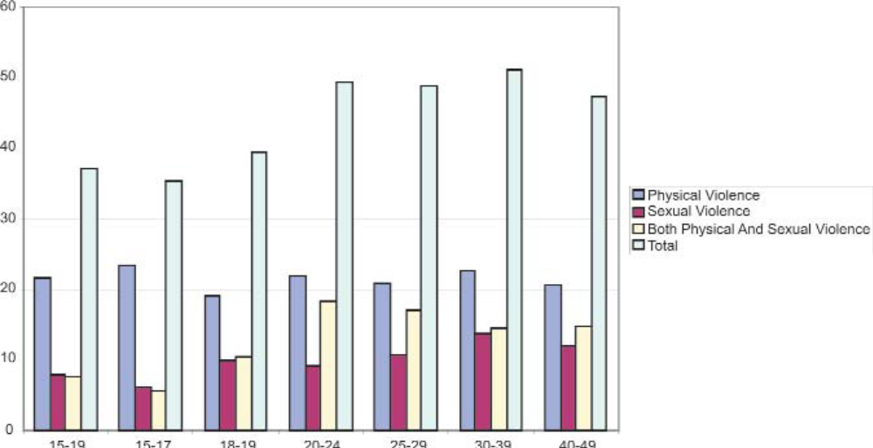
Source: Demographic Health Survey (2006).
47. To further enhance the intended positive effect of the law on the eradication of domestic violence, Section 11 of the Domestic Violence Act [Chapter 5:16], empowers the Court to order the victim, the perpetrator or any member of the family who is affected by violence to undergo counselling.
(i) Challenges
48. The effectiveness of the Domestic Violence Act [Chapter 5:16] is still to be assessed, as the Act came into force in October 2007. It is anticipated that the national strategy against gender based violence will go a long way towards enhancing the effectiveness of the Act. However, some of the challenges include lack of infrastructure to support the Act, for example safety nets, and generally the law is not well known.
(ii) Responses
49. The Government, through the Ministry of Women Affairs, Gender and Community Development, embarked upon awareness campaigns and capacity development initiatives to promote the understanding and effective implementation of the Act. These have targeted communities, traditional leaders, and police and court officials. The awareness programmes are ongoing and are being run with the support of several NGOs and United Nations agencies.
50. An Anti-Domestic Violence Council, which is responsible for the implementation of the Act, has been established The Council comprises representatives from Government ministries, civil society organisations, traditional leaders and representatives of religious institutions.
51. The Ministry of Women Affairs, Gender and Community Development is working towards the establishment of shelters. Three shelters have already been established, two of which were established by NGOs who work in collaboration with the Government. Services at the shelters include counselling. Plans are underway to establish a fund to implement the provisions of the Domestic Violence Act.
(g) Marriage laws
(i) Proposed amendments for marriage laws
52. In response to the Committee’s recommendation, the Government has made an effort to address more issues that affect women’s enjoyment of rights in family related matters. Although still at the level of a Bill, the proposed amendments will have the effect of protecting women from customary practices and beliefs that expose them to discriminatory tendencies.
53. The Government has adopted a policy that recognises three types of marriages in Zimbabwe as being equal.
(a) Marriage Act [Chapter 5:11]
54. Section 21 of the Act sets minimum age of marriage at 16 years for girls and 18 years for boys. It has been proposed that the minimum age should be 18 years for both girls and boys. This will be in line with the legal age of majority under the Legal Age of Majority Act. In addition, traditional leaders who are only empowered to solemnise customary marriages if so appointed by the responsible Minister will be allowed to solemnise civil marriages as well as to preside over divorce proceedings. Caution will, however, be taken to ensure that they are trained before taking on the responsibility.
(b) Customary Act [Chapter 5:07]
55. The two types of customary marriages in Zimbabwe, namely the registered and unregistered, remain as was previously reported. The proposed amendment seeks to equate the minimum age of marriage to the legal age of majority. It further seeks to introduce what will be termed “certified customary marriages”. All spouses in unregistered customary marriages will be required to certify their marriages before competent authorities. Such registration will also be made at the insistence of a woman should a man be resisting registration for selfish reasons. Measures will, however, be put in place to ensure authenticity of claims. A separate register will be opened for certified marriages. Certification will have the effect of according the unregistered customary marriage the same status as the registered customary marriage.
56. Formalities such as the publication of banns will be equated to those obtaining under the Marriage Act.
57. The proposed amendment also seeks to empower magistrates’ courts to preside over divorce proceedings of marriages contracted under the Marriage Act, since these courts are widely distributed in the country, which is not the case with the High Court. This will promote access to structures in the justice delivery system. Divorce and other matters arising out of marriage fall under the jurisdiction of the High Court, which sits in only a few central places. This has subjected women to long distance travel and high legal costs.
58. Furthermore, the requirement for parental consent to marriage, on the part of the woman, will be done away with, in favour of consent by the intending spouses. Lack of parental consent will therefore, not stop the solemnisation of a customary marriage, as this practice perpetuates in a woman of any age, the status of a minor.
(c) The Matrimonial Causes Act [Chapter 5:13]
59. The Act will be amended to extend the jurisdiction over and dissolution of all types of marriages to magistrate’s courts and chiefs.
2. Administrative and other measures
60. The Committee expressed concern over the fact that the national machinery for the advancement of women, lacked real power or responsibility to initiate and implement policy measures to eliminate discrimination against women. It further noted that the absence of a functional coordinating body for Gender Focal Persons may hinder their effectiveness.
61. In response to the Committee’s concerns, the Government has taken the following measures to eliminate discrimination against women and the girl child, as well as to promote gender equality.
(a) Establishment of fully fledged ministry or national machinery responsible for matters relating to women’s empowerment and gender equality
62. The Government established, in 2005, a national gender machinery to spearhead gender mainstreaming efforts by all sectors and promote the advancement of women. Most key positions in the Ministry are held by women.
(b) Policies for the advancement of women
National Gender Policy, 2004
63. The Government developed and adopted the National Gender Policy which was launched on 8 March 2004. Its objectives are:
- To mainstream gender into all sectors in order to eliminate all negative economic, social and cultural practices that impede equality of the sexes
- To promote equal advancement of women and men in all sectors
- To establish the institutional framework to ensure implementation of the gender policy, as well as monitoring and evaluating its impact
64. To date, the Government has reconstituted and trained Gender Focal Persons from Government Ministries, Departments and Parastatals to enhance their capacity to mainstream gender in sectoral policies, programmes and activities. An Implementation Strategy developed by the Ministry of Women Affairs, Gender and Community Development articulates not only the overall national strategy but also the sectoral strategies and responsibilities for the attainment of gender equality, equity and women’s empowerment. It establishes a National Gender Management System that establishes Gender Units from community level through to Ministerial level. Gender mainstreaming and women’s empowerment responsibility and accountability mechanisms and processes have been elaborated in the Strategy. For instance, the Ministerial Gender Units are obliged to submit quarterly reports to the Ministry. The National Gender Policy and its Implementation Strategy provide a framework through which a common perspective and approach to gender mainstreaming are adopted and used in all sectors.
(c) Draft National Gender-Based Violence Strategy, 2005
65. In March 2005, the Ministry, working in collaboration with the United Nations Population Fund (UNFPA), developed the Draft National Gender-Based Violence Strategy, which focuses on prevention, service provision, research, documentation and advocacy in the area of gender-based violence. The process for the development of the Strategy was participatory, involving governmental and non-governmental organisations. The Strategy contains an Action Plan, in which different stakeholders commit themselves to undertaking different activities. The activities being undertaken include awareness raising and training of service providers on the Domestic Violence Act; skills training for survivors of domestic violence; sensitisation of traditional leaders on issues of domestic violence in their capacity as service providers; legal representation of survivors in courts of law; and research, documentation and dissemination of information on domestic violence trends in the country. The Ministry with the support of UNFPA intends to document the victories attained and challenges encountered by the country whilst advocating for the enactment of the Domestic Violence Act.
66. Programmes seeking to create awareness of the Act and the prevalence of domestic violence are ongoing from the national to grassroots levels. These programmes are also intended to enhance women’s capacity to deal with and overcome domestic and gender based violence. Efforts have been made to build the capacity of those who advocated for the enactment of the law, such as the Zimbabwe Women’s Parliamentary Caucus. The Caucus was equipped with gender sensitive skills, enabling them to make gender-sensitive decisions and to support the Domestic Violence Act.
(d) Public awareness on inheritance laws
67. The amendment to the Administration of Estates Act was followed by a countrywide education campaign that brought together Government and NGO. The campaign, named “The Wills and Inheritance Laws Project” was a two-year programme that commenced towards the end of 2000. Several educational and awareness-raising materials were developed and disseminated through workshops and seminars, the print media and electronic media. Meetings and seminars were held at national, provincial and local levels to inform and educate people and communities on inheritance laws and the importance of writing wills to minimise disputes on the administration of estates. This programme was well received not only by communities but also by those involved in the administration of deceased estates.
(e) Policy to promote equal access to pension benefits
68. The Government has developed a policy to enable widows of unregistered customary law marriages to gain access to state pensions upon the death of a spouse. Currently, the lack of proof of marriage in the form of a certificate makes it difficult for some widows to claim the pension. The Pension and Provident Fund (Amendment) Regulations 2002 (No. 8) provides inter alia that:
“The rules of any fund shall provide that on the death of a member or pensioner the benefits payable from the fund shall be paid to the following persons in the following order ... to his surviving spouse and his dependent children.”
69. These Pension and Provident Funds Regulations protect the rights of surviving spouses to have access to and benefit from their deceased spouse’s pension contributions. However, the wording of the Regulations will be aligned to the intentions of the Interpretation Act that requires the use of “her/his” in statutory documents lest it be conferred that only men contribute to pension and provident funds, and that the beneficiaries of these funds are women and children and not men as well.
(f) Allocation of land to women
70. Measures on the allocation of land will be fully discussed under Article 15. The Constitution specifically requires all programmes of land resettlement to treat women and men equally.
(g) Ratification of vital treaties
71. As stated in the last report, the Government has ratified the Convention on the Political Rights of Women and the Convention on Consent to Marriage, Minimum Age for Marriage and Registration of Marriages. The recognition of women under the electoral laws is discussed under Article 7, while the marriage law reform process, which will be discussed under Article 16, is an implementation strategy for the Convention on Consent to Marriage, Minimum Age for Marriage and Registration of Marriages. The Government has ratified the International Labour Organization (ILO) Convention No. 111 concerning Discrimination in Respect of Employment and Occupation of 1958, which prohibits discrimination in employment on the basis of sex among others with respect to equality of opportunity and or treatment in employment or occupation. ILO Convention No. 100 concerning Equal Remuneration for Men and Women Workers for Work of Equal Value and maternity protection has also been ratified by the Government. These ratifications demonstrate the Government’s commitment to the elimination of discrimination against women in employment.
Article 3
Measures to ensure the full development and advancement of women and basic human rights and fundamental freedoms on an equal basis with men
72. The Committee is referred to discussions under articles 1, 2, 7, 10, 11 and 12 on the legal and other measures that the Government has taken to ensure full development and advancement of women and their access to basic human rights on an equal basis with men.
Article 4
Temporary measures to accelerate de facto equality between women and men
73. The Committee recognised the need for affirmative action and recommended that Government take temporary special measures of affirmative action to promote the status of women in all spheres of society.
1. Administrative and other measures
74. The Government has undertaken some positive temporary measures to redress the intractable inequality between women and men permeating all sectors of the Zimbabwean society. The measures are aimed at enhancing the participation of women and/or girls in the various sectors. As stated under Article 2, the Constitution has been amended to legalise affirmative action. This is especially true of the 1992 Affirmative Action Policy in the public service, which sought to have at least 33% female representation in all senior posts by 2000.
75. Figure 2 shows the number of female employees at the various administrative levels in the civil service from Administrative Officer level and above, as at 26 June 2001. The affirmative action policy’s success can therefore be measured in terms of whether or not the target of 33% by year 2000 was met.

Figure 2
Female representation in the public service
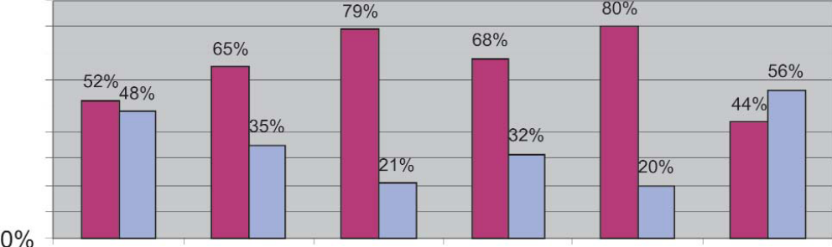
Source: Public Service Commission (2001).
(i) Challenges
76. The measures that have been taken have tended to be selective and have been varied in impact. Some of the policy measures have, for instance, tended to benefit a small proportion of women such as the urban based educated, professional female in paid employment.
77. The policy did not take into account factors that could hinder many females from benefiting from this measure. These include:
(a) The lower numbers of females applying for jobs in the service;
(b) The reluctance by many women to take up promotional posts away from their families; and
(c) The use of a priority list for job interviews by the Public Service Commission, which did not take into consideration issues of gender balance.
(ii) Response
78. It is significant to note that the Public Service Commission has developed a sectoral gender policy in line with the National Gender Policy. This has facilitated the implementation of gender sensitive affirmative action programmes in the public service. In fact, when running internal advertisements for vacancies in the public service, the Commission expressly encourages women to apply. Responses are now checked to ensure women apply and any list drawn up for interviews should include female candidates. To ensure that there are enough females at middle management level, the Commission has developed a policy of striving to ensure that women are recruited on a 50/50 basis with male candidates. This is designed to ensure that more females are promoted to senior management positions.
79. The education sector has also been a target for temporary measures with special focus on tertiary education. Affirmative action policies that sought to encourage the enrolment of more female students in tertiary education institutions were developed and adopted by several tertiary education institutions. As stated in the first Report, the University of Zimbabwe, the largest and oldest institution of higher learning, introduced an affirmative action policy when admitting female students. The policy has since been introduced for entrance to teacher training and technical colleges. For teacher training and technical colleges, the aim was to achieve 50% and 35% female enrolment, respectively. Significant progress has been made towards the attainment of parity levels in teacher training, as shown in Figures 3 and 4 below.

Figure 3
Primary schoolteacher enrolment
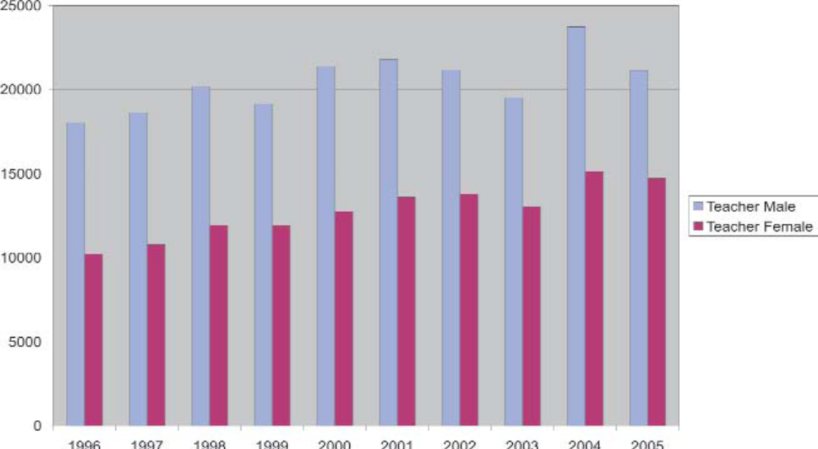
Source: Ministry Education Sport and Culture (2005).

Figure 4
Enrolment in universities
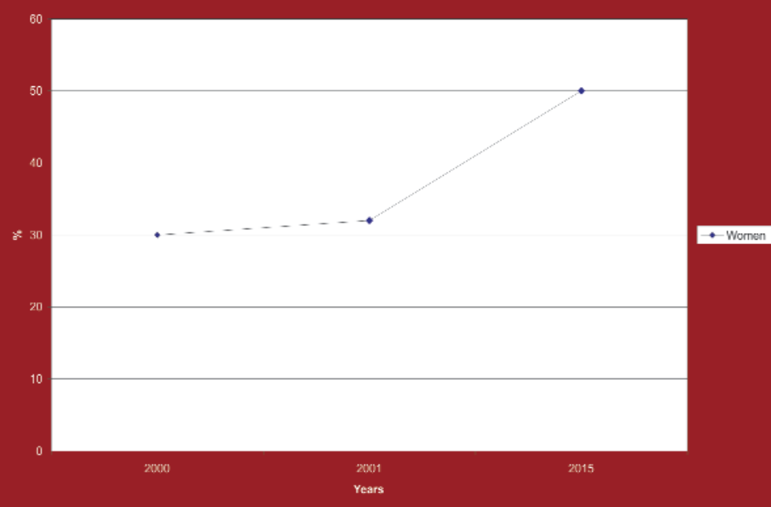
80. More efforts need to be directed to improving female enrolment rates at universities as female students still constitute less than 35% of total enrolment. This is because the policy has met with cynicism and resistance from some sectors. It has also been noted that the worsening economic situation is having a negative impact on the ability of students to complete their education.
2. Women in politics and decision-making
81. The former Ministry of National Affairs and Employment Creation, which housed the gender machinery, initiated the Women in Politics and Decision-Making Project to help increase the number of females in political and decision making positions. The project also aimed to build capacity among women already in positions of power. The project ran from May 1997 to the year 2000. It aimed to attain 50% representation of females in political and decision-making structures. However, according to the Evaluation Report of the Women in Politics and Decision-Making Project, the 50% target was not realistic in a period of only 3 years. The project failed to carry out a baseline survey to establish why few women in Zimbabwe are in political and decision-making positions, according to the evaluation report, and largely focused on training of trainers, rather than on identifying and supporting potential candidates to stand in the elections. Below is a figure showing the percentage of females in Parliament from 1990 to the end of the project in 2000.

Figure 5
Female representation in Parliament
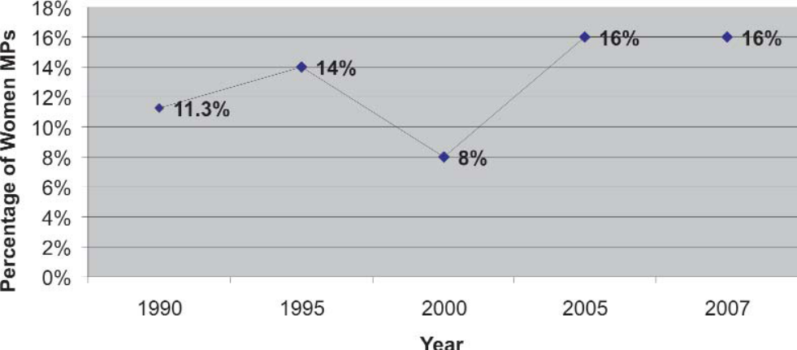
Source: Women in Politics and Decision-Making Project Evaluation Report (November 2000).
82. Figure 5 reflects a negative trend in 2000, as it would seem that society is not yet ready to embrace and practice a culture that promotes gender equality in political and decision-making processes since women are not viewed by society as leaders.
Article 5
Social and cultural patterns that lead to discrimination and stereotyped roles for women
83. The Committee recommended that the Government take measures to codify family and customary laws and incorporate only those customary laws and practices that promote gender equality and the empowerment of women. It further suggested that gender-sensitisation training be extended to all sectors, including healthcare workers.
84. The Government has considered the need to codify customary law. However, due to the dynamic nature of customs and practices, it may not be in the interest of women to codify the law. It is Government’s belief that codification may cause permanence to customs and practice, thereby negatively affecting their dynamic nature.
1. Constitutional and legislative measures
85. The measures taken to eradicate discrimination emanating from social and cultural norms and practices, as well as the challenges faced in doing so, have been discussed under article 2.
2. Administrative and other measures
86. The Ministry of Women Affairs, Gender and Community Development has a wide spectrum of partner NGOs who run sensitisation and capacity-development programmes on gender. The programmes targets school-going children, women, men and traditional leaders through their networks, workplaces and communities. As part of these programmes, a small number of men have been trained in care work within their communities. This is a positive step towards reducing the burden of care on women.
(i) Challenges
87. The levels of gender stereotypical tendencies are still high and of great concern to the Government. Negative cultural and religious beliefs are often used to support and maintain values and practices that relegate women to subordinate positions, not only in religious institutions but in society as a whole. Therefore, there is a need for further interventions in terms of gender awareness and sensitisation complimented by women’s empowerment to enable women and men to demystify the stereotypes and eliminate the disparities arising from the stereotypes.
(ii) Response
88. The National Gender Policy addresses the issue of stereotypes by seeking to eliminate “all negative economic, social the sexes” by empowering women and men to attain sustainable equality and equity. The National Gender Policy Implementation Strategy further elaborates the strategies through which gender stereotypes can be tackled. These include development and dissemination of information on negative cultural, religious and traditional practices. UNFPA has supported training of media personnel in gender sensitive reporting on, HIV and AIDS and the Domestic Violence Act. Furthermore, the Government has, through legislation and policy, put in place mechanisms and processes to enhance the elimination of gender stereotypes. These aim to promote property rights, eradicate domestic violence and abolish discrimination on the basis of gender and sex.
Article 6
Suppression of trafficking in and exploitation of the prostitution of women
89. The Committee expressed concern at the criminalisation of prostitution in the Zimbabwean legal system, while the clientele go unpunished. It was concerned that there were no data on persons involved in prostitution, nor were there any educative programmes for them. Also of concern to the Committee was the higher level of vulnerability to prostitution among poor women and migrant workers. The Committee requested more detailed data on prostitution, as well as trafficking.
90. The Committee then recommended that the Government take measures to adequately address Article 6 by putting in place, socioeconomic programmes that would assist women living through prostitution, as well as document its prevalence for purposes of developing assistance programmes.
1. Legislative measures
91. Part III of the Criminal Law (Codification and Reform) [Chapter 9:23] referred to under paragraph 34, prohibits the movement of persons in and outside the country for purposes of prostitution. Trafficking for purposes of prostitution is, therefore, prohibited under section 83 of the Criminal Law (Codification and Reform). Prostitution itself, however, remains prohibited in the statute books and any attempt to legalise it would require wide public consultations, lobbying and advocacy.
92. The law on prostitution has, however, been amended to ensure that a higher degree of reasonable suspicion is applied before one is arrested for prostitution. Previously, Section 4 of the Miscellaneous Offences Act [Chapter 9:15] provided as follows.
93. Any person loitering or being in a public place for the purpose of prostitution or solicitation shall be guilty of an offence.
94. This gave the Police power to pick up people, in particular women, who they considered were loitering and make inferences that they were doing so for purposes of prostitution. The Criminal Law (Codification and Reform) [Chapter 9:23], which has repealed the Miscellaneous Offences Act [Chapter 9:15], states the following in section 81:
“Any person who publicly solicits another person for the purposes of prostitution shall be guilty of soliciting and liable to a fine not exceeding level five or imprisonment for a period not exceeding six months or both.
“The Act defines soliciting publicly as the act of actually soliciting in a public place or any place to which the public or any section of the public have access or the publication of the solicitation in any printed or electronic medium for reception by the public, thereby removing the aspect of loitering.”
2. Administrative and other measures
(a) Suppression of trafficking
95. Parliament has ratified the Convention on Transnational Organized Crime. The process of ratifying the additional protocols to the Convention, namely the Protocol against Trafficking of Human Beings (mainly women and children) and the Protocol Prohibiting the Illegal Transportation of Immigrants by Land, Air or Sea, is also underway.
96. There are indications that, over the years, Zimbabwe has been used as a transit and source country for the trafficking of women and children to other countries for purposes of forced labor and exploitation, through false promises of jobs, scholarships or marriage. These often result in domestic servitude or sexual exploitation. According to the International Organization for Migration (IOM), countries within the Southern African Development Community (SADC) host a diverse range of human trafficking activities, such as trade in persons perpetrated by small scale syndicates that recruit acquaintances, friends and family members across the region’s land borders and within individual Member States. Poverty has been identified as a major contributing factor in human trafficking, especially trafficking of women and children. Zimbabwe needs to undertake an independent study on human trafficking to determine the extent of the problem in general and, in particular, to establish its gender dimensions.
97. The Government has established an Inter-Ministerial Committee on Human Trafficking consisting of officials from relevant Government Ministries. The Ministry of Foreign Affairs, whose terms of reference include the examination of migration patterns affecting Zimbabwean nationals, coordinates the activities of the Committee. It works in collaboration with IOM in this regard. The Ministry of Women Affairs, Gender and Community Development is represented on this Committee to facilitate gender mainstreaming in its work.
98. Meanwhile, the Government, with the support of IOM, Save the Children Norway and the United Nations Children’s Fund (UNICEF), has already established a Reception and Support Centre for Returnees. The Centre, which is based at the Beitbridge Zimbabwe/South Africa border post offers a vast range of humanitarian assistance including:
- Meals
- Transportation assistance in Zimbabwe for those who wish to return home
- Medical assistance and/or referrals for further treatment
- Overnight shelter for those too weak for onward travel
- Counselling and safe migration advice
- Vouchers for voluntary counselling and testing for HIV
- Provision of post-gender-based-violence services, including post-exposure prophylaxis
- Provision of basic reproductive health commodities, such as sanitary wear
99. IOM has also built a Children’s Centre, alongside the Reception and Support Centre to provide additional care and protection for unaccompanied children. UNICEF and Save the Children Norway operate the Children’s Centre in coordination with the Government, through the Ministry of Public Service, Labour and Social Welfare. The Centre provides health, counselling, and tracing and reunification services. Between July 2006 and March 2007, 358 unaccompanied minors were assisted through the Centre. More reception centres will be opened in the near future, with the Plumtree Zimbabwe/Botswana border post being on the current agenda.
100. The Centre helps individuals with protection concerns to report any cases of rape, confiscation of identity documents, physical assault and trafficking. IOM is concerned by the high incidence of sexual and gender-based violence experienced by female recipients of its services. It therefore coordinates training with the police and other support departments such as immigration and the magistrates’ courts to mitigate the impact of sexual and gender based violence. Concerned with the shortage of rape kits for collecting sexual assault evidence within the Zimbabwe Republic Police, IOM seeks to provide such kits to police stations in Matabeleland Province. They also intend to collaborate with the Ministry of Women Affairs, Gender and Community Development to enhance stakeholder capacities to mainstream gender in migration processes and mechanisms.
101. There is growing concern in Zimbabwe about the trafficking of women who are forced into prostitution after false promises of jobs. Young women are at a greater risk, as they are targeted by traffickers who force them into prostitution. Some victims of trafficking are forced into marriages. A study is underway in Zimbabwe to determine the magnitude of the problem. Since the Centre opened its doors in 2006, 194,908 returned Zimbabweans have received assistance from IOM. Figures for 2007 from the Centre show that very few women pass through. A study needs to be undertaken to investigate why fewer women than men pass through the Centre.
(b) Women and prostitution
102. In response to the concerns of the Committee, the Government worked with partner NGOs to start pilot projects on rehabilitating commercial sex workers. A case in point is the Gweru Women AIDS Prevention Association (GWAPA), an initiative established in the Midlands Province. This has sought to provide the women with an alternative source of living through initiating income-generating projects. The women have also been trained to spread the message of safe sex and non-risk behaviour to their clients and the general public. This programme has spread to other districts within the Province.
103. The police have been working together with the general public to put an end to prostitution. A massive campaign against prostitution was carried out in 2004 under the code name “No to Prostitution”. In this campaign, both men and women were picked up from the streets of Harare for questioning by the police.
(i) Challenges
104. The Act protects persons trafficked for prostitution only and not persons trafficked for other purposes, such as employment.
105. Despite the amendment to the law, the police still arrest more women, than men. There are complaints to the effect that the Police continue to indiscriminately arrest women and girls who are going about their own business at night, regardless of whether they are prostitutes or not. Both the repealed Miscellaneous Offences Act [Chapter 9:15] and the Criminal Law (Codification and Reform) [Chapter 9:23] attribute the offences to ‘any person’. The application of the law, however, continues to target more women than men. This may be caused by societal beliefs that women should not be found in certain places at certain times, hence perpetuating discriminatory tendencies against women.
106. By providing that ‘any person who publicly solicits another person for the purposes of prostitution’ the law does not criminalise the conduct of the buyer of sex. This turns out to be discriminatory against women, as it leaves men unpunished since women engage in soliciting for prostitution more than men.
(ii) Response
107. The Ministry is implementing a women’s economic empowerment programme that also targets women prostitutes.
Article 7
Elimination of discrimination against women in political and public life
108. The Committee expressed concern at the low level of women’s participation in decision-making positions.
1. Constitutional measures
109. The non-discrimination clause in the Constitution applies to participation in political and public life. Furthermore, the constitutionalisation of affirmative action has paved the way for the formulation of policies that will accelerate the advancement of women in any area where they have been disadvantaged, including political and decision-making processes and mechanisms.
2. Legislative measures
110. As stated in the initial report, women in Zimbabwe are legally entitled to take up political and public offices. Section 12 of the General Law Amendment Act [Chapter 8:07] provides as follows:
“Notwithstanding anything to the contrary in any law, women may hold public office or civil office or appointment, subject to the same conditions on which such offices may be held by men.”
3. Administrative and other measures
111. In recognition of the right to vote, the Government acceded to the Convention on the Political Rights of Women, 1952. In an effort to continue encouraging women to participate in politics and also in furtherance of its commitments under the Convention and the Beijing Declaration and its Platform for Action, the Government of Zimbabwe signed the SADC Declaration on Gender and Development of 1997. This Declaration seeks, among other things, to attain at least 30% female representation in political and decision-making levels by the year 2005. Zimbabwe is also party to the SADC Protocol on Gender and Development, which was adopted in 2008, as an upgrade of the 1997 Declaration on Gender and Development.
112. In 2000, Zimbabwe together with the other African countries ratified the Constitutive Act of the African Union, one of the objectives of which is to “ensure the effective participation of women in decision-making, particularly on the political, economic and socio-cultural areas”. The African Union committed itself to function in accordance with the principle of promoting gender equality. In 2004, Zimbabwe was party to the African Union’s Solemn Declaration on Gender Equality in Africa, in which Member States agreed to “expand and promote the gender parity principle ... to the national and local level in collaboration with political parties and the National Parliaments in our countries”.
113. Furthermore, Zimbabwe has recently (2008) ratified the Protocol to the African Charter on Human and Peoples’ Rights on the Rights of Women in Africa, 2003, which in Article 9, calls on Member States to ensure through affirmative action that women participate and are represented equally at all levels with men in elections, all electoral processes and decision-making levels. Zimbabwe now has, for the first time, a female Vice-President, a first and a remarkable achievement in the history of the country. However, over the years, progress towards the enhanced participation of women in politics and decision-making has remained low, and, in some instances, has actually regressed. Below are statistics on female representation in Parliament (House of Assembly and the Senate, respectively) and Cabinet.
(a) Women in Parliament
114. The Constitution was amended in 2005 to reintroduce the Senate, as the Upper House of Parliament. The first senatorial elections were held in November 2005, with more women being elected than those in the House of Assembly. The Senate had 23 women out of 66. As reflected in figure 6 below, of the 150 Members of the House Assembly, 120 were elected on a constituency basis, while the President appointed the remaining 30.
115. Both the Speaker and Deputy Speaker of Parliament were male, while there are 13 portfolio committees and only one is chaired by a woman.
Figure 6
Female representation in the House of Assembly
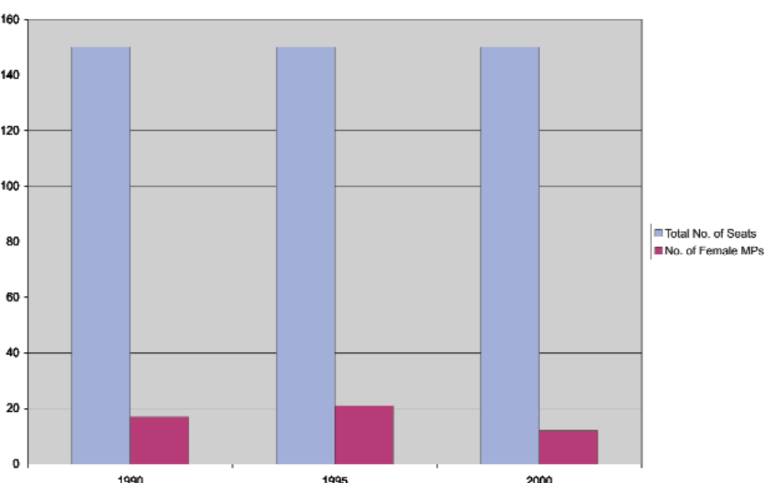
Source: Women in Politics and Decision-Making Project Evaluation Report (November 2000).
116. The Cabinet is appointed by the President from elected Members of Parliament under Part 2 of the Constitution of Zimbabwe. Figure 7 shows the representation of women in Cabinet from 2002 to 2008. The number of elected female Members of Parliament has a bearing on the number of female representation in Cabinet. The President of the Senate was female.

Figure 7
Female representation in the Cabinet
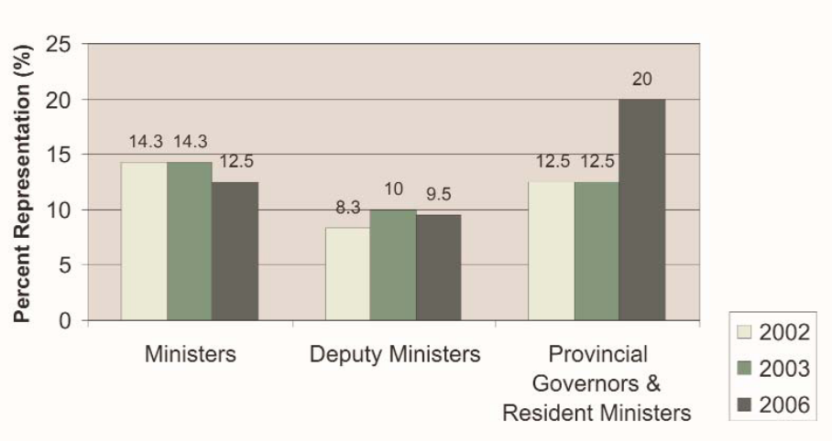
Source: Women in Politics and Decision-Making Project Evaluation Report (November 2000).
(b) Measure taken to increase the number of women in Parliament
117. The Ministry of Women Affairs, Gender and Community Development continues to work with civil society organisations to encourage women to participate in politics in anticipation of increasing the number of women in Parliament and Cabinet. Between 1997 and 2000 the Government implemented the Women in Politics and Decision-Making programme in a bid to increase the number of women in political and non-political decision-making positions. The programme targeted the 1998 Rural District Council elections and the 2000 Parliamentary general elections.
(i) Challenges
118. After the 2000 Parliamentary elections the number of female MPs fell from 21 to 14. An evaluation of the Women in Politics and Decision-Making programme revealed several limitations. These included the fact that the programme had failed to carry out a baseline survey to establish why few women in Zimbabwe are in political and decision-making positions. The programme also largely focused on training of trainers, rather than on identifying potential candidates to stand in the elections and capacitating them to compete.
(ii) Response
119. Both major political parties have indicated willingness to implement a quota system in a bid to increase the number of women in political and decision-making positions. It is debatable whether this would have an impact upon the number of women MPs due to the fact that Zimbabwe uses the first-past-the-post electoral system. Parliamentary elections in Zimbabwe are held every five years, with the last elections having been held in March and June 2008.
120. The Ministry of Women Affairs has embarked on mobilising women in politics to engage in economic activities. Capacity-building workshops have been held with the support of civil society organisations to sensitise women on why they have to participate in politics and decision-making.
4. Women in local government structures
(a) Rural Districts and Urban Councils
121. Rural District Councils (RDCs) and urban councils are the local authorities in rural and urban areas respectively. The Rural and Urban Council areas are divided into wards. The wards are represented in the Council by councillors. Statistics for both Rural and Urban Councils indicate a preponderance of males in the Councils in both elected and appointed positions, as indicated in figures 9 and 10.
122. Executive Mayors are elected directly by the voters in the Council area. Deputy Mayors are elected by fellow councillors for a one-year term. The President appoints Provincial Governors and Resident Ministers and they are also Members of Parliament. There are no elected local government structures at provincial level.
(b) Measure taken to increase the number of women in local government
123. While statistics do indicate the number of male and female Councillors in both urban and rural Councils, information on how many women stood for elections is not readily available.
124. A civic education campaign has been ongoing since 1998, which culminated in a marginal increase of an additional 5 seats for women bringing them to 42. There is a need for a more sustained and long-term campaign to change perceptions and attitudes that would lead to a substantial increase in the number of female councillors. Figures 8 and 9 below give statistics on the participation of women in Urban Councils at the political and senior administrative levels.

Figure 8
Women in local government
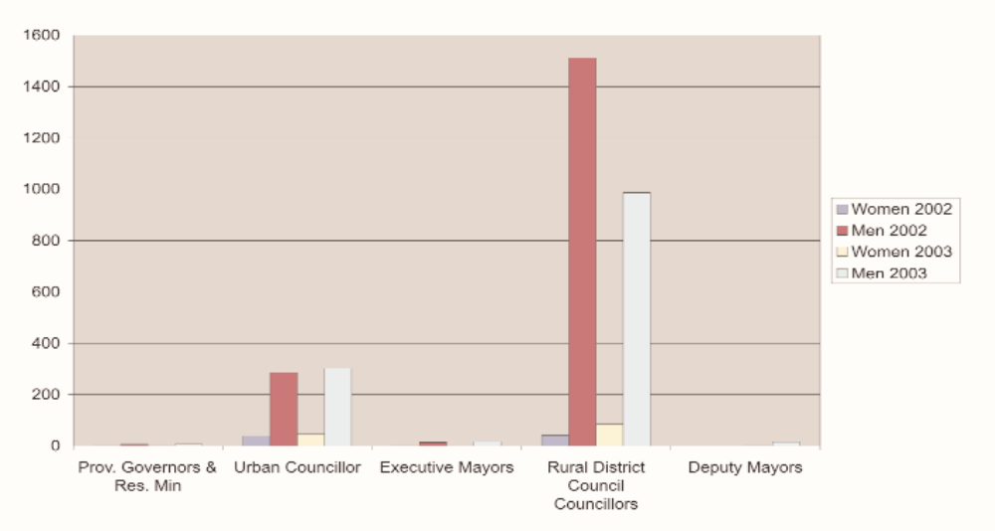

Figure 9
Women in urban councils
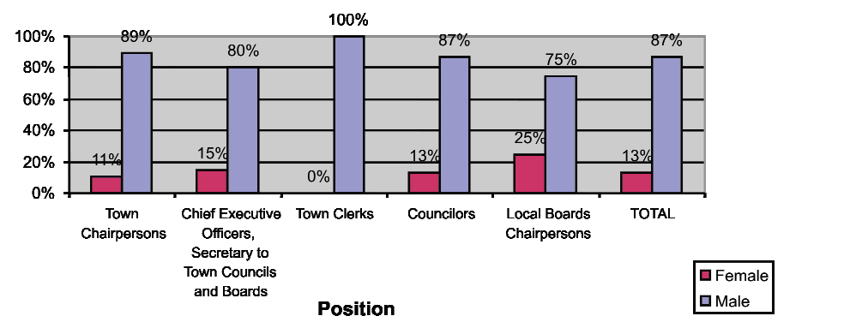
125. The representation of women is also low at the Rural District Councils level, as fully reflected in figure 10.

Figure 10
Women in rural district councils
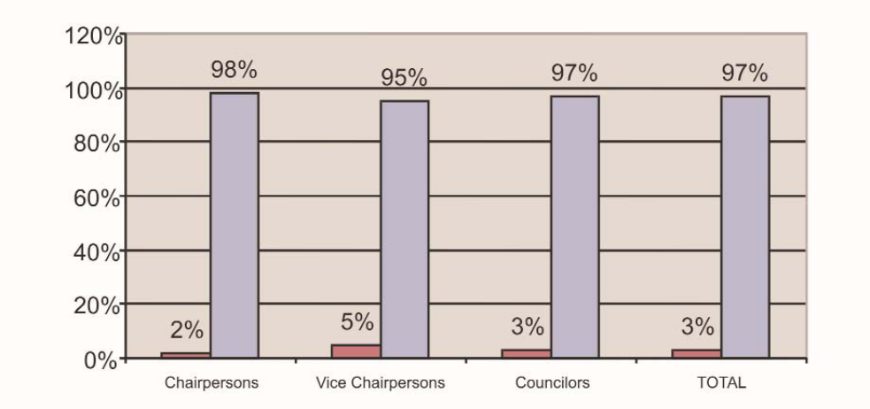
Source: Ministry of Local Government, Public Works and National Housing (August, 2004).
5. Women in the public service
126. Key positions in the Public Service include Commissioners, Permanent Secretaries, Directors and Deputy Directors. The President appoints Permanent Secretaries and Commissioners, while the Public Service Commission appoints successful candidates to all other senior and middle management positions. The number of women in these key positions of power is still low, as reflected in figure 11.

Figure 11
Women in managerial positions in the public service
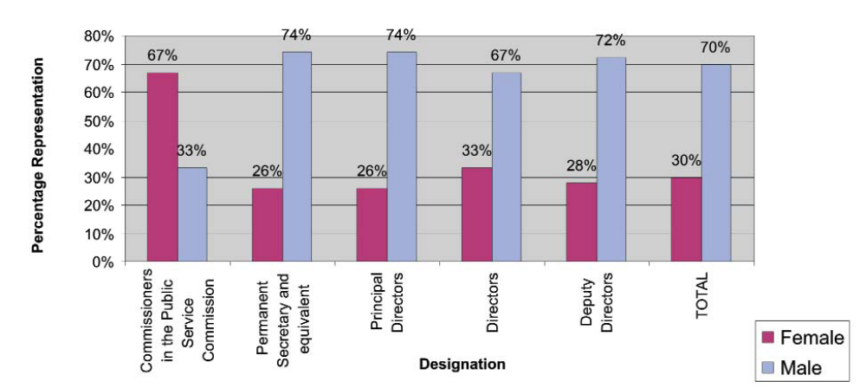
Source: Public Service Commission (2007).
(a) Measure taken to increase the number of women in the public service
127. In 1989, the Public Service Review Commission noted that the potential of women was not being utilised fully due to non appointment to decision-making levels in the Public Service and recommended the following:
(a) The establishment of a broad-based advisory group in the Public Service Commission whose aim would be to improve the position of women in the service;
(b) Gender training during induction;
(c) Inclusion of gender sensitive women in all promotion boards.
128. As a response to the Review Commission’s finding, the Public Service Commission (PSC) adopted a policy aimed at increasing female representation at all levels, especially managerial levels to at least 30% by the year 2000. On average, according to figure 12, the 30% target has been achieved.
129. A Gender Task Force chaired by a Commissioner was established in 2000 by the Public Service Commission to ensure that the current Public Service Reform will be gender sensitive and will not erode current gains made in increasing the number of women. The Task Force developed a draft gender policy for the Public Service.
130. The Zimbabwe Institute of Public Administration and Management (ZIPAM) runs gender related courses as well as capacity-building courses for women managers within the Public Service.
131. Measures have also been put in place to ensure that women do not lose out on promotion and advancement prospects when they go on maternity leave. In terms of section 39 (7) of the Public Service Regulations Statutory Instrument 1 of 2000, a woman’s eligibility for advancement or promotion shall not be affected by her absence on maternity leave. Section 18(7) of the Labour Act [Chapter 28; 01] also secures women’s conditions of service and all entitlements during maternity leave. It specifically provides that a woman’s service shall not be considered interrupted, reduced or broken by the exercise of her right to maternity leave in terms of the law. These improvements to maternity benefits were introduced by way of an amendment to the Labour Act in 2002 (Act No. 17 of 2002).
6. Women in the judiciary
132. Parliament passed the Judicial Service Act [Chapter 7:18] in 2006 to place under the Judicial Service all bodies exercising judicial and quasi-judicial functions. These are the Supreme Court, High Court, Administrative Court, Labour Court, subordinate courts and the Office of the Public Protector. The Act, which is yet to come into operation, provides for the conditions of service of the members of the judicial service.
133. The appointment of presiding officers for the higher courts is and will still be done by the President in consultation with the Judicial Service Commission. The Act will have the effect of conferring the power to appoint members of the subordinate courts into the Judicial Service Commission, as opposed to the Public Service Commission. Figure 12 indicates the number of women in the judiciary.

Figure 12
Women in the judiciary
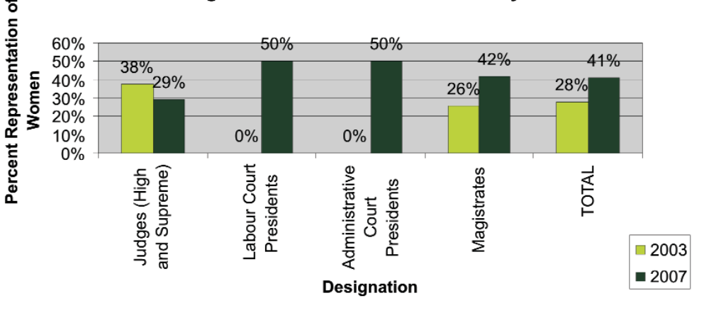
Source: Ministry of Justice (2007) (there are no statistics for the labour court and administrative courts for 2003 because they were not yet established).
134. The Chief Justice is male, while the Judge President (Head of the High Court) is female. Currently there are more females at the lowest levels of the judiciary. The Government will work on the introduction of affirmative action in the Judicial Service Commission to ensure the equitable appointment of women and men in the judiciary.
7. Women in the Uniformed Sector
135. The Uniformed Sector is comprised of the Defence Forces constituting the Army and the Air Force, the Zimbabwe Republic Police and the Zimbabwe Prison Service.
(a) Zimbabwe Defence Forces
136. Tables 1 and 2, below, show the under representation of women at all levels of the Zimbabwe Defence Forces. The figure reflect low representation of women in key positions There is a need for the defence forces to work vigorously on mainstreaming gender in their recruitment, employment and promotion policies and processes. The Ministry of Women Affairs, Gender and Community Development will work with the Ministry of Defence and the Defence Forces in this regard.

Table 1
Women in the Zimbabwe National Army
Rank | Percentage of women
Lieutenant General | 0
Major General | 0
Brigadier General | 0
Colonel | 6.6
Lieutenant Colonel | 5.9
Major | 3.8
Captain | 2.7
Lieutenant | 17.0
Source: Ministry of Defence (2008).

Table 2
Women in the Air Force of Zimbabwe
Rank | Percentage of women
Air Marshal | 0
Air Vice Marshal | 0
Air Commodore | 0
Group Captain | 4.76
Wing Captain | 12.50
Squadron Leader | 8.57
Flight Lieutenant | 16.03
Source: Ministry of Defence (2008).
(b) Police
137. Management positions in the Zimbabwe Republic Police range from the Commissioner to the Superintendent. Though not in the management levels, the positions of Chief Inspector and Inspector have significant decision-making and administrative functions, which include taking charge of stations and sections of stations. The President appoints the Commissioner of Police and other senior personnel on the recommendation of the Police Service Commission. Competitive examinations are also used to determine appointments to other ranks within the Police Force.

Figure 13
Women in the Police
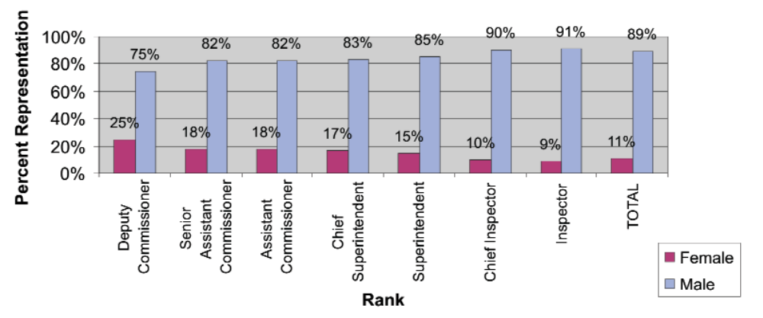
Source: Zimbabwe Republic Police (2007).
138. Figure 13 reflects low female representation in senior and decision-making positions in the Police Force. However, in recent years there have been more female recruits in the Force, paving the way for their elevation to senior positions. More deliberate efforts and mechanisms need to be put in place to ensure the recruitment of more females in the Force in general and in the promotions and appointments at managerial and decision-making levels in particular.
(c) Zimbabwe Prison Services
139. The total Prison Service employment establishment is 7,982 of which 1,525 are women, thereby constituting 19% of the entire establishment. Of the 19% of women in the Prison Service, 8% are in senior positions.

Figure 14
Women in the Prison Service
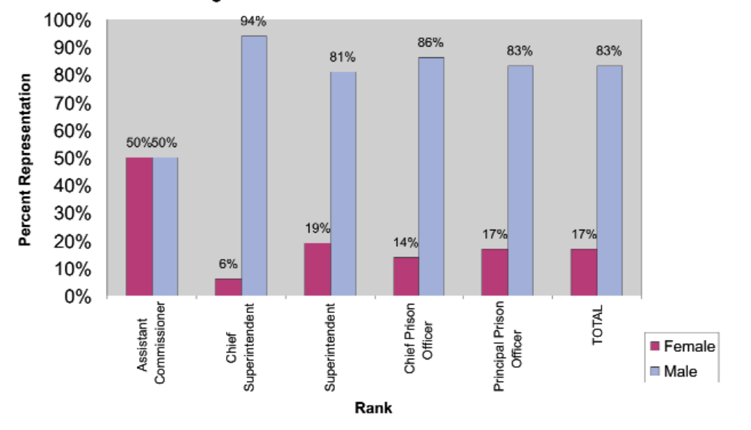
Source: Zimbabwe Prison Service (2007).
140. It is encouraging to note that of the 19% female representation in the Prison Service, almost half are in senior positions, with 50% representation at the Assistant Commissioner level. Assistant Commissioners fall directly under the Commissioner who is the Head of the Prison Service. Currently the Commissioner is male.
(d) Measure taken to enhance women’s representation and participation in decision-making in the uniformed forces
141. The Force has increased the recruitment of women to a capacity that the training depot can hold at any time. Efforts to increase accommodation for female recruits are under way. Women are increasingly being appointed to positions previously dominated by men, such as Head of Stations, Districts and Provinces. In the year 2000, four out of the nine Provinces were being commanded by women.
142. As stated under paragraphs 61–62, the gender machinery is in the process of establishing functional procedures and processes to effectively implement the National Gender Policy. This should see the development of strategies that will increase the numbers of women in decision-making positions.
143. Where spouses are both in the Public Service, some Ministries coordinate geographical transfers to ensure once one spouse is transferred, the other spouse’s department will also transfer them to avoid separation of families. This works to the advantage of women who often suffer the prejudice of separation when their spouse declines to leave their job or business to join them.
(e) Challenges in the Uniformed Sector
144. The numbers of women in decision-making positions overall are still quite low. Women face a number of challenges in their bid to take up decision-making positions, in particular, where such positions involve geographical movements. Certain positions are confined to specific geographical areas, such as urban areas, leading to the separation of spouses where one of them is promoted. In such cases, women may opt to decline an appointment for fear of breaking up the family. Other fears of staying apart are associated with the vulnerability to HIV that may result from extramarital affairs when spouses reside in different geographical areas. The inevitable cost of running two households in such a situation has also forced women to decline appointments.
Article 8
Equal opportunities with men to serve as representatives of Government at international level and as participants in the work of international organizations
145. The Constitutional, legal and policy provisions on women’s ability to take up public positions on an equal basis with men have been discussed under Article 7. The Public Service Commission does play a role in certain international appointments where government support is requested. Diplomatic appointments are made by the President.
1. Diplomatic Service
146. The situation remains as given in the first report that not many ambassadorial posts have been taken by women. There are, however, no legal impediments to women serving in diplomatic missions. Appointments are mainly made from within the service, with the large majority being drawn from the Ministry of Foreign Affairs. Figure 15 reflects female representation in Diplomatic Missions.

Figure 15
Women in the Diplomatic Service
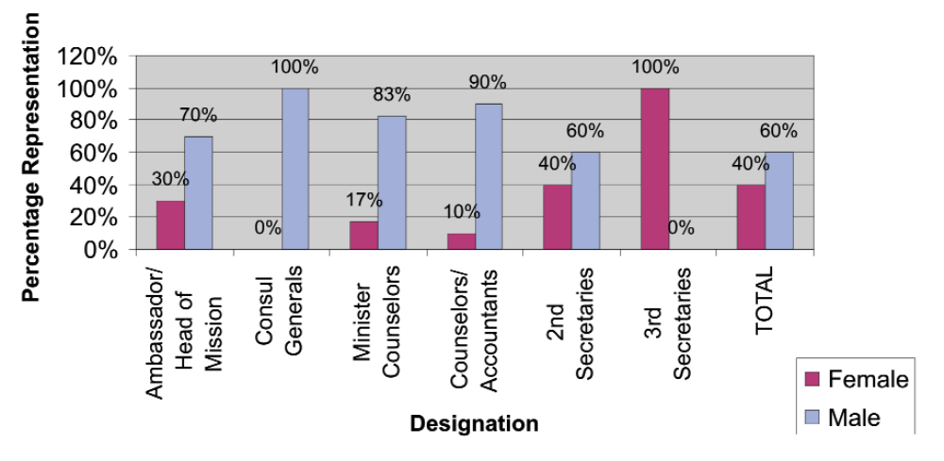
147. In general terms, the Government has managed to reach the 30% target set under the SADC Declaration on Gender. This is an improvement from the statistics reflected in the last report, as the percentage at that time was 12% for female ambassadors. The percentages on the other levels have, however, remained low. There are more women in the lower ranking levels, such as secretaries, than in senior positions.
2. International organisations
(a) Representation in regional and international organisations
148. There are no mechanisms for collecting statistics on the number of women in regional and international organisations. A Zimbabwean woman has, in the past, served on the Committee on the Elimination of Discrimination against Women.
(b) Delegation to international meetings and conferences
149. Persons in such management positions as, Minister, Permanent Secretary, Director and Deputy Director often head delegations to regional and international meetings and conferences. Where a woman holds such a position, that woman automatically heads the respective delegation. This includes heading the delegations in the absence of the designated head. However, since women don’t normally hold senior positions in most sectors, generally more males than females attend international conferences.
150. The absence of an effective system of collecting gender disaggregated data affects efforts targeted at ensuring that as many women as possible serve at the international level.
Article 9
Equal rights to acquire, change or retain nationality
1. Constitutional measures
151. The rules concerning Zimbabwean citizenship were described in detail in the initial report. Amendment No. 14 of the Constitution (1996), as noted in the last report, put foreign spouses of both sexes on an equal footing in the sense that neither men nor women can automatically gain citizenship on the ground of being married to a Zimbabwean citizen. Foreign spouses can now qualify for citizenship like any other foreigners seeking such citizenship. As stated in the last report, foreign women who were married to Zimbabwean men prior to the amendment automatically acquired citizenship by virtue of their marriage, a facility that was not applicable to female citizens who married foreign men.
2. Legislative measures
152. The Citizenship of Zimbabwe Act [Chapter 4.01] provides modalities and procedures for acquiring or applying for citizenship within the confines of the Constitution. In terms of section 15 of the Act, a married woman is capable of acquiring or losing Zimbabwean citizenship as if she were unmarried. A woman shall, therefore, not be discriminated against, in matters of her citizenship on the mere ground that she is married.
(i) Challenge
153. The influence of African culture, as well as that of the Roman Dutch Law, which demands that a married woman acquires the domicile of her husband, still influences the minds of many. It is, therefore, much easier for female foreign spouses to acquire residence or citizenship than their male counterparts.
Article 10
Elimination of discrimination against women in the field of education
154. The Committee expressed concern at the lack of support systems that would enable pregnant teenagers to continue with their education. It requested the Government to provide detailed information on teenage pregnancies and the ability of young mothers to continue with their education.
1. Constitutional measures
155. The principle of non-discrimination in the Constitution of Zimbabwe applies generally. The inclusion of affirmative action in the Constitution, as discussed under Article 2, will ensure that persons previously disadvantaged by unfair discriminatory tendencies, including pregnant teenagers, will no longer face these disadvantages.
2. Legislative measures
156. As indicated in the last report, the Education Act [Chapter 25:04] accords every child in Zimbabwe the right to education. Girl children are protected from sexual harassment in schools by Section 8 of the Labour Act [Chapter 28:01] and the First Schedule of the Public Service Regulations, Statutory Instrument No. 1 of 2000.
3. Administrative and other measures
157. As previously reported, the Government is continuously making an effort to improve access to education by race, class and gender. This includes the promotion of curriculum development to influence a change in attitudes of both educators and parents. There has been a review of the education curriculum in primary schools to ensure that it is gender sensitive and projects a favourable outlook for girls.
158. The shift in policy also extends to the production of textbooks that project gender equality, in order to inculcate a culture of equality among children from a tender age.
(a) Elimination of discrimination on the grounds of sex and gender
159. In teachers colleges a new policy has been adopted since 1997 that enables female students to stay in the college during pregnancy, except where they are unable to do so for health reasons. In the past when a female student fell pregnant they would be expelled. In 1999, the Court ruled in favour of a female student who alleged discrimination on the ground of gender when she was dismissed from a teachers’ college for being pregnant. The High Court case of Mandizvidza vs. Morgenster HH 263/99 is a landmark decision that demonstrates the strength of the non-discrimination clause in the Constitution.
160. In response to the Committee’s concerns, the Ministry of Education, Sport and Culture adopted, in October 1999, a policy to regulate the granting of leave to girls who fall pregnant in primary and secondary schools and their re-enrolment after delivery. Where the person responsible for the pregnancy is a schoolboy, he too is granted leave for the same duration. The granting of such leave is accompanied by counselling, for the affected school children, as well as their parents, by the school authorities. However, due to societal pressures and labelling, more often than not, the girls have had to transfer to other schools. Some girls have eventually failed to go back to school, as they have to deal with the demands of motherhood.
(b) Affirmative action
161. The Ministry of Higher and Tertiary Education has given a policy directive to both technical and teachers’ colleges to enrol women up to a certain accepted percentage. At technical colleges the percentage is at least 30% while for teachers colleges it is at least 50% of the total enrolment. The teachers’ colleges have made significant progress towards the attainment of the parity levels. However, in technical colleges there are more women in the “soft” areas than in the “hard” science and technical areas, which are shunned by women.
162. Female students are provided with the same basic curriculum and the same choice of options as males but they tend to choose what are traditionally regarded as women’s professions.
163. As a form of affirmative action to ensure an increased number of women in higher learning institutions, some women are enrolled in universities with fewer points than their male counterparts for some degrees. Even at the Advanced Level of the formal education system (Form Five), girls are given first priority/preference. Boys are provided with education in domestic science and household management in pursuit of gender awareness.
164. In 1996, primary school enrolment levels stood at 1,227,900 for girls and 1,265,891 for boys. The minimal decrease in numbers to 1,237,270 girls and 1,255,990 boys, in 2006 may be attributed to movements associated with the current economic hardships. The increment in pupil and teacher enrolment levels has also been observed in Secondary Schools, as reflected in figure 19 overleaf.

Figure 16
Primary school enrolment (1996–2005)
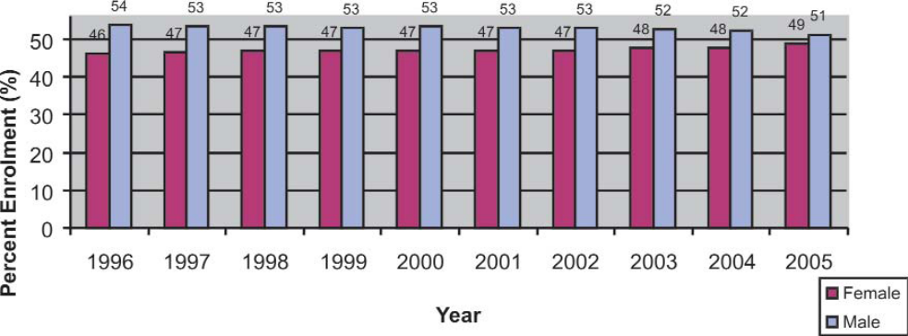
Source: Ministry of Education Sports and Culture.
165. Although statistics still indicate disparities in favour of the boy child, they reveal near parity at all levels.
166. A total of 247,914 children dropped out of school between 1996 and 2004, of whom 126,048 were girls and 121 866 were boys. More girls drop out on account of pregnancy, marriage and failure to pay school fees. The dropout rate seems to be generally low in urban areas, as compared to schools located in rural areas.
(i) Challenges
167. The economic challenges that Zimbabwe is facing have not spared the education sector, as evidenced by the difficulties of maintaining the financial viability of social services.
168. Female students still shun technical subjects and careers which are perceived as the male domain.
169. Misconduct procedures for persons who are involved in acts of sexual harassment do not give school authorities the obligation to report cases to the police. Consequently, perpetrators of sexual harassment may be dealt with administratively, thereby eliminating the possibility of criminal sanctions against them.
(ii) Response
170. The Government formed a Presidential Commission on Education in 1998 and in the course of its work the Commission was expected to focus attention on issues of cost, finance and sustainability, taking into consideration gender equity in all aspects.
171. Plans are underway to introduce Human Rights, Population and Civic Education in colleges, with the hope of eliminating gender stereotyping in the education sector. Teachers are also introduced to gender awareness programmes during and after training.
172. The ministries of labour and education conduct career guidance and counselling in schools with the in terms of emphasis being on breaking gender stereotypes in terms of career choices and professions. The Government introduced the Basic Education Assistance Module (BEAM) to assist disadvantaged children with school fees. A slight majority of the beneficiaries are girl children.
Article 11
Elimination of discrimination against women in employment
173. The Committee recommended that the Government adopts temporary measures of affirmative action to promote the status of women in all sectors, including employment.
1. Constitutional measures
174. As already stated under articles 1 and 2, the constitution contains the principle of non-discrimination that applies to employment as well. Section 14 of the Constitution prohibits forced labour without distinction on the grounds of sex and gender, thus protecting people of both sexes against forced labour.
2. Legislative measures
175. Discrimination in the field of employment is prohibited by law. In particular, the Labour Act [Chapter 28:01] prohibits discrimination, on the basis of gender, at all stages of employment, such as recruitment, selection, working conditions, training and promotion. It is at these stages of employment that most women fall prey to sexual harassment. In a bid to protect women, Section 8 of the Labour Act [Chapter 28:01] and the First Schedule of the Public Service Regulations of 2000 specifically prohibit sexual harassment.
176. While the Labour Act [Chapter 28:01] applies to the private sector, the Public Service Regulation applies to state employees. Both pieces of legislation espouse non-discrimination on several grounds including gender.
177. Thus, reproductive roles such as pregnancy do not prejudice women from employment benefits, as women are entitled to fully paid maternity leave. The Labour Act [Chapter 28:01] has been amended in line with ILO Convention No. 183 on Maternity Protection, which the Government of Zimbabwe is in the process of ratifying. The amendment also increased the duration of maternity leave from 90 days to 98 days.
178. Furthermore, breastfeeding mothers are entitled to at least one hour’s break to nurse the baby during working hours. This is over and above such other breaks as lunch break, to which every other employee is entitled. This benefit is guaranteed for six months or for the period during which a woman is nursing her baby, whichever is shorter.
3. Administrative and other measures
179. In terms of access to health, women in the civil service can benefit from the Government subsidised Premier Service Medical Aid Society Scheme on an equal basis with men. Membership of the scheme is voluntary. The scheme is open to the private sector and plans are underway to expand the scheme to include workers in the informal sector. This will be beneficial to women, the majority of whom constitute the informal sector.
(i) Challenges
180. A woman’s ability to go on maternity leave on full benefits with the same employer is limited to a total of three times. In addition, a woman cannot go on paid maternity leave twice within a period of 2 years. This has not been received well by women, as it is considered to be tantamount to regulating women’s reproductive choices. It is, however, a challenge as the rights of a woman to go on maternity leave more frequently than the periods allowed by the law needs to be balanced with the needs of the employer.
181. There are few women employed in traditionally male dominated careers where there are better opportunities.
182. The Central Statistical Office (CSO) carries out a Labour Force Survey every five years. According to the most recent survey (2004) the figure for those not employed in either the formal or the informal sector is 9.3%. Figure 22 reflects employment by industry and broken down by gender. Women tend to dominate in the agriculture, forestry and farming industries, and the private domestic sector, where salaries tend to be low. Security of tenure in these sectors is not guaranteed, thus making women vulnerable.

Figure 17
Currently employed population aged 15 years and above by industrial sector
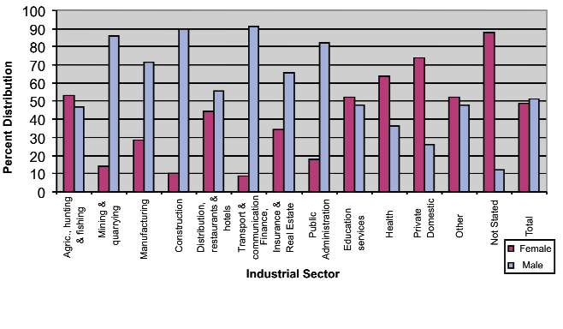Source: 1999 Indicator Monitoring Labor Force Survey: Central Statistical Office (July 2000).
183. The gender disparities in such areas as mining, construction, transportation and communication is reflective of limitations imposed on women to engage in such work associated with societal attitudes and stereotypic perspectives of women, as well as legal impediments. There is no consensus on whether such perceptions and attitudes should be considered discriminatory or positive as they conform to section 23 (5) (b) of the Constitution of Zimbabwe and are alleged to be in the interest of women’s health. Section 23 (5) (b) recognises differential treatment on the ground of sex when such treatment takes due regard of physiological differences. However, this in itself could work against the interests of women, as it can be abused and used to exclude women from certain sectors of employment. It also deprives women of the right to make choices on what they want to do.
184. There is a general lack of supporting social services to enable working mothers to combine family obligations with work responsibilities. Working mothers have to rely on relatives or domestic workers to look after their babies while they are at work as there are generally no facilities for taking care of babies within the workplace.
(ii) Response
185. In line with the recommendations of the Committee, the Government has taken steps to advance the status of women in various sectors, in particular, the following.
(a) Maternal benefit scheme
186. Government is working towards the introduction of a maternity benefit scheme that will remove the burden of paying maternity salaries from the employer. The scheme will also provide for childcare at the workplace and enable breastfeeding during the day.
(b) Career guidance
187. The Ministry of Education, Sport and Culture runs career guidance programmes that encourage girls to take up science and technical subjects. Other ministries complement these efforts through programmes targeting specific areas. The Ministry of Women Affairs, Gender and Community Development runs the Girl Child Empowerment Programme, while the Ministry of Public Service, Labour and Social Welfare runs career guidance schemes in schools.
(c) Promotion of women’s empowerment in entrepreneurial activities
188. The Government has taken a position to establish economic empowerment programmes. This has been strengthened by the establishment of the Ministry of Small and Medium Enterprises, whose mandate is to formulate policy and spearhead the development of small to medium enterprises (SMEs). The Small Enterprises Development Corporation (SEDCO) is the implementing agency of the Ministry. It is a Parastatal mandated to implement the government empowerment policy. Women’s empowerment programmes are part of SEDCO’s initiatives that are aimed at developing these in marginalised communities in both rural and urban areas in order for them to participate in the mainstream economy. Its target is to provide at least 30% of products and services to women entrepreneurs.
189. The Corporation provides business loans and capacity development in such areas as business management and entrepreneurship, as well as business consulting and counselling. SEDCO also assists micro, small and medium enterprises to obtain business shelter. Figure 18 below shows the trend and extent to which SEDCO has funded women’s projects from 1984 to 2006. Women continue to receive less than a third of all SEDCO lending although they comprise the majority of those in the informal and micro enterprise sub sectors.

Figure 18
Funding of women’s projects by SEDCO
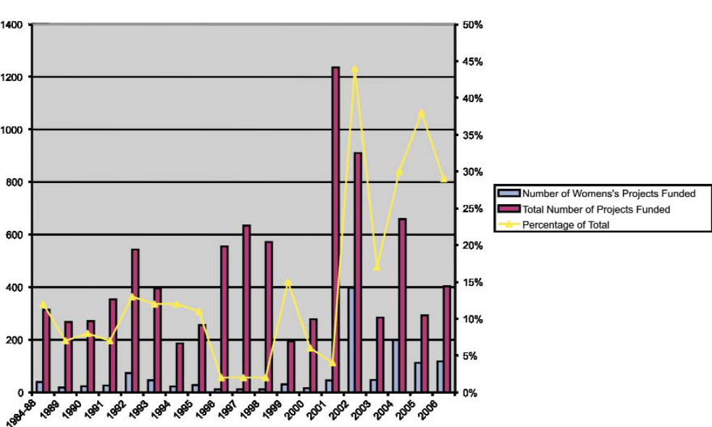
190. A microfinance loan scheme was developed primarily to support the financial needs of SMEs promoted by women entrepreneurs. In 2005, 63% of the microfinance loan portfolio comprised women entrepreneurs, while women comprised 54% of the participants who went through SEDCO management training programmes. The Ministry of Small and Medium Enterprise, in collaboration with the Ministry of Women Affairs, Gender and Community Development, continues to mobilise resources to support women’s entrepreneurship programmes. The Ministry of Women Affairs Gender and Community Development has established a women’s fund to finance income-generating projects for women.
Article 12
Equality in access to health facilities
191. The effect of the HIV pandemic and the high rate of infection among young women were of particular concern to the Committee. It requested the Government to increase its efforts to combat the epidemic and to ensure that appropriate sexual and reproductive health education, information and services are provided to all women, in particular adolescents.
192. The Committee further expressed concern on reports that some healthcare providers denied sexually active adolescents access to family planning services, despite there being no legal restrictions to that effect, and recommended that these adolescents be provided with sex education and family planning services.
193. As a reaction to the statement in the initial report to the effect that illegal abortions were a major cause of death among women in Zimbabwe, the Committee urged the Government to reappraise the law on abortion, with a view to its liberalisation and decriminalisation.
1. Constitutional and legislative measures
194. The principle of non-discrimination, as enshrined in Section 23 of the Constitution, applies to all the people of Zimbabwe. Public institutions and individuals cannot discriminate against women in the field of healthcare. Government continues to make efforts towards ensuring that access to healthcare services, facilities and information is guaranteed for all, despite the absence of specific provision on the right to health.
2. Administrative and other measures
195. The Government, through the Ministry of Health and Child Welfare has adopted a number of policies within the different aspects of health. The Ministry is involved in the funding and supervision of health facilities run by Municipalities, churches and Rural District Councils. It plays a regulatory role with respect to services run by the private sector, including those established by employers.
196. The Government regularly assesses developments in specific sectors of health and devises ways of addressing constraints that such sectors may face, as fully explained below.
(a) Maternal mortality
197. The Ministry of Health and Child Welfare is developing a policy that will reinforce the provision of free healthcare to underprivileged expectant mothers, children under the age of five and older persons over the age of 60 years. However, this is operational in public health institutions only.
198. The Zimbabwe Millennium Development Goals Progress Report of 2004 indicated that maternal mortality continued to be a major problem in national development. In the period 1995–1999 the maternal mortality figures had risen to 695 per 100,000 live births from 283 per 100,000 in live births in the period 1984–1994. The 2005/2006 Zimbabwe Demographic and Health Survey indicates that although there may have been a decrease in this ratio, this difference is not statistically significant, thus confirming concern on the increasing prevalence of an unacceptably high rate of maternal mortality. Several factors were identified as contributing to this situation. The HIV epidemic has increased mothers’ vulnerability. Women in rural areas tend to need to travel long distances to access healthcare services and sometimes fail to do so. Gender inequalities and negative cultural practices continue to limit women’s control over their sexuality and reproductive rights and taking decisions to seek antenatal care.
199. The Government of Zimbabwe continues to provide antenatal, post-natal and family planning services to women at all levels of healthcare services, beginning at the clinic, district, provincial and central hospitals. Expectant mothers are encouraged to attend antenatal clinics where they are provided with advice on antenatal care and nutrition. Both conventionally trained midwives and trained traditional midwives assist in delivery of babies. The traditional midwives are provided with the equipment to use during delivery by the healthcare providers who train them. Furthermore, the Government has declared HIV and AIDS as an emergency to expedite the procurement of antiretroviral and related drugs to mitigate the impact of the HIV epidemic. In 2007, with support and collaboration from the United Nations Development Fund for Women (UNIFEM) and the Joint United Nations Programme on HIV/AIDS (UNAIDS) and the Ministry of Women Affairs, Gender and Community Development, the National Aids Council (NAC) launched the Zimbabwe National Plan of Action on Women and Girls and HIV and AIDS 2006–2010. This seeks to reduce the incidence of HIV and AIDS among women and girls and to improve the quality of life through access to treatment and to mitigate the impact of HIV on them. The Plan also intends to strengthen the capacity for gender responsiveness among institutions/partners and the State on HIV programme planning, management, implementation, and monitoring and evaluation.
(b) Family planning services
200. Implementation of family planning programmes is a national effort that involves the public and private sectors as well as NGOs and United Nations agencies such as UNICEF and UNIFEM also actively support family planning initiatives. The Zimbabwe National Family Planning Council (ZNFPC), a parastatal in the ministry of health, has the mandate to coordinate all family planning activities and ensures the provision of good quality family planning services, information and education. ZNFPC has successfully piloted a number of innovative approaches to inseminating family planning and other reproductive health messages to adolescents and women.
201. ZNFPC has also initiated male motivation projects to promote joint family planning and decision making in order to increase knowledge of family planning methods among men and women of reproductive age. This was designed to remove the dominance of men in making fertility and family planning decisions.

Figure 19
Contraceptive methods used by women
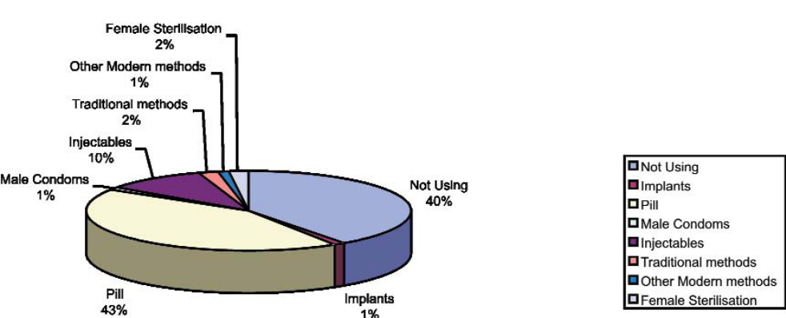
202. Figure 19 above demonstrates the use of specific contraceptive methods among currently married women. It shows that the use of modern family planning methods has more than doubled to 58% in 2005–06. A campaign has been launched to encourage the use of the female condom, to enhance women’s capacity to protect themselves against unwanted pregnancies and sexually transmitted infections.
(c) Women and HIV and AIDS
203. From the recording of the first HIV case in 1985, the rate of infection increased so that, by the year 2000, 2.3 million people were infected and the prevalence rate was recorded at 34%. The prevalence rate dropped to about 20% in 2005 and to about 18% in 2006. Among women age 15 to 49 the HIV rate was 21%, compared to 15% among men aged 15 to 49.

Figure 20
HIV-prevalence by gender
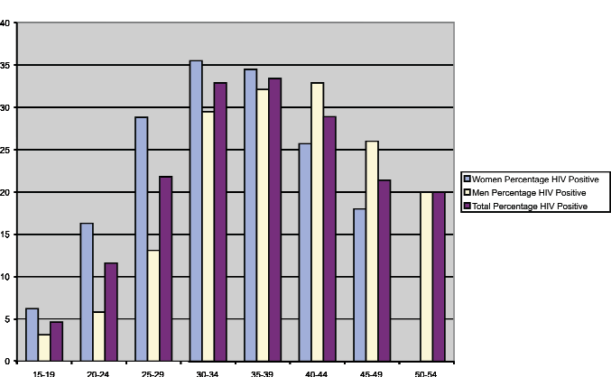
Source: Zimbabwe Demographic and Health Survey (2006).
204. Information from NAC states that married women and those women in long-term partner relationships are more vulnerable to HIV infection as they are not in a position to negotiate for safe sex. The use of condoms and faithful behaviour in marriage are not normal practices and multiple sexual partnerships are more tolerated for men than women. The 2005/06 Demographic and Health Survey revealed an average prevalence rate among young people of age 15 to 24 of 11.25% among females and 4.45% among males. Other studies show that young women make up almost 80% of all infections in the 15 to 24 years age group. High levels of inter-generational sex, exploitative and unequal sexual relations and sexual violence account for this situation. This is compounded by gender related socioeconomic factors, such as customary norms and practices, higher levels of poverty among women, their limited access to, control and ownership of economic resources and opportunities, and the overall low status of women and girls.
205. Women experience a higher level of vulnerability to HIV infection and also bear the brunt of the impact of HIV and AIDS. They carry a disproportionate burden for caring and providing support for their sick husbands, their chronically ill children, relatives, community members and orphans through home based care among other methods. Women constitute more than 95% of all the care givers involved in home based care. As a result of the realisation that only women were being trained as caregivers, NAC and other partners (referred to under Article 5), are training men to get involved in home-based care.
206. The Government has put in place mechanisms to combat the epidemic that include the establishment of NAC through the National Aids Council of Zimbabwe Act [Chapter 15:14], which is charged with the responsibility of designing and implementing the national response to HIV and AIDS.
207. Zimbabwe’s National HIV/AIDS Strategic Plan 2006–2010 recognises the contribution of gender roles and relationships to women’s vulnerability to HIV. The Strategic Plan, therefore, seeks to mainstream gender in all HIV programmes to redress the vulnerability of women and girls to HIV. The Council has initiated programmes to build the capacity of its staff and that of its partners to mainstream gender in all their interventions. These efforts are now augmented by the National Plan of Action on Women and Girls and HIV and AIDS 2006–2010 referred to above. These initiatives demonstrate the efforts by the Government of Zimbabwe, its partners and civil society organisations to reduce not only women and girls’ vulnerability to HIV but also the concomitant care burden they carry.
208. As of March 2006, NAC has provided antiretroviral drugs (ARVs) to Government referral hospitals and other identified sites, enabling the Government to put more people on treatment, as over 300,000 people are in need of medication. Although not distributed free of charge, the drugs were accessed at a nominal charge per month. Around 20,000 people are currently benefiting from the Public Anti-Retroviral Therapy Programme, while 6,000 access the drugs privately. As of August 2007, however, the nominal charge on the public ARVs programme was waived, hence enabling more people to access the drugs.
(i) Challenges
209. The current economic challenges being faced by the country have not spared the health sector.
210. Zimbabwe is facing resource constraints in terms of human, material and financial resources. The shortage of foreign currency has made it particularly difficult for NAC to purchase ARVs. On the other hand, the health sector, in particular, continues to experience brain drain occasioned by unattractive conditions of service and the decline in wages. The current economic climate has also increased poverty levels, resulting in more HIV-related vulnerabilities.
211. Although women and men in Zimbabwe have equal rights to family planning services, girls under the age of years do not have access to these family planning services because having carnal knowledge of children under the age of 16 is considered as statutory rape. Any provision by ZNFPC of family planning services to such people will, therefore, contradict the law on statutory rape. A considerable number of girls under the age of 16 years are married under customary law. While the Marriage Act [Chapter 5:11] sets 16 years as the minimum age for marriage to ensure that a child below the minimum age can only be married with the permission of the Minister of Justice or a Judge of the High Court, customary law does not set a minimum age for marriage. Society has tended to avoid seeking such permission and opted for customary law marriages. Young women involved in such marriages do not often get access to contraceptives because of their age and, therefore, cannot freely exercise their reproductive rights.
(ii) Responses
212. The Government is in the process of regulating youthful marriages to ensure that children of both sexes cannot marry before the age of 18 years, which is the legal age of majority.
213. In the fight against the AIDS pandemic, NAC has worked in partnership with such United Nations Agencies as UNICEF in securing the necessary foreign currency to access the drugs. In order to manage the further spread of the epidemic, ZNFPC is integrating family planning services with STI/HIV and AIDS programmes.
214. In addition, NAC initiated efforts to mainstream gender in its programmes and has come up with a draft gender policy to guide its operations.
215. Information on HIV and AIDS is communicated to women and girls by service providers including community-based distributors and information, education and communication (IEC) officers who are trained in STI or HIV counselling. ZNFPC launched the ‘Promotion of Youth Responsibility’ project in 1997. This was a campaign targeted at young people (10 to 24 years) to promote responsible sexual and reproductive behaviour. ZNFPC also publishes information on use of condoms through electronic and print media.
216. Consideration will be made to undertake a study to establish the reasons for the slow reaction to information, in terms of behavioural change, while efforts continue to be made in disseminating information on HIV. The Ministry of Education, Sport and Culture has added lessons on HIV to their curriculum. This initiative aims at instilling a culture of HIV prevention within young people to avert new infections. As a matter of policy, Government now provides free condoms and regular sector HIV and AIDS-awareness training. Civil servants have access to condoms in their toilet facilities.
Article 13
Elimination of discrimination against women in other areas of economic and social life
217. The Committee requested the Government to utilise its General Recommendations in order to adopt measures targeted at advancing the status of women, thereby implementing such measures effectively.
1. Economic empowerment
218. The need to redress economic deprivation and poverty experienced by women emanating from gender disparities that create women’s limited access to, control and ownership of economic resources and opportunities and participation in decision-making processes has increasingly become central to achieving gender equality and women’s empowerment. The poverty levels are higher among female-headed households, estimated at 72%, than in male-headed households, at 58% (see figure 21).

Figure 21
Poverty by gender of head of household (1995)
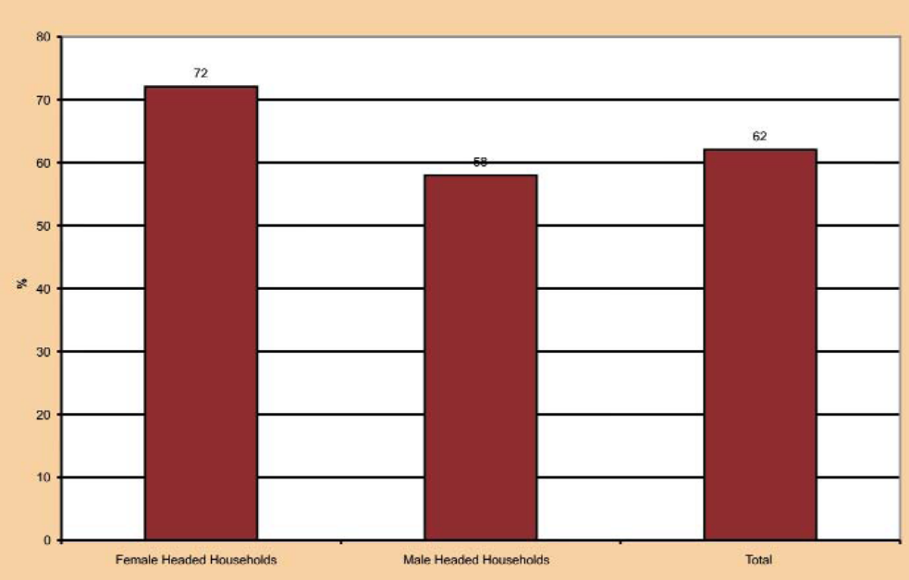
Source: Zimbabwe MDG Progress Report (2004).
219. In the A1 model, where the land allocated is less than ten hectares, more women (17%) were allocated land than those allocated land in the larger A2 model, where only 12% of all land allocations were made to women.
220. This is despite the fact that Government had set aside a 20% quota for women under the Fast Track Land Reform Programme and that Section 23 (3) (a) of the Constitution provides for the equal treatment of women and men in the allocation or distribution of land, as well as other rights and interests under any land reform programme. Generally access to and security of tenure for land for women is precarious in all types of land tenure systems in Zimbabwe. In communal areas, where the majority of women reside in Zimbabwe women have secondary use rights through their husbands. In small-scale commercial areas very few women own land in their own right. The farms tend to be taken over by sons when the male head of the household dies. This prevailing situation causes great concern considering that women are the cornerstone of agricultural production, especially in relation to food security at household level.
221. Women in rural areas own fewer productive assets than their male counterparts, as shown in figure 22, the facts in this figure confirm the established fact that women have limited access to, control over and ownership of economic resources and opportunities.

Figure 22
Ownership of assets by gender
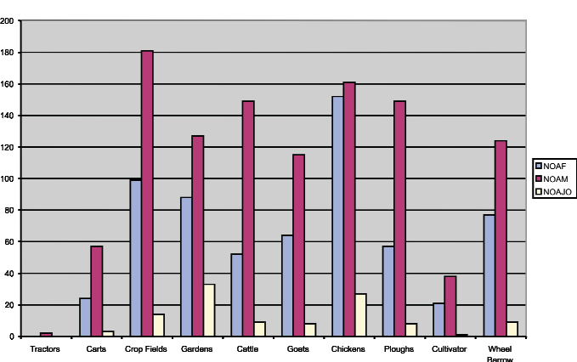
Source: Zimbabwe MDG Progress Report (2004).
Key: NOAF – Number of Assets Owned by Females.
NOAM – Number of Assets Owned by Males.
NOAJO – Number of Assets Owned Jointly.
222. Over the past 22 years the Small Enterprise Development Corporation (SEDCO) has been providing financial support to micro, small and medium-scale enterprises. However, consistently fewer women than men have benefited from this support, with an average of 14% over the years. In another facility offered by the Reserve Bank of Zimbabwe in 2006, intended to bolster production in small to medium-scale enterprises, women had accessed nearly 44% of the total amount allocated to this scheme by August 2007. Women continue to receive less financial support even in sectors where they dominate, such as in the informal sector, micro and small scale enterprises and agricultural production, where they outnumber men as laborers in the formal agricultural sector. They constitute the majority of subsistence food producers in Zimbabwe and contribute 70% of household and family labour in rural communities where they comprise 86% of the population. In the 2008 National Budget, the Ministry of Finance allocated some funds for women and youth in order to enhance the economic empowerment of these groups.
(a) Constitutional measures
223. The Constitution of Zimbabwe aims to promote the economy through the use of land, as Zimbabwe is an agro-based economy. To this end section 23 (3) (a) of the Constitution provides for the equal treatment of women and men in the allocation or distribution of land, as well as other rights and interests under any land reform programme.
(b) Legislative measures
224. The Immovable Property Prevention and Discrimination Act [Chapter 10.12] prohibits discrimination in respect of disposal of immovable property. This Act further prohibits financial institutions from perpetuating discrimination on the grounds of sex, among others grounds, by refusing to grant loans or other financial assistance for the acquisition, hire, construction, maintenance or repair of any immovable property, to people of a particular sex.
225. There are other pieces of legislation, such as the People’s Own Savings Bank of Zimbabwe (POSB) Act [Chapter 24:22] and Building Societies Act [Chapter 24:02], that do not discriminate against women’s independent rights as depositors. While the POSB Act is gender neutral, section 18 of the Building Societies Act specifically recognises women as potential independent depositors and denies male spouses who are also members of a particular Building Society the opportunity to demand from the society any particulars regarding the shares their spouses hold or the deposits they have made with that society, unless women provide their written consent. Legally, women of any marital status can procure loans from financial institutions for investment purposes and to purchase immovable or other forms of property.
(c) Administrative and other measures
226. Government works with civil society organisations involved in the economic empowerment of women in order to implement empowerment policies.
227. The Government provides loans to viable women projects through the Women’s Fund and the Community Development Fund, which is administered by the Ministry of Women Affairs, Gender and Community Development.
228. In 2006, the Government availed a loan facility for women’s developmental projects. While some of the banks still require collateral in the form of immovable property, others consider the value of household effects, as a sufficient form of collateral. This addresses the challenge faced by women who do not own immovable property.
(i) Challenges
229. Although financial institutions are prohibited from discriminating against women in granting loans, many women continue to be disadvantaged because they lack collateral security emanating from their weak economic position. Women also lack relevant skills in business management.
2. Elimination of discrimination in women’s social life
(a) Constitutional and legislative measures
230. The Constitution does not make provision for social rights. However, legislation on sporting activities does recognise the promotion of women in their social lives.
231. The Sports and Recreation Act [Chapter 25:15] establishes a Sports Commission, among whose objectives is to ensure that opportunities for sports and recreation are made available to all persons throughout Zimbabwe. The regulations made in terms of the Act empower persons aggrieved by specific sporting clubs to appeal to the national frameworks for the sport. A person who is not satisfied by the decision of the national framework may then appeal to the Sports and Recreation Board, a mechanism falling under the Sports and Recreation Commission.
(b) Administrative and other measures
232. The Sports and Recreation Commission has initiated a programme on “Women in Sport”, designed to create opportunities for women to participate in sport at all levels, including decision-making. The programme advocates for the inclusion of women in leadership structures in sport.
233. In order to ensure that women participate effectively in sport at all levels, the Commission conducts training sessions for women in the areas of tuition and coaching in various sporting disciplines. Furthermore, it conducts awareness programmes at the district level. This includes the creation of a safe space and environment to ensure women at community level participate through community clubs. An awareness programme at the national level was conducted in September 2007. Sporting organisations have introduced formally male dominated sports to women as well, such as hockey, cricket and soccer. However, male dominated sporting activities receive more public attention than those of women. There are negative cultural attitudes towards women’s involvement in sport, particularly if it is on a full time basis.
Article 14
Rural women
234. The Committee expressed concern over the continued adherence to customary laws, as this perpetuates discrimination against women, in particular within the family context. It identified women in rural areas as being particularly vulnerable to negative attitudes and discriminatory traditional practices. The Committee further noted that women in rural areas work longer hours than any other group.
1. Administrative and other measures
235. The welfare of women living in rural areas in Zimbabwe is addressed through policies, rather than legislative pronouncements. However, the principle of non-discrimination enshrined in the Constitution applies to everyone, including rural women. Generally in Zimbabwe, about 65% of women live in the rural areas and are actively involved in the development of their communities through public works programmes and other community development projects, such as market gardening and subsistence farming. The Government and other development agencies initiate and support these activities.
(a) Access to health facilities
236. The Government has decentralised health institutions to ensure that people living in rural areas access medical care. To this end, Government health institutions are established at rural, district and provincial levels. It has specific structures and personnel that run its programmes in rural areas, such as the Village Health Worker.
237. To complement Government efforts, religious organisations have also established mission hospitals in many rural settings. As stated under article 12, the Ministry of Health and Child Welfare funds and supervises all public health facilities. The supervisory role also extends to privately run facilities.
238. A policy is now in place to ensure that all children under the age of 5 years and expecting mothers receive free medical care. In the area of family planning, products offered by the Zimbabwe National Family Planning Council (ZNFPC) are distributed at community level. ZNFPC personnel, referred to as, Depot Holders also carry out education and counselling programmes on STIs, including HIV.
(b) Gender-based violence and rural women
239. Gender-Based Violence awareness programmes are held for rural women through the grassroots structures of the Ministry of Women Affairs, Gender and Community Development in collaboration with women’s NGOs. Awareness campaigns target traditional leaders and other opinion leaders. As discussed under articles 2 and 15, Parliament passed a law on domestic violence, which received Presidential assent in February 2007.
(c) Status of orphans and vulnerable children in rural areas
240. Government developed an orphan care initiative, namely the National Action Plan for Orphans and Vulnerable Children (NAP for OVC), in response to the HIV pandemic, the prevalence rate of which now stands at about 18% and has left an estimated 761,000 orphans in its wake. The Action Plan aims to offer basic services to affected children. The Government, in partnership with UNICEF undertook a survey on the situation of OVC in rural and urban high-density areas in December 2005, to establish a basis for monitoring their situation. Among other things, the survey established that OVC are twice as likely to drop out of school. As compared to one-third of male-headed households, the survey also revealed that two thirds of female-headed households care for one or more OVC, indicative of the concentration of social responsibilities on rural women.
241. The Zimbabwe Demographic and Health Survey (ZDHS) also established that maternal orphans were less likely than paternal orphans to be living together with all siblings under 18 years of age and that female teenage orphans may be more frequently at risk of early sexual activity than male teenage orphans. Maternal orphanhood has been identified as a prime factor in this regard. All these factors demonstrate the gendered conditions and experiences of OVC with female OVC tending to be worse off than their male counterparts. The National Gender Policy, the National Plan of Action on Orphans and Other Vulnerable Children, the National Gender-Based Violence Strategy and the National Strategic Plan for the Education of Girls and other Vulnerable Children seek to address some of the gender issues in the national response to the OVC situation.
(d) Access to education and entrepreneurship programmes
242. The Ministry of Education, Sport and Culture has established various schools in rural areas. There is near gender- parity in enrolment for girls and boys in rural primary schools. Statistics to this effect are contained under Article 10. It also runs adult literacy programmes for rural women and the majority of beneficiaries are women.
243. Women also participate in various educational programmes undertaken by other Government Ministries and NGOs. In particular, Government has established a training centre for rural women, run with the support of the United Nations Children’s Fund (UNICEF). The Ministry further established self-help projects at the grassroots level to cater for marginalised women, who are mainly aimed at the alleviation of drought induced hunger in rural areas.
(e) Access to land, safe water and energy
(i) Land
244. As stated under article 13, the Constitution guarantees women’s access to resettlement land on an equal basis with men. In terms of section 23(3a), the Government shall treat men and women on an equal basis with respect to the allocation or distribution of land, including rights and interests accruing from it, regardless of whether or not such persons subscribe to customary law.
245. Government, through the Agricultural Research and Extension Services (AREX) Department continues to provide valuable advice on viable production to new women farmers. The Agricultural Development Bank (Agribank) is also funding agricultural activities for women.
(ii) Water
246. The Government introduced the Integrated Rural Water Supply and Sanitation Programme (IRWSSP) to spearhead provision of clean water, through construction of boreholes, piped water schemes and protected wells in rural areas, and reduction of walking distance for women and children who are the most often engaged in carrying water.
247. The Government has also started a project on a Water Resources Management Strategy (WRMS). The project is concerned with the equitable distribution of water to the mining, farming and domestic sectors in rural areas. At the community level Water Point Management User Committees have been established. In recognition of the fact that women are the main users of the water, 60% of members on the Committees are women. Planning of all programmes is done at the village level by the Village Water and Sanitation Sub-Committees, which include women.
248. Capacity building programmes that are run under the Management Strategy include hygienic use of water and gardening at the water points. Consideration has also been taken of the extra demand for safe water and sanitation in home based care facilities for HIV and AIDS patients. In infrastructural training programmes, women always comprise not less than a quarter of trainees. Programmes include latrine building, village pump mechanics and well sinking.
(iii) Energy
249. The Government has established the Rural Electrification Agency to embark on the rural electrification programme. The programme has since resulted in a substantial number of rural households, and service centres being electrified. The programme targets such institutions as schools, business centres, Government extension offices, chiefs’ homesteads, small-scale farms, villages, and irrigation schemes, borehole and dam points. A total of 5 124 sites had been electrified as of March 2006.
250. The electrification programme has opened opportunities for rural women to engage in income generating projects. It has also improved the services of health facilities, as 67.5% of rural health centres were electrified by March 2006. A study conducted by the Rural Electrification Agency revealed that electricity use by rural women, especially poor rural women, is currently low. Areas of benefit to women were, however, identified as follows:
- Reduction of labour in water collection by energising water pumping
- Saving of women’s time and labour spent in cooking, and agricultural processing such as grain, grinding, sorghum hulling and peanut butter making
- Improving security and women’s ability to participate in community and school activities at night
- Making women’s domestic work easier and improving the productivity of women’s income earning work through home and commercial lighting, refrigeration and key appliances like irons, electric kettles and hair dryers and
- Enhancing women’s and family social capital, in health and or education
251. A system has not yet been put in place to collect sex disaggregated data.
(iv) Challenges
252. As is the case with urban areas, men play a dominant role in making fertility and family planning decisions, thus restricting women’s ability to make their own reproductive choices.
253. Discriminatory tendencies that may be brought about by customary law affect rural women more than their urban counterparts since customary law largely governs them. Although the extended family system still exists, it is fast disintegrating due to poverty, high unemployment levels, urbanisation and the HIV pandemic. This has seen the emergence of child-headed households. Housing in the rural areas has not improved much as people still build their own houses.
(v) Response
254. The Zimbabwe National Family Planning Council also runs promotion programmes aimed at encouraging joint family planning and decision-making between women and men in rural areas.
255. The Government has established the Ministry of Rural Housing and Social Amenities to oversee programmes on rural housing. The Ministry has District Officers in all rural areas in order to ensure that all persons requiring housing have access to it. Families, widows and people living with disabilities are given particular recognition. Financing is provided through the Ministry’s district and ward structures and repayments to the Ministry are commenced upon completion of the housing units. However, the level of financing is reduced if the applicants supply adequate labour and such other building material as river sand. The Ministry supplies the other building material.
256. In order to try as far as possible to bridge the gap between rural areas and urban areas in terms of housing structures, a model house has been build in each province to ensure that all construction meets the standards of the model house. There are also initiatives by some NGOs, like Habitat Zimbabwe, to assist rural populations to build affordable and modern houses on their property.
Article 15
Equality before the law
1. Constitutional and legislative measures
257. The non-discrimination clause under the Constitution guarantees the equality of women and men. The prohibition of discrimination on the grounds of sex and gender legally places women on an equal level with men. Section 18 of the Constitution entitles every person to the protection of the law.
258. As discussed under articles 2, 4, 7, 11 and 13, women have the same legal capacity as men in civil and all other matters. Access to facilities such as courts of law, tribunals or other adjudicating authorities is guaranteed on an equal basis, regardless of the capacity in which women appear. The decision to enshrine affirmative action under the Constitution has the effect of ensuring that women have the same opportunities as men to exercise the legal capacities. Under Article 9, this Report discusses legal measures that have been taken to ensure women have the same rights as men to acquire and retain citizenship. The Legal Age of Majority Act remains effective.
(i) Challenges
259. The effect of Section 23 of the Constitution on the equality of women and men under customary law is still a matter of concern, as can be seen from the Supreme Court decision in the case of Magaya vs. Magaya SC 210 of 1998, which has been fully discussed under Article 2. Women’s fair representation in court can generally be hampered by the difficulties in obtaining legal representation.
(ii) Response
260. The Government has taken a gradual approach towards the eradication of discriminatory tendencies under customary law. Parliament has amended and enacted legislation that outlaws harmful cultural practices that have been identified as perpetuating discrimination against women. As stated under Article 2, the Criminal Law (Codification and Reform) Act [Chapter 9:23] and the Domestic Violence Act [Chapter 5:16], both prohibit harmful cultural practices. The Domestic Violence Act [Chapter 5:16] introduces the concept of counselling in order to afford persons affected by domestic violence in one way or another, opportunities to express their views and concerns to persons other than judicial officers. Perpetrators of domestic violence can be ordered by the court to undergo counselling. This will reinforce the principle of equality in the home environment. The Act also establishes the Anti-Domestic Violence Council that will monitor the problem of domestic violence through such means as research. Government’s efforts to effectively implement the National Gender Policy will lead to the monitoring of the effectiveness of existing laws, thereby causing amendment or enactments of laws that promote equality between women and men.
261. In 1996, Parliament enacted the Legal Aid Act to provide for the establishment of the Legal Aid Directorate. The main function of the Directorate is to provide legal aid to indigent persons. The services offered by the Directorate range from civil to criminal matters. Currently, the offices of the Directorate are based in Harare. However, the Government has allocated financial resources for purposes of decentralisation. These efforts are complemented by civil society organisations that offer free legal services to women in specific areas of need. It is, finally, anticipated that the establishment of the National Human Rights Commission will place women’s rights on a wider agenda.
Article 16
Equality in marriage and family law
262. As stated under Article 14, the Committee was concerned about the continued adherence to customary laws in relation to the family environment. The Committee was of the view that Customary Law perpetuates discrimination against women.
1. Constitutional measures
263. Section 23 of the Constitution prohibits all forms of discrimination, including discrimination based on one’s marital status.
2. Legislative measures
264. The Marriage Act [Chapter 5:11.] does not require either intending spouse to obtain parental consent to the marriage. Section 14 of the Act requires all persons desiring to marry to apply for a notice of intention to marry stating their full names and ages. The fact that both parties should sign the application to marry legally equates their status. Furthermore, Section 94 of the Criminal Law (Codification and Reform Act [Chapter 9:23]) prohibits the intimidation or compulsion of female persons to enter into marriages against their will.
265. As undertaken in the initial report, the Administration of Estates Act was amended to ensure that spouses in any type of marriage could inherit from estates of their deceased spouses. The surviving spouse inherits the matrimonial home, and the goods and effects in it. In the case of polygamous marriages, the estate is shared between the surviving spouses and the children of the deceased in proportions which are specified in the Act. In terms of section 68F, children of a deceased person are entitled to inherit two-thirds of the net estate, while surviving spouses share the one-third at a ratio calculated according to seniority, in favour of the senior wife. Prior to the enactment of the Act, a woman married under civil law could inherit from her husband’s estate since a civil marriage recognizes spouses as equals. The same did not apply to women married under customary law. As stated under paragraph 1(g) of the initial report, inheritance rights under customary laws accrued, as a first preference, to the male heir.
266. The three types of marriages discussed under the initial report still exist. However, the proposed amendments to the Marriage Laws will have the effect of according spouses in any type of marriage equal rights. The amendments will also enhance the enjoyment of the improved inheritance laws, which enjoyment has been negatively affected in some instances, by the ranking of the different types of marriage in the order of superiority.
267. Although the Domestic Violence Act [Chapter 5:16] is not limited to violence against women, the Government is cognisant of the fact that women are more vulnerable to domestic violence than men. Government deliberately made the Act to apply generally, in order to deal with the root causes of domestic violence, rather than its symptoms. It is against this reality that violence committed in the presence of children is considered as violence against such children. It is anticipated that, while section 3 (2)(c)(iv) will have the effect of protecting children from the mental injury that may be caused by witnessing incidences of violence, it will have the long-term effect of cultivating a violence free culture in children. This could result in protecting women from the double impact of domestic violence on them and their children.
3. Administrative and other measures
268. In order to ensure the effective operation of the Administration of Estates Act, the Ministry of Justice, Legal and Parliamentary Affairs carried out the Wills and Inheritance Programme, with the financial support of the Department of International Development Central Africa in the year 2000. The main objective of the programme was to take the inheritance laws to the people and ensure that they were effectively utilised. The programme involved several NGOs, which conducted nationwide awareness campaigns. The campaigns included the publication and distribution of literature both in print and electronic form.
269. As regards the effect of non-registration of marriages, women married under the unregistered customary law no longer are so prejudiced where the sharing of matrimonial property at separation is concerned. The courts have passed a number of judgments that recognise tacit universal partnerships. In the case of Chapeyama vs. Matende & Another 2000 (2) 356 (s), the spouses had been married under customary law in 1990 and two children were born of the marriage. During the subsistence of their marriage, they acquired several properties jointly, including a house registered in both their names. Upon the breakdown of the marriage, the husband made an application to court to have the wife’s name removed from the deed of assignment. The wife counter claimed for a fair distribution of all asserts in the house. The High Court decided in favour of the wife, holding that the application of the concept of a tacit universal partnership was fully justified. In dismissing the husband’s appeal, the Supreme Court recommended a review of marriage laws to specifically recognise unregistered customary law marriages, as was done under the Administration of Estates Act.
(i) Challenges
270. As already stated, the protection of customary law under section 23 of the Constitution exacerbates discrimination against women in matters of personal law.
271. The difference in the minimum age of marriage at 16 years for girls and 18 years for boys also results in discrimination against girls, as they are exposed to marriage at an earlier age. Furthermore, the maintenance of the age of 16 as the minimum age of sexual consent under the Criminal Law (Codification and Reform) Act [Chapter 9:23] may negate the efforts being made to harmonise the minimum age of all the types of marriage with the legal age of majority, as girls will be exposed to sexual activity much earlier than they are entitled to marry.
(ii) Response
272. As discussed under Article 2, the Government, through the Ministry of Justice, Legal and Parliamentary Affairs, is in the process of reforming marriage laws in order to harmonise their application. It is envisaged that parental consent will not be a requirement to any type of marriage and this would be in line with the legal age of majority. The marriageable age will also be harmonised to apply to both female and male intending spouses.
III. Conclusion
273. Zimbabwe continues to make efforts towards removing discrimination against women by the enactment of the necessary legislation and policy frameworks, the development and implementation of programmes and projects, the creation of partnerships with national and multinational organisations and the establishment of a national machinery to address issues of gender inequality and women’s empowerment in society. The Government is also a signatory to and has ratified several regional, continental and global instruments that not only seek to further define discrimination against women, but also commit the Government to take measure to address gender issues in national socioeconomic development.
274. Discrimination against women is defined in the process of interpreting the constitutional and legal provisions that prohibit discrimination on the grounds of sex, gender and even marital status. The absence of a specific legal provision defining discrimination against women does not, therefore, hinder the identification of discriminatory practices. However, the need to expressly define discrimination against women in the legal framework cannot be ignored.
275. By enshrining a non-discrimination clause in the Constitution that specifically prohibits discrimination on the grounds of gender, sex or marital status, the Government has set a platform for the development of both legal and administrative measures to further eliminate discrimination against women. The effective implementation of the National Gender Policy and its concomitant Implementation Strategy will not only complement but also enhance these efforts. The amendment of the Interpretation Act to remove the use of language that denotes either the feminine or the masculine gender will go a long way in legally recognising women and men as equals. On the ground, the application of affirmative action will ensure that women and men are treated equally in all aspects of life. In sectors such as education and the Public Service, inroads have already been made to advance the status of women. Programmes such as rural electrification and housing have already had an impact towards the inclusion of rural women in economic and social development.
276. As the family could be identified as the main origin of all forms of discrimination against women, it is anticipated that the amendment to the Constitution and the enactment of such laws as the Domestic Violence Act [Chapter 5:16] and the Criminal Law (Codification and Reform) Act [Chapter 9:23] will cultivate a culture of equality between women and men.
277. The Government, through CSO, has already started to compile Gender Disaggregated Data (GDD) to facilitate the monitoring of the situation of women in Zimbabwe. These efforts, however, still need to be extended to all sectors of society to ensure that a clear picture of the situation of women is adequately portrayed in official statistics. Despite these significant efforts to eliminate discrimination against women in Zimbabwe, this report has demonstrated that a lot more still needs to be done to enhance the status of women and improve their quality of life in general. Gender inequalities and imbalances continue to manifest themselves in several sectors. In politics and decision-making women continue to lag behind their male counterparts, despite the commitment of the Government to get women to at least 30% representation. Women have consistently owned less than 20% of land since 1980 despite efforts through legislative and administrative measures to ensure that women and men have equal and/or equitable access to control over and ownership of land over the years. Furthermore, women continue to bear the brunt of the HIV pandemic. They not only continue to be disproportionately infected by the virus, but they also bear the brunt of the impact of the HIV epidemic as they carry a disproportionate share of the burden of caring for their ill relatives and those sick members of the community through home based care. All this is done with little or no remuneration. Women and girls constitute the majority of the victims of gender and domestic violence and sexual abuse.
278. It is in recognition of the need for continued and sustained efforts to address these and many other forms of discrimination against women that the Government of Zimbabwe has adopted the National Gender Policy Implementation Plan, the Zimbabwe National Plan of Action on Women and Girls and HIV and AIDS (2008–2010), the National Gender-Based Violence Strategy, the National Strategic Plan for the Education of Girls, Orphans and Other Vulnerable Children amongst others. It is hoped that theses strategies will play a leading role in addressing the concerns on the elimination of discrimination against women in Zimbabwe in the medium term.
References
Administration of Estates Act [Chapter 6.01]
African Union Solemn Declaration on Gender Equality in Africa, 2004
Comprehensive Review of Behavioral Change as a Means of Preventing
Sexual HIV Transmission in Zimbabwe, 2006
Constitution of Zimbabwe, Revised Edition 1996
Constitutional Amendment No. 18 of 2005
Constitutive Act of the African Union
Counter Trafficking Handbook for Law Enforcement Officers in Southern Africa
Criminal Law (Codification and Reform) Act [Chapter 9:23]
Domestic Violence Act, 2006
Gender and HIV/AIDS: An Analysis of Zimbabwe’s National Policies and Programmes on HIV/AIDS/STIs by the Zimbabwe Women’s Resource Centre and Network, 2003
Khan, Naira (2005) Perfect Crimes: Sexual Harassment at the Work Place in Zimbabwe
Ministry of Water Resources and Infrastructural Development, October 2007
National Census Report of 2002
National Gender Policy
National Gender Policy Implementation Strategy 2007–2010
Progress Report to the United Nations on the Millennium Development Goals (MDGs), 2004
Protocol to the African Charter on Human and Peoples’ Rights on the Rights of Women in Africa
Rural Electrification Agency, June 2007
SADC Declaration on Gender and Development of 1997
Tsanga, A.S., Taking the Law to the People
UNDP, Evaluation Report of the Women in Politics and Decision-Making Project, Harare, November 2000
Zimbabwe Demographic and Health Survey, 2005–2006
Zimbabwe Millennium Development Goals, 2004 Report
Zimbabwe National Plan of Action on Women and Girls and HIV and AIDS 2006–2010

* * In accordance with the information transmitted to States parties regarding the processing of their reports, the present document was not formally edited before being sent to the United Nations translation services.
? 11 July 2000.
? July 2004.
? 3 July 2003.
? The SADC Declaration on Gender and Development of 1997.
? Constitutional Amendment 17 of 2005 brought about the prohibition of discrimination on the ground of sex.
? Zimbabwe Millennium Development Goals, 2004 Report, page 17.
? The National Gender Policy, page 2.
? A.S. Tsanga, Taking the Law to the People, Weaver Press.
? Perfect Crimes: Sexual Harassment at the Work Place in Zimbabwe by Naira Khan 2005.
? Zimbabwe Demographic and Health Survey, 2005–2006.
? The National Gender Policy Implementation Strategy 2007–2010.
? The National Gender Policy, page 2.
? A Counter Trafficking Handbook for Law Enforcement Officers in Southern Africa.
? IOM Training Manual and facts sheet.
? African Union Constitutive Act, Articles 3(i) and 4(i).
? Zimbabwe Demographic and Health Survey, 2005–06, page 239.
? Zimbabwe National Plan of Action on Women and Girls and HIV and AIDS 2006–2010, page IV.
? Zimbabwe National Plan of Action for Women and Girls and HIV and AIDS 2006–2010, page 2.
? Zimbabwe National Plan of Action for Women and Girls and HIV and AIDS 2006–2010, page 2.
? Zimbabwe Millennium Development Goals: 2004 Progress Report, page 17.
? Comprehensive Review of Behavioural Change as a Means of Preventing Sexual HIV Transmission in Zimbabwe, 2006.
? Source, Ministry of Water Resources and Infrastructural Development, October 2007.
? Source: Rural Electrification Agency, June 2007.

