http://www.bangkokpost.com/opinion/opinion/252067/a-changing-migration-landscape-for-thailand
Opinion > Opinion Published: 16/08/2011

FOREIGN LABOUR

A changing migration landscape for Thailand
In 2009, Thailand imposed a February 2010 deadline for 1.3 million registered migrants from Burma, Cambodia and Laos who originally entered the country “illegally”, to complete nationality verification (NV) and become fully “legal.” Those missing this deadline were threatened with deportation.
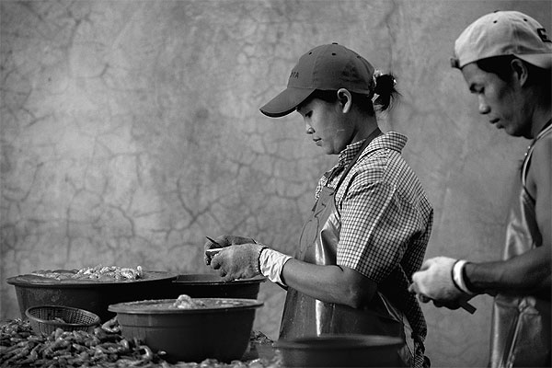
Picture: Migrants from Burma work at a shrimp factory in Mahachai on the outskirts of Bangkok. Thailand needs to address its migration challenges in inclusive and rights-centred ways.
Few workers had completed NV a month before this deadline due to fear, lack of information, unregulated broker costs and confusion. The cabinet then affirmed the deadline but changed the rules. Migrants had to enter NV by February 2010 but completing the process would be extended until next year.
Over 930,000 migrants met the NV deadline but 300,000 fell through the net. Given a million undocumented migrants were already in the country but not entitled to enter NV, just over 17 months ago the majority of migrants in Thailand were undocumented.
An abusive and untransparent crackdown that followed the NV deadline saw migrants spinning into circles of arrest and extortion coupled with deportation abuse in Ranong province and in Mae Sot district of Tak. This all rapidly brought increasing global attention to the suffering of migrants in Thailand.
Migration management had failed to ensure that migrant regularisation, planned for more than a decade, was achieved. Migrant rights protection lagged far behind international standards and domestic law.
Thailand's migration landscape seems to have changed for the better since last year. A policy U-turn allowing an amnesty from June 15 to July 14 this year saw a million undocumented migrants register in a relatively successful regularisation push. The process was employer-led and information to migrants remained very scarce but most migrants - 2 million - are likely now registered anyhow.
After an initial reluctance to take part in NV, over half a million migrants from Burma now possess temporary passports which, as of July 1 this year, are valid for up to six years. Migrants passing NV have more confidence travelling in Thailand unhindered (with notable exceptions). For migrants who can speak Thai (driving tests are still only in Thai, English, Japanese and Chinese), they can even legally ride motorbikes. Access to expansive systems of social protection is apparently guaranteed.
The changes in Thai migration management can be explained by employers' insistence to the government that low-skilled labour shortages existed and needed to be addressed. The Board of Investment relaxed rules for hiring low-skilled migrants in BoI-registered com panies in 2009. Domestic and increasingly international media coverage of systematic rights abuses facing migrants, and effective rights groups campaigning, and UN and diplomatic pressure have played a role in moving things forward, too.
Appalling stories from fisheries workers meant this sector remained under close scrutiny.
Burma seems to have been an important factor also. Senior Thai officials report increased cooperation offered by the Burmese government to facilitate NV of migrants. Firstly an NV centre was transferred from Kawthaung to Ranong which, although officially to ensure “safety” during the monsoon season, remains open. Burma issued some basic leaflets to explain NV to its fearful citizens too. The New Light of Myanmar, mouthpiece of the Burmese regime, reported how officials lobbied the Thais to re-open registration for its workers. The Burmese embassy provided support to road accident victims and mediated labour disputes in Thailand. Many still view such moves with deep suspicion however, questioning the motives of this apparent benevolence.
The scales seem close to tipping towards increased protection for migrants working in Thailand. But it remains unclear whether the coming months will see positive gains increase or whether there will be a strong return to security- centric economic and social exploitation that migrants still experience.
The official policy of the Thai government remains clear. Once migrants pass NV they are entitled to the same labour rights as Thais. Most domestic law never excluded migrants from coverage, however, and more efforts will be required to ensure this becomes reality.
Multiple social, cultural and economic factors that ensure migrants are one of the most powerless groups in Thailand remain unaddressed.
Socially (with notable exceptions), migrants remain the “other” in Thailand. Many confess to having no or few Thai friends and few Thai language skills as their communities remain distinctly separate. Few policy-makers broach the issue of migrant integration into society, even in the short term. Marriage of migrants remains restricted; childbirth and pregnancy hot topics. Provision of a specific budget to improve the situation of migrant communities is fraught with sensitivities.
Social debate on migrants lags far behind changed situations. Migrants now “fully legal” with passports generally remain viewed, even by officials, as no different to “illegals” without any documents at all. The fundamental right to organise and collectively bargain is still denied to migrants.
Culturally migrants from Burma, Cambodia and Laos remain rungs lower on Thailand's hierarchy than native Thais. Karmic beliefs, both by Thais and migrants, lessen moral disgust at exploitation and push responsibility onto individuals who “entered illegally” or “failed to protect themselves”.
Economically, migrants caught in a grey area of law and landscape have provided a cheap source of labour for two decades for employers who want to keep profits high, labour costs low and choose not to hire Thais or increase their productivity.
Significant numbers of migrants still take home less than US$3 (90 baht) a day, particularly in border areas. Even in export-certified workplaces, unlawful deductions and abusive mafia-like broker networks mean average daily wages remain low.
The smuggling of workers continues. There is a lack of forward momentum in formal worker import schemes beset by excessive broker costs, lack of regulation and incompetence or intransigence of home countries which remains a key to undermining regularisation plans.
Trafficking remains a stain on Thai society, as the Special Rapporteur on Trafficking in Persons is surely seeing during her visit.
The social security system applied to “legal” migrants seems worryingly inaccessible. Just a few days ago, a Burmese migrant who had passed NV tragically lost his life when his family could not pay for his medical treatment and his employer refused to respond for costs or register him for social security.
National and human security continues to be strongly undermined in a lawless zone of informality involving arrest, extortion and deportation of migrants as corruption, trafficking, forced labour and sexual abuse remain rife.
Widespread sale of 500-600 baht per month in protection cards continues in most migrant communities. Genuine regulation of brokers remains almost entirely absent.
A recent survey by the International Labour Organisation painted a negative picture of host communities across Asia, including Thailand, whose perceptions of migrants remain tainted and ill-informed. The response is an expensive private sector marketing strategy to improve the image of migrants and challenge stigma.
Although useful work, particularly with a focus on youth, another survey United Nations agencies are unlikely to undertake would be studying perceptions of leaders of these same societies towards migrants. There is a need to explore vested interests at stake really preventing change. Thai communities literally “taken over” by migrants without consultation require a genuine response and understanding too.
As the new administration unveils its policies, a well thought-out, long-term migration policy for Thailand that equally promotes economic, national and human security gains for Thais and migrants and which creates a holistic, independent and effective migration management body is much needed. Regularisation processes need to be kept effective, cost efficient and closely monitored for abuses.
Civil society, UN agencies and diplomats need to pressure Thai authorities to promote migrant rights and transparent migration management. Domestic media needs to understand migration debates better and more objectively whilst refusing to play the political migration card in its coverage.
Home countries of migrants, particularly Burma, need to increase effort to protect their workers in Thailand and work more effectively with the Thai government to this end. Thailand needs finally to take the lead in pushing for the long-awaited Asean framework on migration with its regional partners, so as to ensure a holistic regional solution to migration challenges.
There is hope that even more light will shine on the millions of migrants in Thailand in the coming days and months, as seems to have been the case in the past year. But the clouds that could easily place these workers back into the darkness of the past two decades remain worryingly close at hand.

Andy Hall is a foreign expert at the Mahidol Migration Centre and a Consultant to the Human Rights and Development Foundation.

