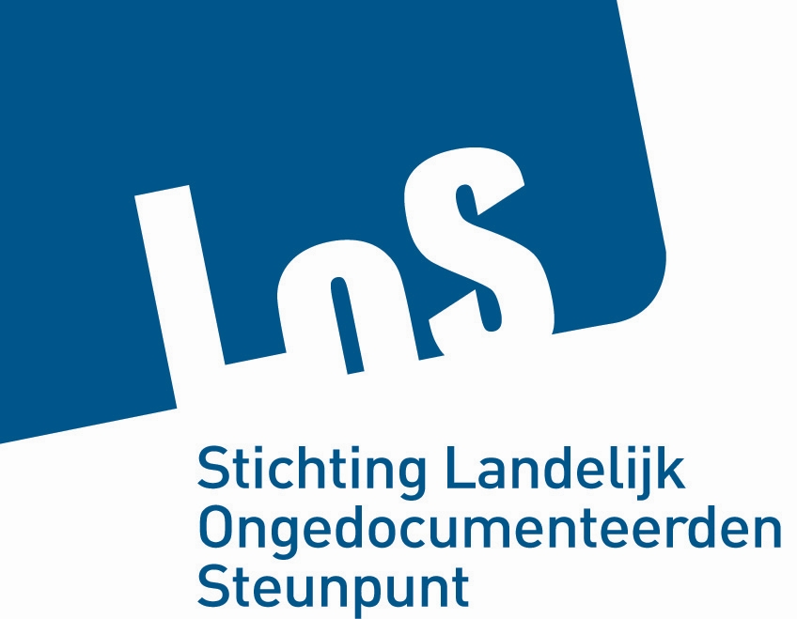

To: Committee on the Protection of the Rights of All Migrant Workers and Members of their Families

Concerns: Day of General Discussion, september 19, 2011, Geneva

Utrecht, september 9, 2011

Stichting LOS is the National Organization for the Support of Undocumented Migrants in the Netherlands. Stichting LOS works with about 100 local organizations and about 200 self-organizations to improve the position of undocumented migrants.

On the occasion of the Day of General Discussion on the Convention for Migrant Workers, and on behalf of our members, we would like to ask your attention for the following topics concerning the position of undocumented migrants.

Article 25: renumeration and other conditions of work and terms of employment
Although in the Netherlands, the right to equal renumeration for undocumented migrants exists in theory, in practice it is almost impossible for them to claim unpaid wages, sick leave, holidays. In these cases, employers either threat to report the undocumented migrant to the police, or end the working relationship.
We recommend:
- access to claim-procedures against employers with guarantee that the position as undocumented migrant will not be used against the worker
- protection against dismissal for undocumented workers who claim their rights
- claim-procedures should be actively promoted in case the worker is being kept in aliens detention and even after his expulsion: provisions have to be arranged to continue the claim-procedure
- claim-procedures against the employer should be kept separately from fines for undocumented employment

Article 26: Participation in trade unions
Although in the Netherlands the possibility to participate as undocumented workers in trade unions exists, there are many practical administrative obstacles like identification, lack of bank account, and communication.
We recommend:
- enhance the openness of trade unions for membership of undocumented migrants

Article 27: Access to social services
The Dutch Benefit Entitlement Act (Linkage Law) of 1998 links social rights to the legal status of the migrant. Through this law, undocumented migrants lost most of their social rights, like participation in social insurances, health care insurances, social housing, access to homeless shelters and womens shelters, education for adults, social benefits etcetera. The last years, courts have decided that the effect of this exclusion violates the right to private life, and therefore the law should not be applied.
We recommend review of the Benefit Entitlement Act in the light of this recent case law.
Especially we recommend:
- access to homeless and womens shelters for undocumented migrants
- access to education for adults for undocumented migrants
- access to emergency social benefits for undocumented migrants in need

Article 28: Access to health care
In the Netherlands, a special fund exists to reimburse health care providers and hospitals who offer care to undocumented migrants. However in practice, access to this fund can be quite problematic. One reason is that health care providers often don’t know of the existence of this fund. Another reason is that decisions about the use of the fund are in practice made by employees at the registration desk, who have to check the staypermit and the financial means of the patient.
Therefore we recommend:
- continuous education of health care providers about the existence of the fund
- clear instructions for the registration desk employees how to approach migrants who claim to be undocumented and want to make use of the fund
- at the bigger health care institutes: specialized employees who are familiar with undocumented migrants and are able to assess their status and ability to pay

Article 30: Access to education and preschool educational institutes
In the Netherlands, access to education for undocumented children is officially guaranteed. However, schools often don’t know about the rights of undocumented children. Access to preschools can sometimes be problematic because of an obligation to prove income. And in practical education, the prohibition to work affects the possibility to finish education.
Therefore we recommend:
- continuous education of schools and preschool institutes about the rights of undocumented children
- access to work as an intern in order to fullfill the curriculum of schools for practical education

