

Committee on Migrant Workers

Day of General Discussion on Migrant Domestic Workers
14 October 2009

Working group two: Effective protection of MDWs rights
- How can MDWs be empowered?
- What can be done before MDWs leave their country of origin to assist them in preparing for their employment?
- How to establish effective complaint mechanisms for MDWs?
- How to avoid situations of abuse and forced labour?
- What should be the role of the countries of origin of the MDWs in providing effective protection from abuse?
- How can the family unity of MDWs be protected?
- How to address the recurring situation of the recruitment agency or employer confiscating the documents of MDWs?

First, I would like to thank the organisers and our colleagues at CI for giving me the opportunity and chance to share with you the experience of Caritas Lebanon Migrant Center (CLMC) in ensuring effective protection for MDWs’ rights.

Let me start by saying that the Migrant Center was created by Caritas Lebanon in 1994, to respond to the growing needs of migrant workers, asylum-seekers and refugees in the country, who are a marginalized portion of the society.

Background
Labour migration has become an integral part of the world economy, permanently reproducing on the one hand a demand for cheap and low-skilled migrant labour, and on the other hand, migrant labour flexibly reacts to any demand and any conditions of employers.

Since the 1980s, the demand for migrant women to take low-skilled or unskilled jobs shunned by local labour force has gradually increased in Lebanon. Temporary foreign contract employees are the favourite type of migrants for the country, since there are no expectations of permanent settlement and/or citizenship rights. Moreover, seeing that till date the Middle East seems to have circumvented the current global economic crisis effects, migrant workers are willing to work in ME countries, of which Lebanon is part.

The majority of migrant workers in Lebanon are women originating from Asia and Africa, working as domestic helpers. They are everywhere in the country, in nearly every household, factory, or business. Women migrant domestic workers are usually young and poor, living in fear of losing their jobs, having had to leave their families in their countries of origin. They often do not speak the language of the country of employment or a shared language with their employers and are unaware that they have rights that are being infringed.

For rather low wages and under very tough work conditions, migrant workers cope with their situation, with the sole hope of sending their remittances or going back home and improving their financial situation and their families’.

According to the Lebanese Ministry of Labour statistics for year 2007, of the total 121,375 work permits delivered that year, 42,218 were for newcomers and 79,157 for migrants whose work permits were being renewed. A total of 87,668 were granted for house maids (37,104 starting a new contract and 50,564 renewing their contract) and 247 for women working in the cleaning area (of which 31 were under a new contract and 216 renewing the old one). Officially, women represent 72.5% of the total migrant population. Breakdown by nationalities (but not by gender) is as follows: 2,468 Nepalese (1,374 newcomers, 1,094 renewing their contracts), 7,063 Bangladeshis (2,908 newcomers, 4,155 renewing their contracts), 21,294 Sri Lankans (3,903 newcomers, 17,391 renewing their contracts) and 22,997 Filipinos (1,924 newcomers, 21,073 renewing their contracts). However, these statistics do not include those women migrant workers that are in an irregular status. It is estimated that the number of irregular migrants is equal if not more to the official figure.

According to the Lebanese Ministry of Labour statistics for year 2008, of the total 131,112 work permits delivered that year, 36,714 were for newcomers and 94,398 for migrants whose work permits were being renewed. A total of 99,043 were granted for house maids (32,649 starting a new contract and 66,394 renewing their contract) and 279 for women working in the cleaning area (of which 45 were under a new contract and 234 renewing the old one). Officially, women represent 75.8% of the total migrant population. Breakdown by major nationalities (but not by gender) is as follows: 5,399 Indians (597 newcomers, 4,802 renewing their contracts), 6,738 Nepalese (4,756 newcomers, 1,982 renewing their contracts), 11,032 Bangladeshis (4,993 newcomers, 6,039 renewing their contracts), 16,644 Sri Lankans (2,520 newcomers, 14,124 renewing their contracts), 21,685 Filipinos (5,915 newcomers, 15,770 renewing their contracts), and 42,947 Ethiopians (13,225 newcomers, 29,722 renewing their contracts). However, these statistics do not include those women migrant workers that are in an irregular status. It is estimated that the number of irregular migrants is equal if not more to the official figure.

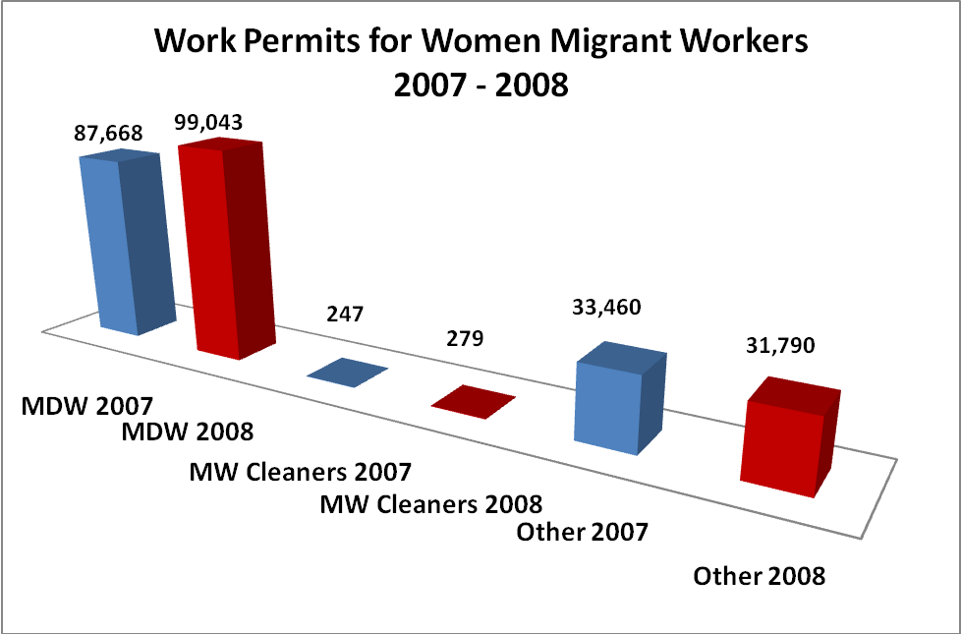

Source: Lebanese Ministry of Labour

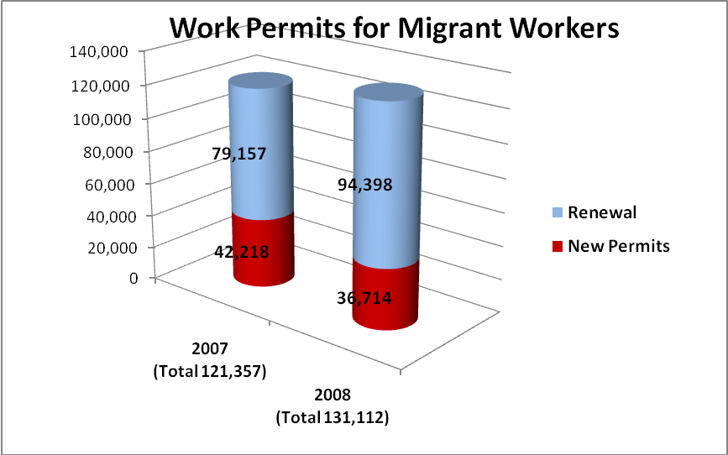

Source: Lebanese Ministry of Labour

When figures compared between 2007 and 2008, one should consider the reasons behind this demographic change of migration patterns, and reconsider migration policies such as the ban to travel to Lebanon put by the Governments of Philippines and Ethiopia respectively, whereas roughly 30% of Filipino and Ethiopian migrants are newly arrived and recruited. This also appeals to CLMC to consider its strategies in addressing migration-related issues.

Problems encountered by MDW
In Lebanon, migrant workers (especially unskilled or low-skilled ones) tend to become the underdog (second best) of the local labour market and are disadvantaged in terms of social capital, access to legal and labour market information, language barriers and ability to defend their interests.

Often by the very nature of their jobs, WDW are vulnerable to all sorts of abuse and exploitation. This vulnerability is further increased in the case of migrant WDW. The following characteristics make migrant domestic workers vulnerable to serious abuse:
- Being forced to live in the privacy of their employer’s house (=limited access to the outside world and limitation of movement);
- They are not protected or recognized under the legal and regulatory frameworks;
- The laws about foreigners in Lebanon are outdated (1960s);
- Lebanon did not sign the Convention for the Protection of all MW and members of their families;
- Theoretically, they are unable to enforce contracts;
- They are firmly tied to their employers through the sponsorship system (which conditions the delivery of work and residency permits), and thus are at their employer’s mercy;
- They receive little/no legal or social protection;
- They are highly dependent on the attitude of public authorities;
- Many don’t even have in Lebanon a Diplomatic Mission of their native country.

The major problems arising are:
- Limitation or prohibition of contacts with outsiders, including family members and members of their ethnic and religious community;
- Confiscation of passports and/or identification documents;
- Exploitation from the employer: food deprivation/restriction, restricted communication;
- Long working hours with little/no rest and, at times compulsory work in more than one place;
- Physical mistreatment, which includes beating, burning, murder attempt, etc;
- Sexual harassment and abuse, as well as forced prostitution;
- Forcing MDW to stay with their employers until they cover their travel fees even if the latter are abusing them;
- Threatening MW, especially those in an irregular situation of informing authorities of their illegal status, which will entail their imprisonment and deportation;
- Delay, under or non-payment of the MW’s salaries;
- Switching of contracts.

These issues identified by CLMC staff over the years, through the daily work with thousands of migrant workers were corroborated by the findings of a qualitative and quantitative study conducted in August and October 2008. The aim of the research was to depict the perception of Lebanese people towards migrants’ rights and their behaviour towards them.

Protection and Interventions
Caritas Migrant Centre’s Response
CLMC’s response is two-fold: on the one hand, the Center provides direct services adapted to expressed and identified migrants’ needs, and on the other, it has developed strategies to raise the awareness about migrants’ situation in the country, in addition to advocacy and lobbying efforts deployed in favour of migrants’ cause.

Since its inception, CLMC has afforded social counselling and follow-up to migrants, both inside and outside prisons, as well as legal assistance for those requiring it. In 2000, the CLMC initiated efforts to expand its activities on a wider range and to reach out to more vulnerable destitute groups, requiring a more comprehensive vision and mission statement for the organization. The results of this reformulation expanded both the breadth of migrants served in Lebanon as well as the depth of services provided to them.

Direct services
Direct services include, but are not restricted to, social and legal assistance, medical and psychological aid, recreational activities, vocational and informal trainings, repatriation and sustainability grants.

In 2000, the Center initiated a regular protection presence inside the state General Security Retention Center for foreign persons, whereby social, medical and legal assistance are provided on a daily basis. CLMC is the sole NGO allowed to operate within the facility by General Security (GS), which is the governmental authority responsible for the legal status of foreigners in Lebanon. A CLMC multidisciplinary team present 24/7 ensures protection and respect for detained migrants’ rights. Activities include social and administrative follow-up by social workers to accelerate release of vulnerable detainees (such as pregnant women, sick persons, students, etc); medical assistance (consultation by doctors, distribution of medications, first aid, referral to hospital, etc); moral support; recreational activities; prevention campaigns against skin diseases, washing of detainees’ clothes; hot meals; improvement of detention conditions: ventilation, mattresses, sheets, etc.

In 2002, CLMC started implementing a programme funded by the EU, to protect the Rights of Migrant workers and Asylum-seekers. Activities included: social counselling and follow-up; legal aid, whereby around 2,404 migrant workers and Asylum-seekers cases were processed in favour of their rights by Caritas lawyers either through negotiation or agreeable settlements with employers, police, or General Security, or before Courts or General Prosecutors.

In 2003, the Migrant Center initiated a project aiming at affording protection, integrated assistance and options for durable solutions to women victims of trafficking. This programme involves extensive cooperation with the General Directorate of General Security, with whom Caritas has a one-of-its-kind standing Memorandum Of Understanding (MOU). Through this project migrant women victims of trafficking have access to a safe house where they can escape their situation and consider future options, receive medical care, basic needs assistance, trauma counselling, legal aid and counselling for future options in a supportive environment, as well as possibility to return to their country of origin or to a safe work situation in Lebanon. Through partners in several countries of origin, beneficiaries returning home are availing from follow-up and rehabilitative services to ensure their smooth re-integration in their native communities.

As of 2005, CLMC staff visited migrants detained in all Lebanese prisons. This entailed social counselling, administrative follow-up and acceleration of transfer to the Retention Center and repatriation, humanitarian and medical assistance, in addition to legal aid.

In November 2005, an “Awareness Raising Workshop on the Situation of Women Migrant Domestic Workers in Lebanon” co-organised by the ILO, CLMC, UNIFEM, OHCHR, and the Lebanese Ministry of Labour took place in Beirut and gathered over 60 participants representing UN Agencies, NGOs and CSOs, Embassies of major sending countries, and relevant Lebanese Ministries. As a result, in January 2006, a National Steering Committee (SC) was formed by a Decree Law, in view of improving the protection of the human and legal rights of the domestic migrant workers in Lebanon. CLMC is part of this SC, alongside the Ministries of Labour, Justice, Interior, and Social affairs, in addition to UN Agencies (ILO, OHCHR), relevant Embassies of sending countries, the Syndicate of recruitment agencies, and the Beirut Bar Association Institute for Human Rights. The SC mandate is three-fold:
- Drafting a unified contract granting the protection of MDWs’ human and labour rights. The new text stipulates the minimum labour rights for MDW. This contract became official on 31 January 2009 through a Decree Law, and came into force as of 01 April 2009.
- Amending the current Lebanese labour laws, thus extending them to cover MDWs. The laws to be tackled need to cover more than 50 articles.
- Developing and publishing booklets on rights and responsibilities of 3 different populations: MWs, employers and recruitment agencies. All 3 booklets cover the rights and responsibilities of concerned parties, guidance for culture adaptation, guidance for treatment and respect of the rights of both parties migrant worker and employer, general information regarding recruitment procedures and questions to ask for before adhering to an oversee job or recruiting a migrant. The booklets include also additional information such as dictionary and services available for migrants and employers should they require assistance or clarifications/counselling.

Although MDW are not covered by the local labour laws, CLMC lawyers have been able in the last five years to set legal precedents in the following areas:
  - Physical abuse
  - Sexual abuse
  - Passport confiscation
  - False accusations of theft
  - Non-payment of salaries
This jurisprudence is the basis to further enhance MDWs’ protection while waiting for a new protective legislation.

Indirect services
Indirect services encompass orientation sessions on rights and responsibilities addressing migrants, awareness campaigns and sessions for the Lebanese public and recruitment agencies, trainings for law enforcement agents, in addition to advocacy and lobbying at the national, regional and international levels.

Since 2002, CLMC has developed and has been conducting orientation sessions on rights, responsibilities and services available, to help migrant workers protect themselves and find mutual support. Till date over 20,000 migrants, mainly women, have attended these sessions. The curriculum is available in different native languages, such as Amharic (Ethiopian), Singhalese (Sri Lankan), Tagalog (Filipino), and English. It is periodically reviewed and adapted to the migrants’ situation and needs. In 2007, the Center was granted access to the airport. The staff members (including peer counsellors) welcomed the newly arrived migrant workers and conducted immediate post-arrival orientation sessions. They also distributed small flyers in different native languages, which provided information on services available and relevant numbers to contact for help.

Since 2002, a Public awareness raising and promotion of behavioural change campaign was initiated. Within this context, in July 2005, a broad survey took place, involving a qualitative and quantitative research to depict the perceptions of Lebanese people towards domestic migrant workers and how they justify their behaviour and views to problems faced by migrants. Based on the survey outcome, in collaboration with the Ministry of Interior and the Ministry of Health, CLMC initiated in March 2007 a multi-media multi-level public awareness campaign (TV, Radio, Billboards, newspapers and magazines) to improve the knowledge of Lebanese about the rights of migrant workers and to promote their change of attitude towards migrant workers. The Centre’s hotline numbers were highly publicized during these campaigns.

In August and October 2008, qualitative and quantitative studies were conducted to monitor the previous campaigns’ impact and identify the evolution in Lebanese people behaviour. The results were used for the forthcoming national awareness campaign, whereby messages were developed accordingly. The results are also used to design future activities.

Sessions addressing various Lebanese strata were coupled with the campaign, to increase its impact. These sessions were led in universities, schools, parishes, mosques, etc… Till date, over 5,000 Lebanese people participated in these workshops. Leaflets detailing CLMC’s activities and services as well as contact information (including hotlines numbers) are distributed to participants.

A movie entitled « Maid in Lebanon » was released in March 2006, depicting the situation of women migrant workers in Lebanon and different experiences lived while there. A sequel “Maid in Lebanon II, Voices from Home” was released in 2008. These movies are uses as tools during the awareness sessions, whereby some portions are viewed and discussed.

In its efforts to raise awareness about migrants’ rights, the Center has also offered trainings for General Security and Internal Security Forces agents/investigators to reinforce their knowledge regarding human rights, trafficking-related issues and the rights based approach. Investigation/interview techniques, formal and informal pacifist dialogue, as well as conflict resolution and prevention were also tackled during training sessions. In 2008 and the first half of 2009, 200 law enforcement agents benefited from these trainings.

The Centre’s staff also conducted sessions with recruitment agencies from all over the country, to raise their awareness on the real situation of migrant workers, and abuses to which they are subjected. Techniques in dealing with abused migrants, especially victims of trafficking were shared, and cooperation to handle critical cases was encouraged.

The Center advocates regularly for the cause of migrant workers. This is done through regular meetings held with relevant governmental entities. Through these efforts, the General Security has accepted on several occasions in the last years to grant an amnesty to migrant workers in an irregular situation.
For instance, after the December 26, 2004 Tsunami that hit the South-Eastern Coasts of Asia, the taxes of migrant workers from India and Sri Lanka (whose families were impacted) returning to their home countries were waived by both GS and Ministry of Labour. Likewise, after the July 2006 conflict, General Security has permitted the migrant domestic workers to change their employers. Besides contributing to the decrease of irregular migrant workers, it has helped as well some migrant workers escape abusive employers and working conditions. In 2007, 2008 and 2009, GS has declared a three-month amnesty period, whereby irregular migrant could regularize their status, and all migrant workers could change their employers, if the latter agree to give release papers. These periods were regularly extended to five months.

The General Security has a “Complaints’ Desk”, where violations to migrant workers’ rights can be reported. The Centre communicates to GS information regarding abusive employers, or recruitment agencies. GS is compiling a “Black List” of abusive employers, and accordingly those short-listed persons (and any relative/member of family) are prohibited from hiring any MDW. Black listed recruitment agencies are likewise investigated, and some are being closed.

Additionally, the Centre has constantly encouraged GS to form a core group of personnel and investigators with specialized skills and extensive training. This group could be exclusively assigned to handle victims of trafficking cases.

Caritas Migrant Center prepared a code of conduct between Caritas employees and migrant workers. This code is intended to regulate the conduct of any individual working at Caritas Lebanon and CLMC in their relationship with migrant workers whether or not they are at their service. This code is a responsive document to meet the needs of implicated parties and to ensure the delivery of relevant up to date regulations. When required/requested, this code is being customized to be signed by other NGOs, Embassies, and institutions that employ migrants.

The Centre has weaved good working relationships with various sending countries’ Diplomatic Missions. CLMC coordinates largely with relevant consulates/embassies to handle migrant cases. It is also solicited by these missions to ensure social, medical, legal assistance as well as shelter to some of their nationals, especially potential victims of trafficking. Through the MOU signed with GS, CLMC is well positioned to better protect and assist this vulnerable population.
It is worth noting that some embassies of sending countries have set few measures in an attempt to help protect from and prevent the abuse of their expatriates’ rights. This was done through:
- Accreditation of recruitment agencies at both national and Lebanese levels;
- A regular monitoring of employment agencies;
- Fixed minimum wages;
- Registration of all newly-arrived nationals to Lebanon thus allowing the Embassies to track the movement of their expatriates within the country and to monitor their working and living conditions (mainly Philippines Embassy);
- The Philippines Embassy has started establishing a list of non-compliant agencies and abusive employers. Non-compliant agencies are banned from bringing Filipino manpower, and abusive employers cannot hire another Filipino migrant worker.

As already stated, the large majority of migrant workers do not speak a shared language with their employers. Consequently, in many cases, communication barriers might likely lead to the migrants’ abuse, since the employers get frustrated from their employee’s failure to understand their requirements. This was corroborated by the findings of researches mandated by CLMC. Furthermore, on several occasions, the Centre’s staff has had to resolve problems resulting from miscommunication between the Lebanese employer and the respective migrant employee, who didn’t speak/understand or hardly spoke/understood few words of Arabic. Moreover, the Center is partner of many NGOs active in the Migration field in several countries of origin, which were pointing at this issue of language barriers. The necessity of drafting a Linguistic Guide to be used by both the employers and their employees was hence acknowledged. CLMC drafted a linguistic guide addressing at a time the Lebanese employer (Arabic-speaking) and the migrant working at this employer’s house. Peer experts (CLMC staff members and volunteers) from various nationalities were involved in drafting the guide. The guides include the commonly used words and sentences in Arabic and the migrant’s language, as well as their phonetic pronunciation and their meaning. The ultimate aim is to facilitate the communication flow between pertinent stakeholders. These guides are being distributed through the recruitment agencies with who CLMC is networking, as well as during orientation sessions. The ultimate view is though to distribute these guides in relevant countries of origin, as part of country-specific pre-departure orientation sessions.

Challenges
CLMC faces several challenges in accomplishing its mission aiming at strengthening and protecting the human rights of migrants, refugees and asylum-seekers in Lebanon.

Although involved in drafting the unified contract, the Centre has several reservations regarding the indicted version:
- The contract should be available in both Arabic and the MDW’s respective native language;
- The provision for a weekly day-off does not clearly stipulate if this day-off could be spent out of the house;
- The current contract duration is of 3 years, while before it was of 2 years 3 months;
- There are limited provisions enabling the MDW to terminate the contract, while the employer can terminate it when it suits her/him.

Migrant workers are transplanted from their home environment to a socially, culturally, institutionally and politically unfamiliar and often alien environment; and many of them experience cultural shock for these reasons. The Centre is coordinating efforts with partners in sending countries to address the lack of information experienced by MDW. The scope would be offering to MDW bound to Lebanon accredited programs for pre-departure orientation and training, providing country-specific information about conditions of recruitment, employment, and social security and legal rights.

Perspectives
- Enactment of legislation giving domestic workers the status of real workers;
- Ensuring equality in working rights;
- National legislation should hold abusive employers accountable;
- Improving the regulations of recruiting agencies;
- Allowing MDWs to change their sponsor;
- Changing the kefala (sponsorship) system;
- Ratification of the CMW that would ensure a better protection for migrant workers and adapting the Lebanese legislation accordingly.

