
The Work of Parc Supporting Families at HMP & YOI Parc – WALES UK.
In 2006 HMP & YOI Parc developed a small steering group of staff from a multi-disciplinary background, whose purpose was to create a strategy to meet the growing remit for the children and families of offenders. The steering group became known as Parc Supporting Families and was comprised of internal staff from Interventions, Drug Strategy, Learning and Skills, Resettlement and Offender Management. In time, external membership developed as it became clear that the work required partnerships with statutory, private and voluntary organisations within local communities.

Initially PSF sought to offer small-scale information, advice and guidance to prisoners at Parc and their families. However it became clear early on that this area represented not only an enormous gap in terms of provision, but also an opportunity to address the issues of offending behaviour, recidivism and intergenerational offending in a unique and effective manner.

The diagram below demonstrates the quantity of phone calls from children and families of offenders at Parc. Prior to PSF, this 24/7 support line service was not available so the level of direct need was considerable.

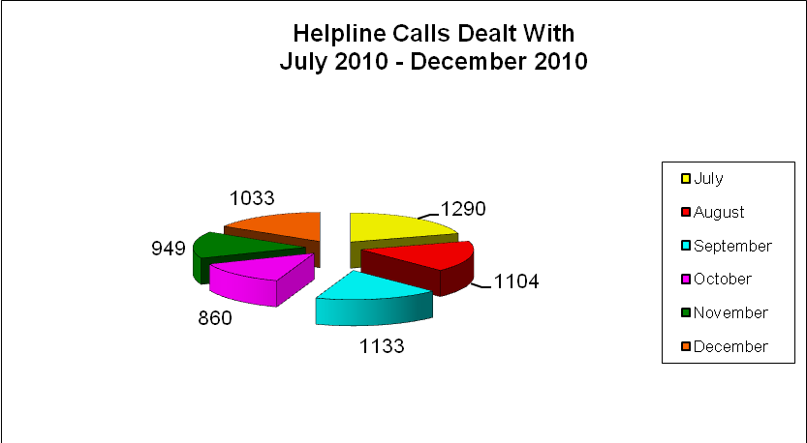
Drawing on key research and evaluation findings of documents such as the ‘Social Exclusion Unit Report 2002’, ‘Every Child Matters 2004’, ‘Reducing Re-offending: Supporting Families: MOJ 2009’, ‘Every Family Matters 2009’, ‘A Review of Child-Centred Prison Visits: Kids VIP 2010’, ‘Improving Prisoners Family Ties: NPC April 2011’ as well as the policy, practice and findings of organisations such as, Partners Of Prisoners, Action for Prisoners Families, Kids VIP, Safe Ground UK, Time For Families, String of Pearls and Barnardo’s, PSF has constructed provision based on evidenced that if a prisoner maintains and improves family engagement whilst in custody, that prisoner is up to six times less likely to re-offend following release. (Social Exclusion Unit Taskforce 2002)
The key challenge for PSF has been to make the remit credible within Parc and to G4S. In meeting this challenge, PSF has been able to gradually integrate with every function within the prison.
In re-classifying the support work of children and families of offenders, from a bolt-on function, to an alternative method of addressing offending behaviour, PSF has been able to graft resource and staff support from a variety of internal and external bodies.

PSF has gradually become relevant to Parc, G4S and relevant external organisations. The benefits of the developing provision have been experienced not only by the prisoners, children and families, but also by the staff, Senior Management, Director and the Company. PSF has grown in response to internal need and support, as well as to the rapidly emerging national frameworks for this area from the Ministry of Justice, National Offender Management Service and the Department for Education.

The development of PSF at Parc during the first four years presented an opportunity to take a bold step forward with the remit. There was sufficient foundation to progress PSF in order to encompass the management and running of the prisons Visits complex, as well as to open a ‘Family Interventions Unit’. Both of these moves represent a major shift in established and accepted prison culture.

The strategic rationale for these progressive moves is shown figuratively in Diagram E below. The inverted triangle represents the current and historical sentence interventions template. The wider sections depict the usual amount of prisoner access to established functions. As the sections diminish in size, access to those functions also tends to diminish.

PSF has at its core the practice of taking what works, what is proven to be most effective with most offenders in reducing recidivism and amplifying that critical ingredient in many different ways.

The PSF approach is about distilling the established generic values surrounding children and families and using that distilled ingredient to create a powerful cognitive dissonance around the ‘gap’ between behaviour and values that becomes the catalyst for positive change.

To return to Diagram E, the bottom half triangle represents a different approach to using what works for the majority rather than the few. By developing the PSF remit as a credible function, integrated within the establishment, the provision has had a ‘trickle down’ effect throughout the traditional interventions template. The opportunity to engage, promote and use the children and families value with offenders becomes possible throughout all of the existing functions, as opposed to an isolated, unsupported activity for the minority.

This way, more offenders and their families are offered more of a chance to become involved in family based interventions than was previously possible. This maximises the potential to use what works with the greatest numbers in a meaningful and holistic manner.

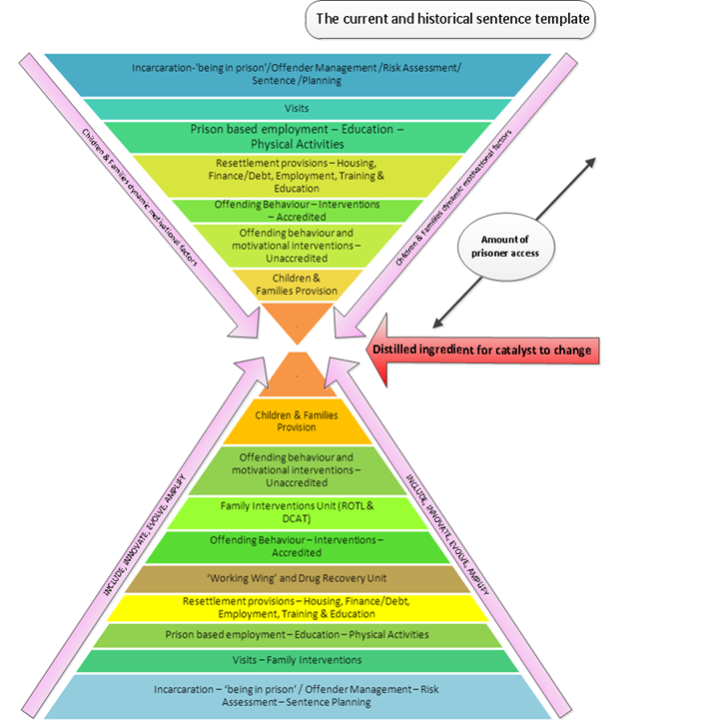

It is this development of a tangible working approach with the children and families of offenders, built upon a significant cultural shift in terms of the ‘way’ in which prison can work with its staff and offenders, that has produced the platform for overhauling the established prison visits culture and practice, as well as creating a new living unit for family interventions.

- Interventions Led Visits Complex (ILVC)

PSF believe that Visits can be run with a less visible yet more dynamic security method, similar to that of the Category A prisons, which is based more upon the staff and management working with the visitors and prisoners, getting to know them and understanding their situations, relationships and circumstances.

PSF proposed a different model of managing the staff and the physical space of visits, which would present opportunity to work with prisoners, their children and families, in a different, more engaging manner, using special provision with the aim of reducing re-offending and intergenerational offending.

Following a detailed proposal by PSF, in the summer of 2010 the Director at Parc sanctioned PSF to manage and run the visits provision as an intervention.

The three key aspects to the ILVC which distinguish it from traditional prison service provision are firstly - the staffing arrangements. PSF selected eighteen Prison Custody Officers that were deemed the most suitable for this new approach. All had a motivation to work in an interventions led way, with rehabilitation as a central goal. Similarly, the same process was conducted for the three Senior Officers who would supervise the officer team in both the ILVC and the planned FIU.

PSF staff attend family focused training sessions and short courses with Bridgend County Borough Council Business Support and Organisational Development section. They provide an extensive portfolio of training and information sessions in areas such as:

- Safeguarding children (part 1 and 2)
- Safeguarding children with disabilities
- Working with dangerous and evasive parents
- Working with parents with mental health issues
- Domestic violence

The courses develop an awareness of vital family issues and help staff to recognise indicators of problems. Qualifications include:

- NVQ Level 3 in Learning, Development and Support Services for Children, Young People and Those who Care for Them
- NVQ Level 3 in Information, Advice and Guidance
- Learning through play
- Family Man facilitator training
- Understanding Care, Welfare and Community (OU K100)
- Working with Families and Children (OU K302)
- Certificate in Youth Justice (OU K308)

Secondly, the newly established ILVC provides family engagement opportunities that do not normally happen in this area within prisons and certainly not as a scheduled calendar of interventions delivered with the frequency with which PSF offer.

- Family Centred Visits
- V.P.U. Family Centred Visits
- Learning Together Club
- Moving Parents And Children Together
- Positive Parenting Time Out Series
- Family Interventions Lounge
- Safe Ground Presentations
- Domestic Legal Advice Surgery

Thirdly, the physical space. Historically, the visit hall space of most prisons tends to be an austere, environment. The booking in process for visitors and the areas where searching is undertaken, prisoner property handed in and where essential waiting is accommodated are often uninviting, drab spaces reflecting an out-dated and inappropriate attitude towards children and families of prisoners

The ILVC physical space at Parc reflects a change to this attitude. The use of plants, colour and art form an important aspect of the visit areas. With over 1500 children visiting Parc every four week period, the experience from a child’s perspective has also been carefully considered. Similarly, facilities to cater for an extremely broad range of diversity needs have been accounted for.

- Family Interventions Unit

PSF proposed in conjunction with the ILVC, to open the first ever Family Interventions Unit. A 60 bed living unit where the focus of the environment is upon repairing, enhancing and taking responsibility for relationships, parenting and family. The Director of Parc sanctioned the development of the FIU and with the timing of the Invisible Walls project in mind, the FIU became operational as in November 2010.

Intervention – Parenting For Dads – PSF

This 10 session intervention works with prisoners who are fathers or ‘fathers-to-be’.

This course is designed to assist fathers to be the best parent they can in the confines of their circumstances. Parenting for Dads provides fathers with the opportunities to meet other dads, share experiences and have access to advice and information as well as developing important skills such as:

- Understanding the role of a father.
- Exploring a variety of parenting styles.
- Developing an awareness of how best to deal with misbehaviour/challenging behaviour in children.
- Understanding the impact of parenting on self-esteem.
- Increasing awareness of what effective parenting entails.
- Understanding how positive influences can make a difference in a child’s life.
- Exploring the many ways in which (absent) fathers can maintain family ties.
- Investigating where to access further help, advice and support as a parent.

Intervention – MPACT – PSF & Action On Addiction
Moving Parents And Children Together – this is a pilot intervention PSF is developing in conjunction with the charity Action On Addiction. The programme focuses on the impact and support needed for prisoners who misuse substances within a family setting. Each group lasts approximately six weeks.

The programme offers a ‘Whole Family Approach', working with parents and children from up to eight families at any one time in different group combinations. The programme has 10 sessions; this includes an individual family assessment, eight consecutive weekly core sessions and a family review session. The programme is run by experienced professionals who work with the young people and parents to reduce the harmful impact that parental substance misuse and addiction has on family life.

The programme has been evaluated by the Mental Health Research & Development Unit (MHRDU) at the University of Bath. Their findings have shown that all the families involved felt that they had been helped by attending the programme. Following solicitation of PSF by Action On Addiction, this will be the first time MPACT has ever been delivered in a prison setting and as such the model will continue to be evaluated both independently and as part of the wider Invisible Walls research, the former research integrating with the latter.

Intervention - Learning Together Club – PSF

The Learning Together Club (LTC) is an innovative PSF project that gives fathers a chance to spend time with their children and maintain relationships that develop the family unit.

All children attend a visit with their fathers without their mothers/carers on two evenings per month, enabling children and fathers to interact. The children bring in work from school to show their fathers and work together. Parc provides educational resources for all curriculum and key stages for children who do not bring anything.

The librarian also attends and operates a book lending service. Play Area workers support the fathers with younger children and encourage learning through play. Originally the LTC was aimed at fathers and their children, but that developed to include the wider family unit including grandchildren and younger siblings.

Success stories include a father and teenage son who didn’t communicate at all. The father knew nothing about what his son was doing at school, but through the LTC, soon became aware of his son’s Year 10 options, encouraged him through his exams and the son achieved unexpected GCSEs. Other fathers have experienced supporting their children for the first time. Previously they had taken no part in schoolwork or even reading to their children when they were at home.

There have also been several cases where children afraid to come to the prison on normal visits have ‘broken the ice’ by attending the LTC, which is a more relaxed and informal setting; they have then continued to visit.

The LTC has developed over the last two years as a result of the passion and commitment of the staff and volunteers involved. The LTC has further developed in response to the needs of the families and in June of this year, children under the age of two also attended.

Everyone attending the LTC attends a short course to learn about key stages, the national curriculum, how children learn and the importance of supporting learning. This has developed in response to changes in the school curriculum and in future groups additional topics will be included such as:

- The importance of family learning and its contribution to raising the achievement of their child
- A variety of ways in which family members/carers can help their child with literacy and numeracy skills

- Intervention - Family Centred Visits PSF
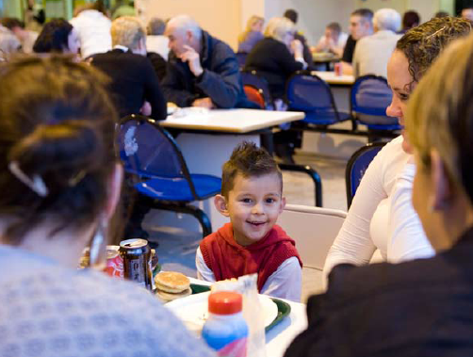
Family visits have long been recognized as important in maintaining family ties and the relationship between a prisoner, their children and other young relatives in whose care and upbringing they have played a significant role. Good relationships between parents and children not only contribute to a reduction in re-offending risk, but also to the healthy development of the child. This is true for stepchildren, siblings and other younger family members.

Family Centered Visits are organized by PSF on the last Wednesday of each month. These visits are designed to maximise the engagement between families and serving prisoners at Parc.

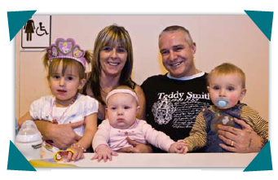
This is achieved through a multi-disciplinary approach to the event, with numerous activities staged for children and families such as arts and crafts, face painting, table-top games as well as more physically active challenges, well-being clinics, interventions awareness, competitions, book shares, certificate presentations and themed events. Prisoners can also book to have two photographs taken of themselves and their family on the day.

Refreshments are provided through free drinks and later in the day, a buffet that is partly paid for by the prisoners on the visit, allowing them the opportunity to provide for their family.

The Family Centered Visit is more than ‘just another visit’ and aims to provide a positive intervention. It works on three levels.

Firstly to change the perceptions of the prisoner in terms of how he can still maintain and develop relationships with his family whilst in prison. Secondly the families are provided with information on what is available to them and the family member in prison with regard to their links and support. Thirdly, the officers and staff interact with the prisoner in a more ‘normal’ setting, engaging and interacting with children, family and each other.

All three groups leave with an altered perception about each other, which can trigger positive change in their dealing with one another.
(2,500 words)
Corin Morgan-Armstrong
Senior Manager: Family Interventions
July 2011

Annex - Recommendations for action to be considered by the Committee:
- That EU governments reclassify and align the children and families agenda as reducing reoffending strategy.
- That EU governments audit and inspect prisons upon their children and families provision.
- That EU governments make a financial commitment to support the children and families remit.
- That EU governments commit to appropriate staff training and support so as best to accommodate the remit.

