Committee on the Rights of Persons with Disabilities

Progress Report and Recommendations for the
Implementation of the ICT Accessibility Dispositions of the CRPD
Axel Leblois
Founder and Executive Director
G3ict
October 7, 2010

Agenda

- Why ICT Accessibility matters
- CRPD dispositions on ICT Accessibility
- Status report on international cooperation on ICT accessibility
- Survey results - CRPD ICT Accessibility Progress Report
- Going forward – Recommendations

Why ICT Accessibility Matters
A Massive Increase in ICT usage:
1.1 billion personal computers
2 + billion Internet users (incl. shared / mobile access)
1.2 billion telephone land lines
2.3 billion TV sets and 2.4 billion radios
5+ billion cell phones, hundreds of billions of text messages
- Risks of exclusion of Persons with Disabilities from essential services, contents and social interaction if ICT interfaces are not accessible
- Major opportunities to leverage ICTs for new assistive technologies and services
Why ICT Accessibility Matters
Accessibility and asistive solutions exist for virtually all ICTs:
Mobile phones, personal computers interfaces, television, ATMs, fixed phones, web sites, digital contents, interfaces to Braille, peer to peer video for sign language, multiple assistive technologies, speech recognition, broadband services, remote wireless services etc.
But their availability to Persons with Disabilities is limited due to:
Lack of awareness and effective policies, multiple stakeholders and government agencies, speed of technological innovation, lack of standardization, weak assistive technologies eco-system, all resulting in lack of availability and high costs
Accessibility in the CRPD: ICTs On Par with Physical Environment & Transportation

« To enable persons with disabilities to live independently and participate fully in all aspects of life, States Parties shall take appropriate measures to ensure to persons with disabilities access, on an equal basis with others, to the physical environment, to transportation, to information and communications, including information and communications technologies and systems... » (Article 9)

Implications of Article 9, Linkages

- Based on the definition of Article 9, all sector specific accessibility dispositions cover ICT accessibility
- The terms “Accessibility” and “Accessible” appear respectively 9 and 17 times in the text of the Convention
- The term “Reasonable Accommodation” is included 7 times with equal impact on ICT applications
- 57 times in the reporting guidelines to State Parties issued by the United Nations SG

Articles with Implications for ICT Accessibility
CRPD Dispositions Applicable to ICTs | CRPD Articles | Accessibility Requirements | Reasonable Accommodation | Promoting Assistive Technologies
Non discrimination | 5 |  | Y
E-Government | 9.2.a | Y
Media and Internet | 9.1, 9.2.g | Y
Television | 30.1.b | Y
Private Sector Services | 9.2.b | Y
Liberty and Security | 14 |  | Y
Living independently | 19 |  |  | Y
Education | 24 | Y | Y | Y
Employment | 27 | Y | Y
Political Rights | 21, 29 | Y |  | Y
Emergency services | 9.1.b, 11 | Y
Culture & Leisure | 30.5.c | Y
Private sector services | 9.2.b | Y
Personal Mobility | 20 |  |  | Y
Rehabilitation | 2 |  |  | Y

Additional Dispositions in Support of Accessible & Assistive ICTs

- General mandate to promote R&D
- ICT Products Development and Universal Design
- Obligation for States to set accessibility standards
- Intellectual property rights
- Promoting New Media and the Internet for Persons with Disabilities
- A complex set of dispositions requiring multi-stakeholders involvement and international cooperation

Status of International Cooperation on ICT Accessibility
- Information Infrastructure
  - Mobile phones, Television, Fixed phones, web sites, e-government
  - Opportunity: telecom regulatory authorities oversee a small number of operators – ITU membership – ongoing activities, UNESCO
- Access to contents
  - Copyrights exemptions
  - Opportunity: current WIPO negotiations – WIPO membership
- Promoting assistive technologies
  - Ministries overseeing education, workplace and rehabilitation
  - Opportunity: World Bank and UNDESA, UNESCO, ILO and WHO membership, all currently initiating policies and programs
- Standards
  - Lowering costs, ensuring interoperability
  - Opportunity: ISO, ANSI, ETSI, ITU, W3C activities and memberships
- Public procurement
  - Major policy tool to promote standards and influence ICT vendors
  - Opportunity: nascent international cooperation among OECDcountries led by US TEITAC and supported by European Commission
Status of International Cooperation on ICT Accessibility – G3ict Programs

- Global network of volunteer experts from the private sector, DPOs, international institutions and governments
- Knowledge sharing platform: www.g3ict.org
- E-Accessibility Policy Toolkit for Persons with Disabilities (with ITU): www.e-accessibilitytoolkit.org
- Capacity building programs in cooperation with international institutions (UNDESA, ITU, UNESCO, UNESCAP, World Bank), governments, academia
- Books and publications
- Research

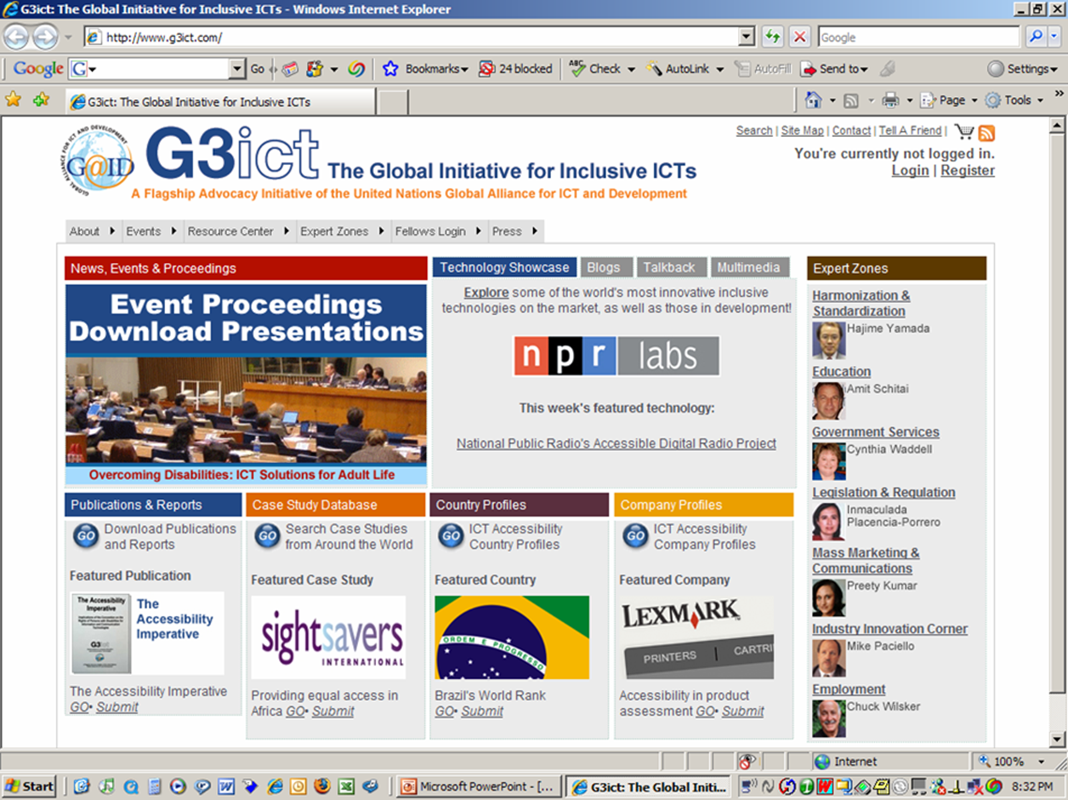
Screen shot of G3ict home page
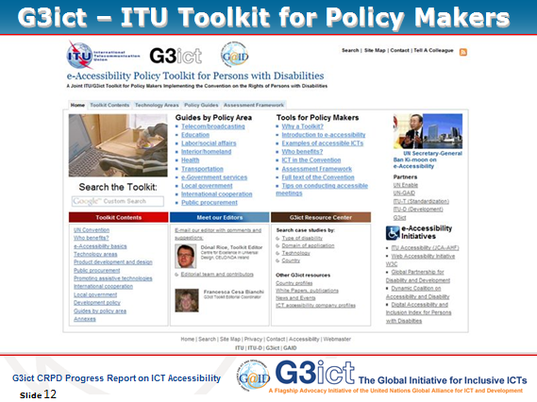
Screen shot of ITU-G3ict e-Accessibility Policy Toolkit for Persons with Disabilities
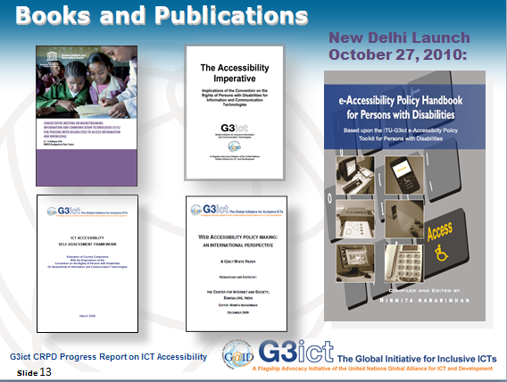
Screen shot of G3ict books and publications

G3ict 2010 Survey - CRPD ICT Accessibility Progress Report

- Objective: Assessing progress of CRPD implementation among ratifying countries for ICT accessibility and identify gaps
- Article by article examination of the CRPD dispositions covering ICTs by the G3ict Research Committee
- 57 data points selected measuring:
  - Country commitment
  - Ability to implement
  - Actual results for persons with disabilities
- Consistent with UNDP guidelines on Human Rights reporting (Structure, Process, Outcomes)
- Two different questionnaires per country
32 Countries Surveyed – 31 with Ratification + United States
Those 31 countries (US excluded) represent 75% of the population of the 90 ratifying countries as of 9-1-2010 (4.9 billion)

Argentina
Austria
Bangladesh
Belgium
Brazil
Burkina Faso
Canada
Chile
China
Costa Rica
Denmark
El Salvador
France
Germany
Guinea
Hungary
India
Kenya
Mali
Mexico
Morocco
Nicaragua
Portugal
Rwanda
South Africa
Spain
Thailand
Tunisia
Uganda
United Kingdom
United States
Zambia

General Legal and Regulatory Framework: Progressive Alignment with CRPD

- 91% have a constitutional article, law or regulation defining the rights of persons with disabilities
- 72% have a definition of "Reasonable Accommodation" included in any law or regulation regarding the Rights of Persons with Disabilities
- 56% have a definition of accessibility that includes ICTs or electronic media in the country laws or regulations

Government Policies and Programs to Promote ICT Accessibility

- 66% have laws, policies or programs that ensure that persons with disabilities and their representative organizations are consulted in the development and implementation of legislation in general
- 59% provide to the general public, including through the Internet, information and services in accessible and usable formats for persons with disabilities
- 35% define public procurement rules policy promoting accessible ICTs
% of State Parties with Policies Covering Information Infrastructure: Significant Gaps

- 56% Television
- 56% Web sites
- 47% Fixed telephony
- 47% Mobile telephony
- 41% ATMs and electronic kiosks
- 38% Digital talking books
- 34% Public building displays
- 31% Transportation public address systems

% of State Parties with Policies Covering ICT Accessibility in Specific Areas: Education #1
78% Primary and secondary education
72% Higher education
63% Rehabilitation services
59% Health services
59% Reasonable accommodation at work
50% Emergency services
44% Voting systems
44% Judicial information & legal proceedings
38% Community services
34% Independent living
Capacity to Implement Is Still Limited
- 97% have a government body specifically dedicated to Persons with Disabilities, BUT:
- 41% define, promote an monitor accessibility standards for ICTs
- 38% have government funds allocated to programs in support of Digital Accessibility
- 28% have a systematic mechanism to involve DPOs working in the field of digital access to the drafting, designing, implementation and evaluation of laws and policies
- 13% have statistics or data accessible for the general public about digital access by persons with disabilities
- 9% have mandatory training programs (at universities, vocational schools etc.) for future professionals about digital access for persons with disabilities (Tunisia, Hungary, South Africa)

Country Actual Implementations
78% Have closed captioning or sign language interpretation implemented by TV broadcasters
69% Mention having accessible government web sites
66% Have libraries for the blind or public libraries providing e-books services
59% Have assistive technologies available to students with disabilities at major universities
50% Have programs in place to facilitate the usage of telephony by persons with disabilities (Transcription, TDD/TTY devices, relay services, accessible public phones)
47% Have wireless handsets with accessible features
44% Mention having accessible web sites among the top 10 commercial and media web sites
44% Have accessible ATMs or electronic kiosks deployed
Survey Conclusions:

- General legal framework making progress, However:
  - ICT accessibility policies and programs lagging significantly vs. CRPD dispositions
  - Need for State Parties to work on their capacity to implement in order to succeed
  - ICT accessibility technical solutions and policies are in place and documented
- ICT accessibility policies and programs must be further promoted in areas identified via benchmarking, self-assessment and survey results

Going Forward – Recommendations to the Committee
- Promote existing knowledge sharing tools and programs and provide feedback and suggestions for improvement
- Establish a minimum set of data to be reported by countries on ICT accessibility in cooperation with international organizations and G3ict
- Recommend State Parties to accelerate and fund capacity building programs for policy makers with a focus on areas with greatest room for improvement
- Request that Standard Development Organizations provide an annual report to the Committee regarding the progress made in the development and actual implementation of ICT Accessibility Standards as per article 9.2 (a).
- Monitor WIPO negotiations for conformity with CRPD art. 30 – (3)

Committee on the Rights of Persons with Disabilities

Thank You
For Your Attention

www.g3ict.org
www.e-accessibilitytoolkit.org

axel_leblois@g3ict.org

Annex: Survey Results, Lessons Learned, Next Steps

- Enhance reliability by collecting evidence and seeking more independent validation
- Add and coordinate data collection with international institutions and DPOs to improve accuracy of results by providing checks and balances
- Integrate additional data points corresponding to the United Nations guidelines for CRPD State Parties reporting
- Seek more detailed data (i.e. % of captioned TV programs rather than Yes or No)
- Expand number of countries & collaborations

